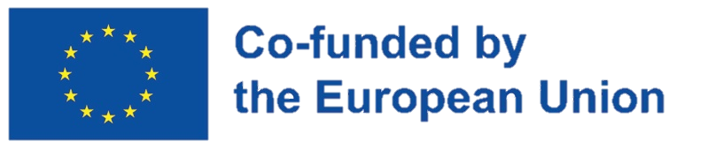


The Informal Training Set towards the European Green Deal Concept

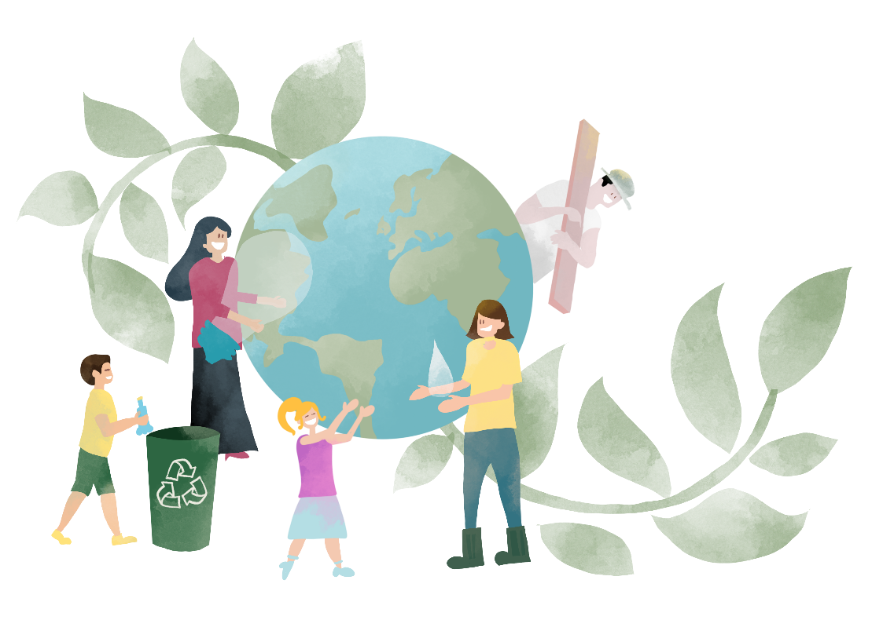
General information on the European Green Deal

European Green Deal
In June 2019 European Council adopted a strategic agenda for a climate-neutral, green, fair, and social Europe. As a response to the need to implement the requirements of the Paris Agreement, the European Commission developed a package of political initiatives and proposals as the future central development strategy of Europe, and called it the European Green Deal.
The European Green Deal represents a new growth strategy in Europe, which aims to achieve sustainable growth by turning climate and environmental challenges into opportunities in all policy areas through a just and inclusive transition and provides a roadmap towards more efficient use of resources by moving to a clean, circular economy and halting climate change, reversing biodiversity loss and reducing pollution. By adopting the European Green Deal, Europe has demonstrated its commitment to achieving the fundamental goal of climate neutrality by 2050.
The transition to climate neutrality will bring great opportunities, such as the potential for economic growth, for new business models and markets, and for new jobs and technological development.
European Council conclusions,
12 December 2019

The European Green Deal covers all sectors of the economy, emphasizing particularly transport, energy, agriculture, construction and industries such as steel, cement, ICT, textiles and chemicals.

What is the European Green Deal?
Basically, the European Green Deal is a set of political initiatives that are supposed to direct the EU towards a green transition and legislative initiatives that would help transform the European Union into a modern, resource-efficient and competitive economy by 2050 (Fig. 1), and help it achieve its goals:
- net zero greenhouse gas emissions;
- economic growth decoupled from resource use;
- no human and no place ignored.
The European Green Deal aims to support transformation of EU into a fair and prosperous society with a modern and competitive economy, where all relevant policy areas contribute to the ultimate climate goal through holistic and cross-sectoral approach.
The package includes initiatives that regulate the areas of climate, environment, energy, transport, industry, agriculture, and sustainable finance, all of which are closely related.

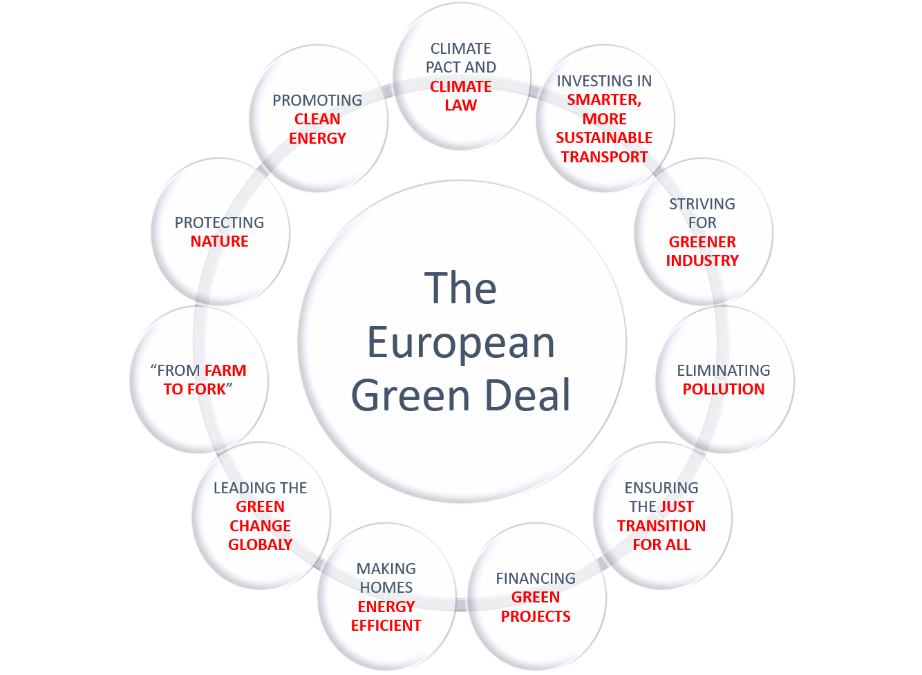
Fig. 1. The structure of the European Green Deal

The European Green Deal is not only about political initiative and legislative proposals, but also the financing of measures that will bring Europe to its goal. For this type of investment, the European Commission allocates 30% of 2021-2028 total budget and a large part of the special instrument for recovery after the COVID19 pandemic.

Which initiatives are part of the European Green Deal?
In align with the vision for the Green Deal, the European Commission has already put forward numerous policy proposals and initiatives for improving energy, mobility, and food systems, for enhancing circular economy as well as supporting ecosystems and biodiversity.
The European Green Deal includes a whole range of public policies, legislative solutions, and specific activities, which can generally be classified into five basic packages (Fig. 2):
- Ready for 55;
- European climate rules;
- EU strategy for Adaptation to Climate Change;
- EU Biodiversity strategy;
- “From Farm to Fork” strategy.

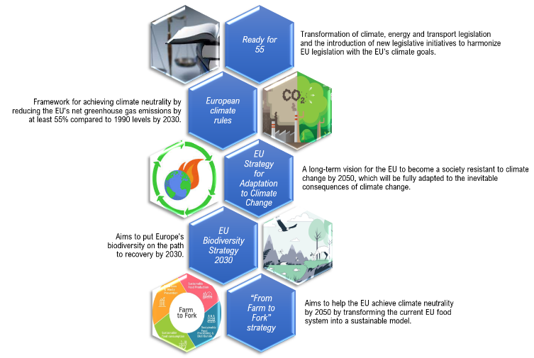
Fig. 2. EU Green Deal packages

Ready for 55
The "Ready for 55" package aims to translate the ambitions of the European Green Deal into legislation.
Since 2005 (when it was introduced), the EU’s emissions trading system (EU ETS) is one of the world’s largest carbon markets and the EU’s key tool for reducing greenhouse gas emissions, covering around 40% of total EU emissions. The system puts a price on carbon. Every year, entities covered by the ETS have to buy ‘allowances’ corresponding to their greenhouse gas emissions. This creates financial incentives for companies to cut emissions. However, certain sectors that are exposed to ‘carbon leakage’ get free allowances to support their competitiveness. EU ETS reform will result in further emissions reductions, bringing the EU closer to climate neutrality. The package is a set of proposals for the transformation of climate, energy and transport legislation and the introduction of new legislative initiatives to harmonize EU legislation with the EU's climate goals.
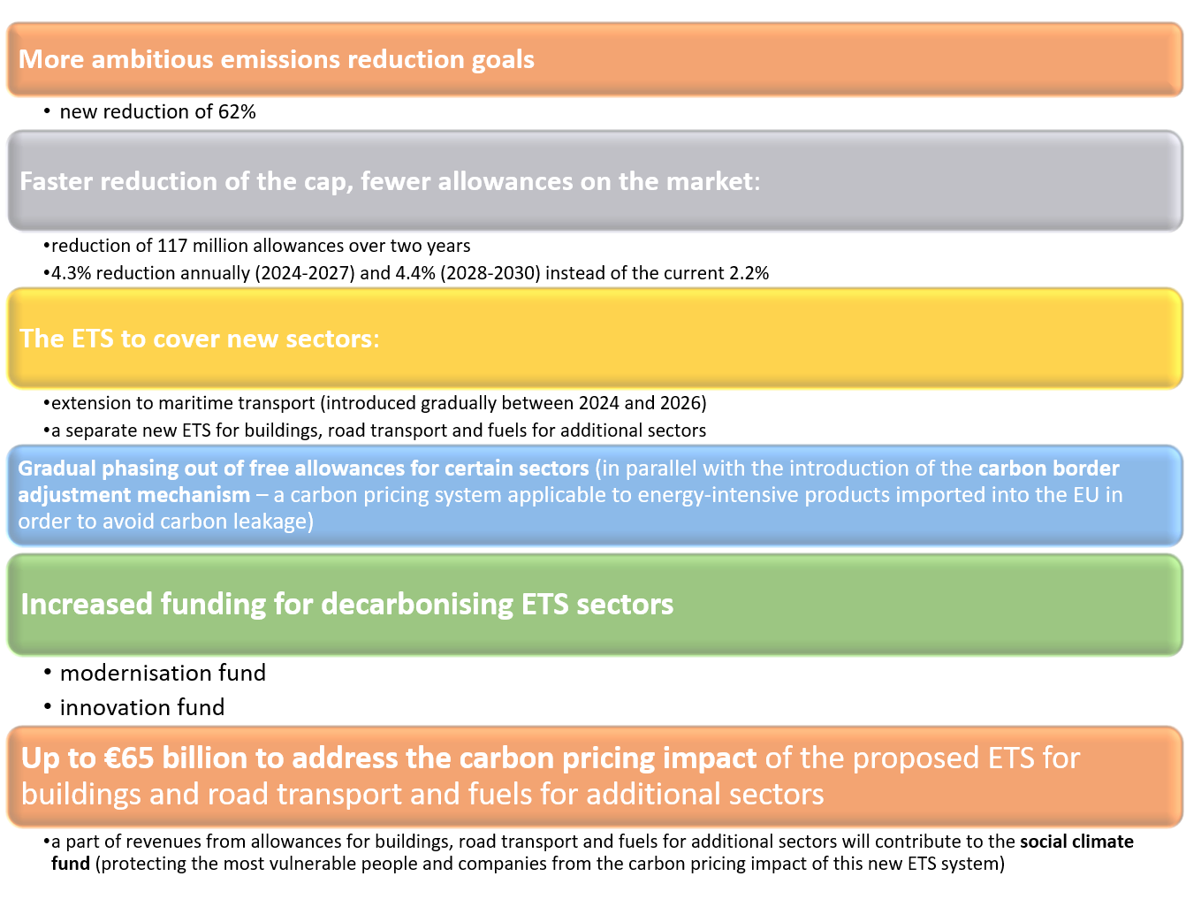
Fig. 3. “Ready for 55” package
By June 2022, EU countries agreed on a Council position on most of the Fit for 55 proposals. Negotiations with the European Parliament are currently ongoing on these proposals.

European climate rules
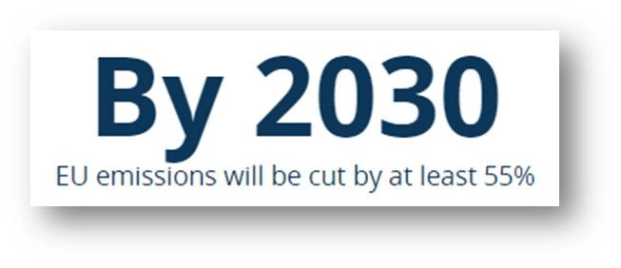
A central objective of the EU Green Deal is to set out the trajectory for the EU to be climate neutral by 2050. Becoming climate-neutral means that, by 2050, EU countries will have to drastically reduce their greenhouse gas emissions and find ways of compensating for the remaining and unavoidable emissions to reach a net-zero emissions balance. With the regulation establishing a framework for achieving climate neutrality, the political ambition to achieve climate neutrality by 2050 has become a legal obligation for the EU.
The EU and its Member States have committed to reducing the EU's net greenhouse gas emissions by at least 55% compared to 1990 levels by 2030. This target is legally binding and based on an impact assessment carried out by carried out by the Commission.
In June 2021, Council of Europe adopted the European climate law – a key element of the European Green Deal. Climate law sets the framework for actions to be taken by the EU and the member states to progressively reduce emissions and ultimately reach climate neutrality in the EU by 2050.
The main measures defined in the regulation are:
- planning the pace of emissions reduction until 2050 to ensure predictability for companies, stakeholders, and citizens.
- designing a system for monitoring and reporting on progress towards the goal
- care for a cost-effective and socially just green transition.
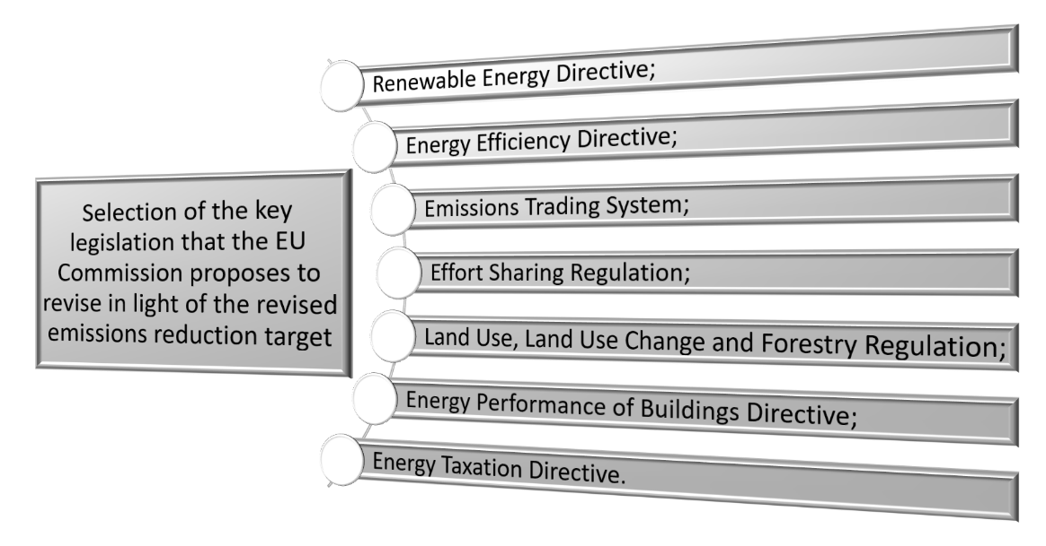
Fig. 4. Selection of the key legislation that the EU Commission proposes to revise in light of the revised emissions reduction target

EU Strategy for Adaptation to Climate Change
On 24 February 2021, the European Commission adopted the EU Strategy on Adaptation to Climate Change. The strategy presents a long-term vision for the EU to become a society resistant to climate change, fully adapted to the unavoidable impacts of climate change by 2050. The Strategy aims to build a climate resilient society
- by improving knowledge of climate impacts and adaptation solutions;
- by stepping up adaptation planning and climate risk assessments;
- by accelerating adaptation action; and
- by helping to strengthen climate resilience globally.
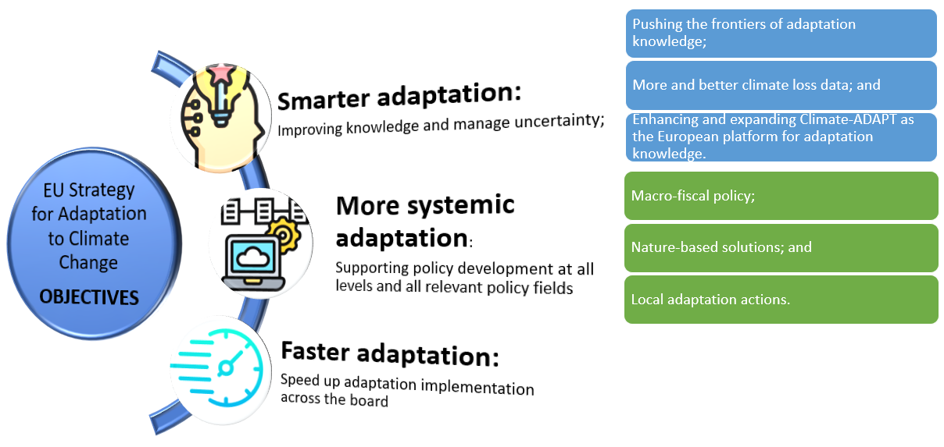
Fig. 5. Objectives of the EU Strategy on Adaptation to Climate Change
Among the measures set out in the strategy are:
- improving data collection and sharing to facilitate access to and greater sharing of climate impact knowledge;
- sonar solutions to help build resilience to climate change and protect ecosystems;
- mainstreaming adjustment into macro-fiscal policies.
These decisions set the political guidelines for the Commission regarding the implementation of the strategy.
In March 2022, the Council adopted resolutions calling for the adaptation of civil protection due to extreme weather events resulting from climate change.
Ministers called for the adaptation of civil protection systems, with emphasis on:
- prevention;
- readiness;
- responding;
- recovery.

EU Biodiversity Strategy 2030
European Union (EU) Biodiversity Strategy for 2030 has been adopted in May 2020. The aim of the Strategy is to put Europe's biodiversity on the path to recovery by 2030. This will be achieved by:
- improved protection and management of protected areas,
- restoration of degraded ecosystems for the benefit of biodiversity, climate mitigation, adaptation, and disaster risk reduction,
- reduced pollution including supporting farmers to shift to agroecological and organic practices.
- intensified battle against invasive species.

Among the measures set out in the strategy are:
- expansion of protected terrestrial and marine areas in Europe
- restoration of degraded ecosystems by reducing the use and harmfulness of pesticides
- increasing funding for actions and better monitoring of progress
The Member States are committed to 17 key targets to achieve this ambition, among other to enlarge the network of protected areas in the EU, building upon existing Natura 2000 sites and protected areas, to at least 30% of land and seas, with at least 10% of it strictly protected. Recent estimates suggest that only 3% of land and 1% of marine areas in Europe are under strict protection, which is far behind the new target and what is required if we are to curb the tide of current massive biodiversity loss. To obtain such ambitious targets, the Strategy contains over 100 specific actions and commitments ranging across several policy areas.
To meet the needs of this strategy, at least EUR 20 billion a year will be unlocked for biodiversity through various sources, including EU funds, national and private funding. In 2021, the Commission will adopt a delegated act under the Taxonomy Regulation to establish a common classification of economic activities that substantially contribute to protecting and restoring biodiversity and ecosystems.

Establish protected areas for at least 30% of land in Europe

Establish protected areas for at least 30% of sea in Europe

Increasing organic farming and biodiversity rich landscape features on agricultural lands

Halting and reversing the decline of pollinators

Restoring at least 25.000 km of EU rivers to a free flowing state

Reducing the use and risk of pesticides by 50% by 2030

Fig 6. EU Biodiversity Strategy 2030 targets

“From Farm to Fork” strategy
Food systems are responsible for around 21-37% of global greenhouse gas emissions and use up significant natural resources. The “From Farm to Fork” strategy aims to address these environmental issues as well as fairness, sustainability of the food system and the health of Europeans, and to help the EU achieve climate neutrality by 2050 by transforming the current EU food system into a sustainable model. In October 2020, the European Council adopted a set of decisions on the strategy, in which it supported the goal of developing a sustainable European food system from production to consumption. The focus is on reducing waste, and transforming the manufacturing, processing, retailing, packaging and transportation of food.
The strategy has six main goals:

Fig. 7. “From Farm to Fork” strategy objectives
- Ensuring sustainable food production;
- Ensuring food security;
- Stimulating sustainable food processing, wholesale, retail, hospitality, and food services practices;
- Promoting sustainable food consumption and facilitating the shift to healthy, sustainable diets;
- Reducing food loss and waste;
- Combating food fraud along the food supply chain.
To enable the EU to reach these broad goals, the strategy also outlines a range of concrete targets that need to be met in each area. For example, by 2030, 25% of total farmland has to be under organic farming, the use of chemicals and certain pesticides in agriculture should be reduced by 50%, and the EU sales of antimicrobials for farmed animals and agriculture should be reduced by 50%.
The plan also outlines several actions to be undertaken in the coming years to enable the food system actors to achieve these objectives:
- €10 billion on research and innovation on food, bioeconomy, natural resources, agriculture, fisheries, aquaculture and the environment, as well as digital technologies and nature-based solutions for agri-food, funded by Horizon Europe, the EU’s research and innovation framework program;
- Focusing EU policies and legislation on trade policy to obtain commitments from third countries in areas such as animal welfare, the use of pesticides and the fight against antimicrobial resistance;
- Development of EU Code of conduct for responsible business and marketing practice;
- Seeking commitments from food companies and organizations to start taking steps towards improving health, sustainability and the environment;
- Reform of the common agricultural policy (CAP);
- Development of a strategy to reduce methane emissions.

Collection of information on the transition process of sectors under the Green Deal
Overview of the current situation in project members countries
With the aim to take an insight into partner countries opinion in this field, the adequate questionnaire was performed. A survey of 14 questions was delegated to more than 100 students and academic citizens from project members countries.
The random sample on which the research was conducted includes citizens in the territory of Sophia, Istanbul, Ankara, and Nis (from participation countries) was used.
The first part of the questionnaire contained questions concerning the basic informations of the respondents, such as gender and age.
33.6% male respondents and 66.4% female respondents participated in the research. (Fig. 8).
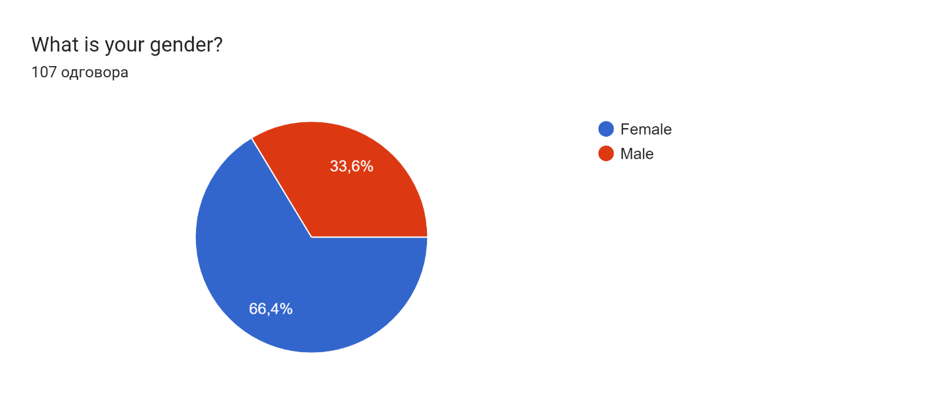
Fig. 8. Distribution of respondents by gender
The survey covers all age categories over 20 years old.
To the question "Do you think you are knowledgeable about the European Green Deal?", most respondents answered no (67.4%). On the other hand, 23.6% of respondents point out that their knowledge about European Green Deal is sufficient, (Fig. 9).
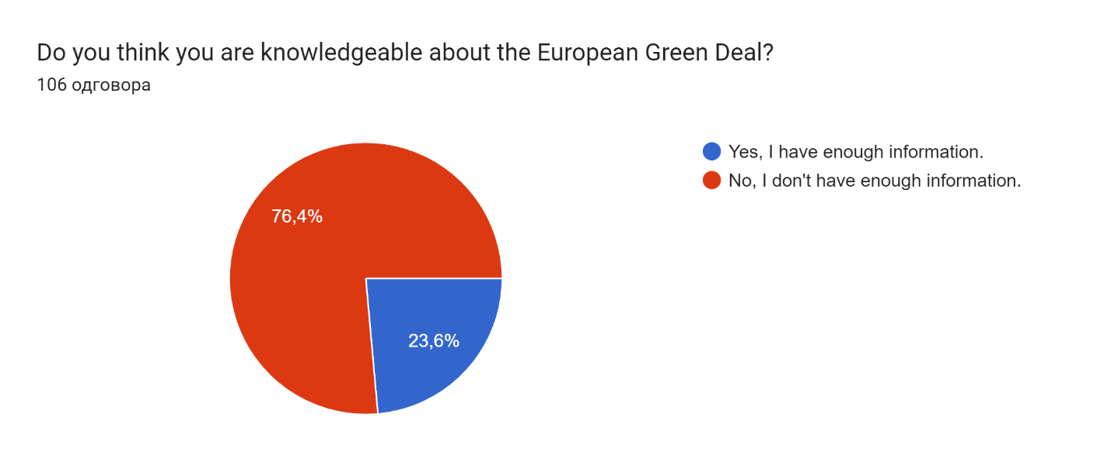
Fig. 9. Distribution of answers to the question " Do you think you are knowledgeable about the European Green Deal?"
To the next question, “How important do you think the following issues are on a global scale?” more answers could be circled. The largest of the respondents (more than 75%) has market that the very important issues are Air pollution, Pollution of rivers and seas, Temperature increase or Decrease, Poor use of the world's resources, Diversity loss and Radioactive waste.
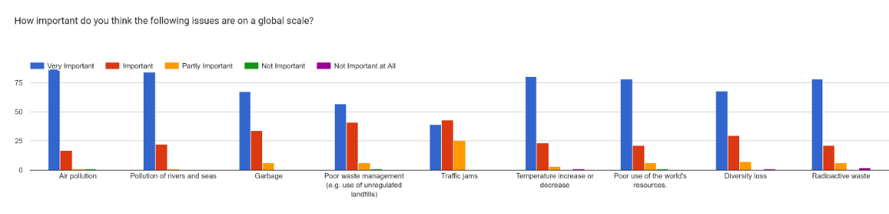
Fig. 10. Distribution of answers to the question "How important do you think the following issues are on a global scale?”
Regarding the general information about presence of European Green Deal and climate change in print and broadcast media, the following question was asked: " Do you think that the European Green Deal and climate change are given sufficient coverage in print and broadcast media?".
Most respondents think that it has not been covered enough (66.4%), then 23.4% don't have enough information on this subject, while 10.3% of respondents think that it has been covered enough (Fig. 11).
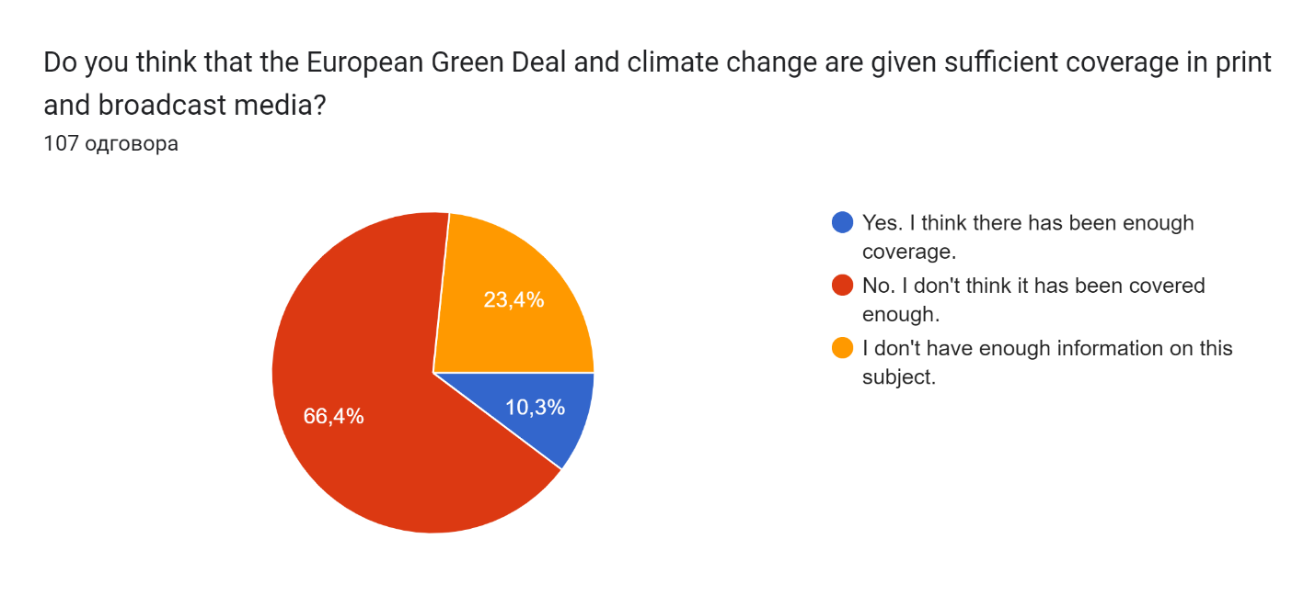

Fig. 11. Distribution of answers to the question " Do you think that the European Green Deal and climate change are given sufficient coverage in print and broadcast media?"

Fig. 12 shows the platforms from which the participants get the most information about global climate change. As expected, the most information about global climate changes examiners obtained both from internet (91.6%) and school/University (74.8%).
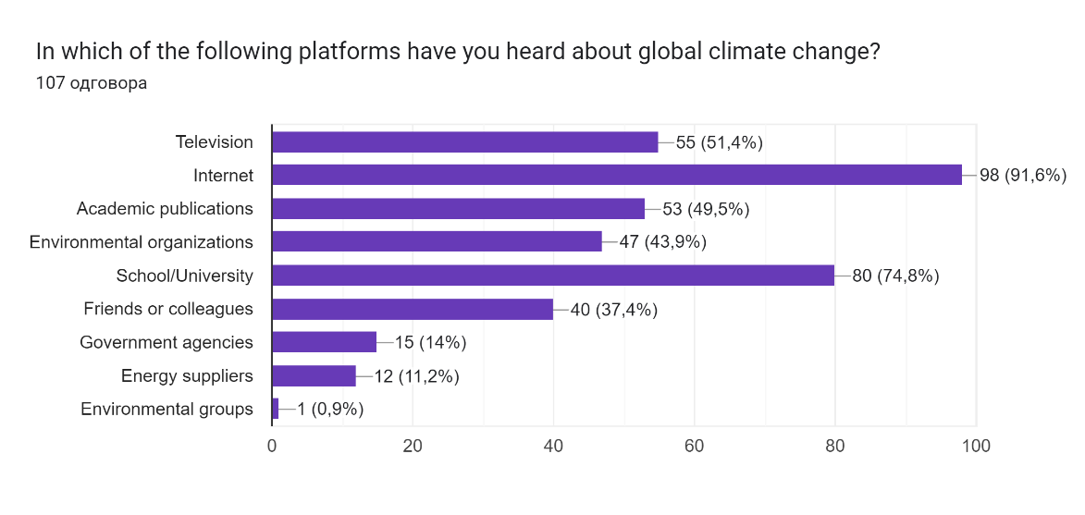
Fig. 12. Distribution of answers to the question " In which of the following platforms have you heard about global climate change?”
The next question deals with young people have resources for green skills and active citizenship air quality in the city itself. On question “Do you agree that young people have sufficient resources for green skills and active citizenship?” the answer agree and strongly agree was given by 46.7% examiners, 33.6 were neutral, while the answers disagree and strongly disagree takes 24.3%
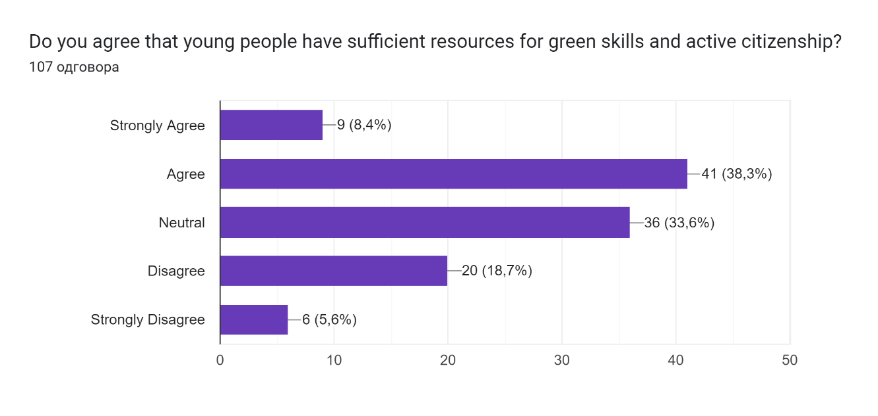
Fig. 13. Distribution of answers to the question " Do you agree that young people have sufficient resources for green skills and active citizenship”
It was necessary to examine whether the respondents are aware of opportunities in the Green Deal transition processes. The majority of respondents (62.3%) stated that they are not sure about the opportunities in the Green Deal transition processes, 20.8% do not have information, while only 16% of respondents are aware of opportunities in the Green Deal transition processes (Fig. 14).
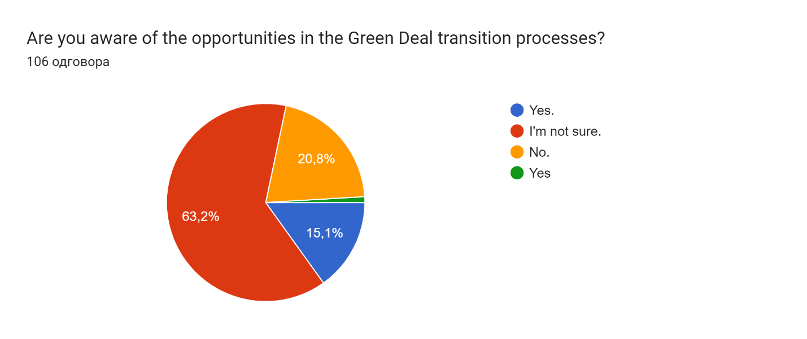
Fig. 14. Distribution of answers to the question " Are you aware of the opportunities in the Green Deal transition processes?”
The next question was about participations desire in learning about European Green Deal strategy where the 90.5% of respondents answered positive (Fig. 15).
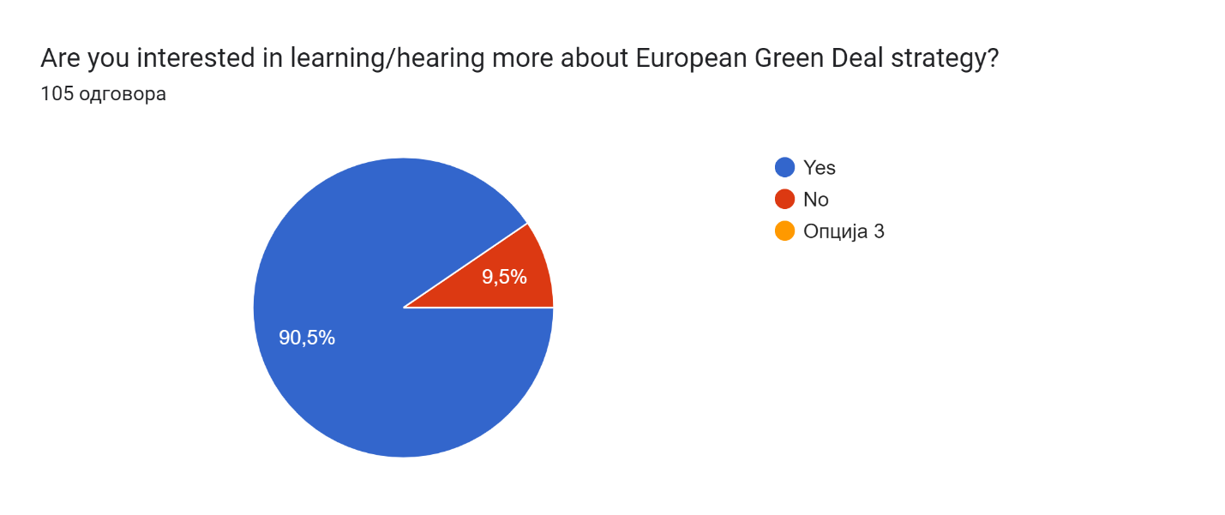
Fig. 15 Distribution of answers to the question " Are you interested in learning/hearing more about European Green Deal strategy?"
The answers to the question "Do you agree that climate change poses a serious threat to people around the world?" indicate that as many as 92.5% believe that climate change poses a serious threat to people around the world, 7.5% are neutral, while 2.8% disagree that climate change has a serious threat to people around the world (Fig. 16).
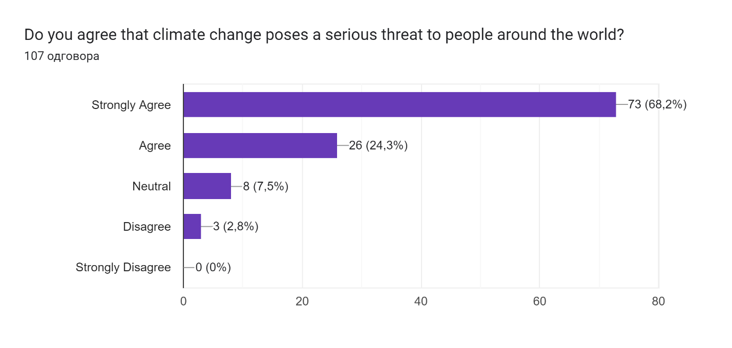
Fig. 16. Distribution of answers to the question " Do you agree that climate change poses a serious threat to people around the world?"
The next question related to information on whether citizens have enough information about the ETS II Competence Model. As many as 94.4% stated that they were not aware, while only 5.6% were aware ETS II Competence Model (Fig. 17).
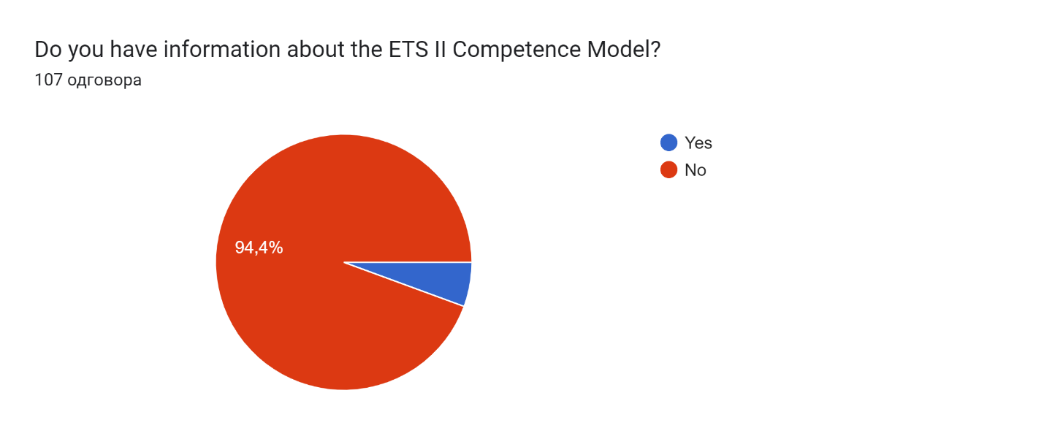
Fig. 17. Distribution of answers to the question " Do you have information about the ETS II Competence Model?"”
To the question “Do you think that a sufficient number of activities for environmental management and sustainability (resource efficiency, circular economy, waste recovery, etc.) are carried out to reduce environmental impacts?", the answer no was given by (41.5%) participants, while 25.5% gave a positive answer (Fig. 18). The rest of 33% answered that they don't have enough information on this subject.
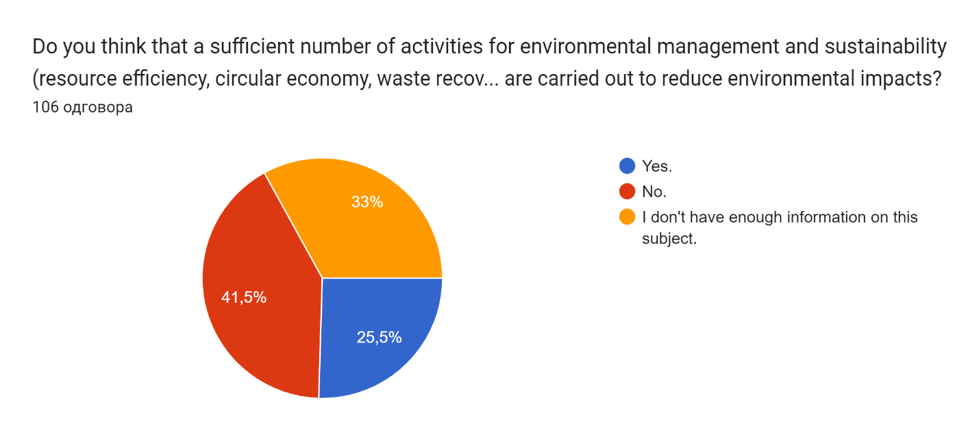
Fig. 18. Distribution of answers to the question "Do you think that a sufficient number of activities for environmental management and sustainability (resource efficiency, circular economy, waste recovery, etc.) are carried out to reduce environmental impacts?"
In next questions participants were asked the question "Are you aware of global policies or initiatives implemented by various organizations to reduce global warming / global climate change?". According to participants opinion, 60.7% are aware while 39.3 do not aware of global policies or initiatives (Fig. 19).
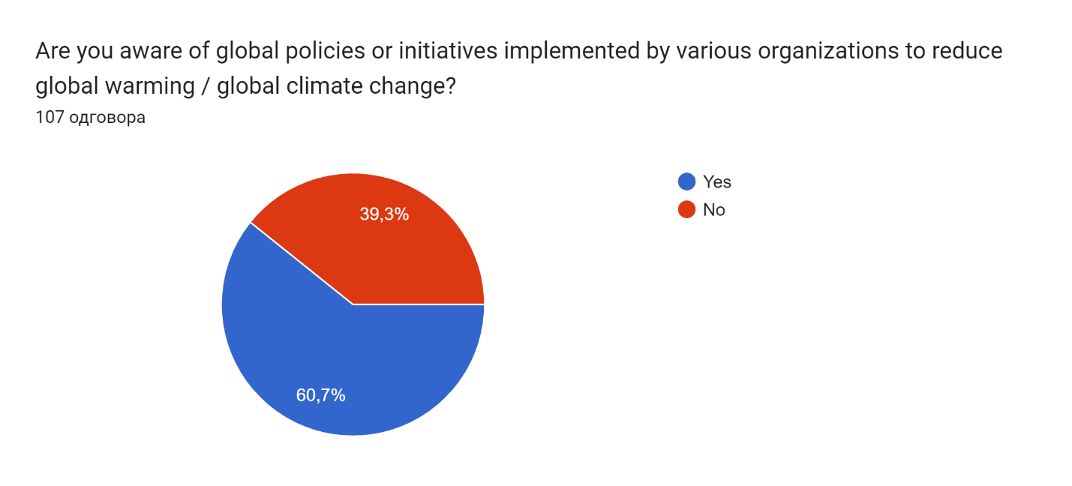
Fig. 19. Are you aware of global policies or initiatives implemented by various organizations to reduce global warming / global climate change?"”
One of the questions related to the education of citizens was “What kind of activities would you like to participate in about EGD”? The participants gave the following answers: Seminars (61%), Workshops (52.4%), Conferences (50.5%), Research (41%), Education activities (65.7%), (Fig. 20).
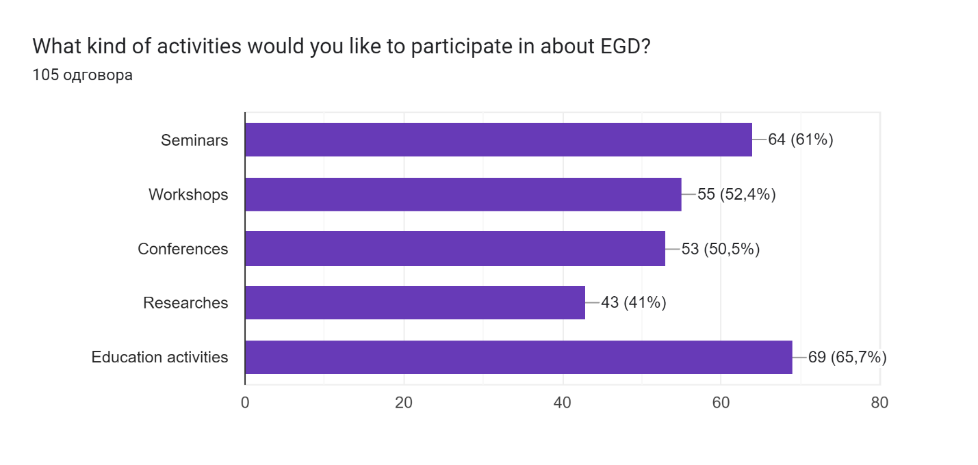
Fig. 20. Distribution of answers to the question " What kind of activities would you like to participate in about EGD?"
Now, the obtained results are then separated into two groups (younger and older than 25 years).
The results which show statistical significance in groups answers are present in Fig. 21.
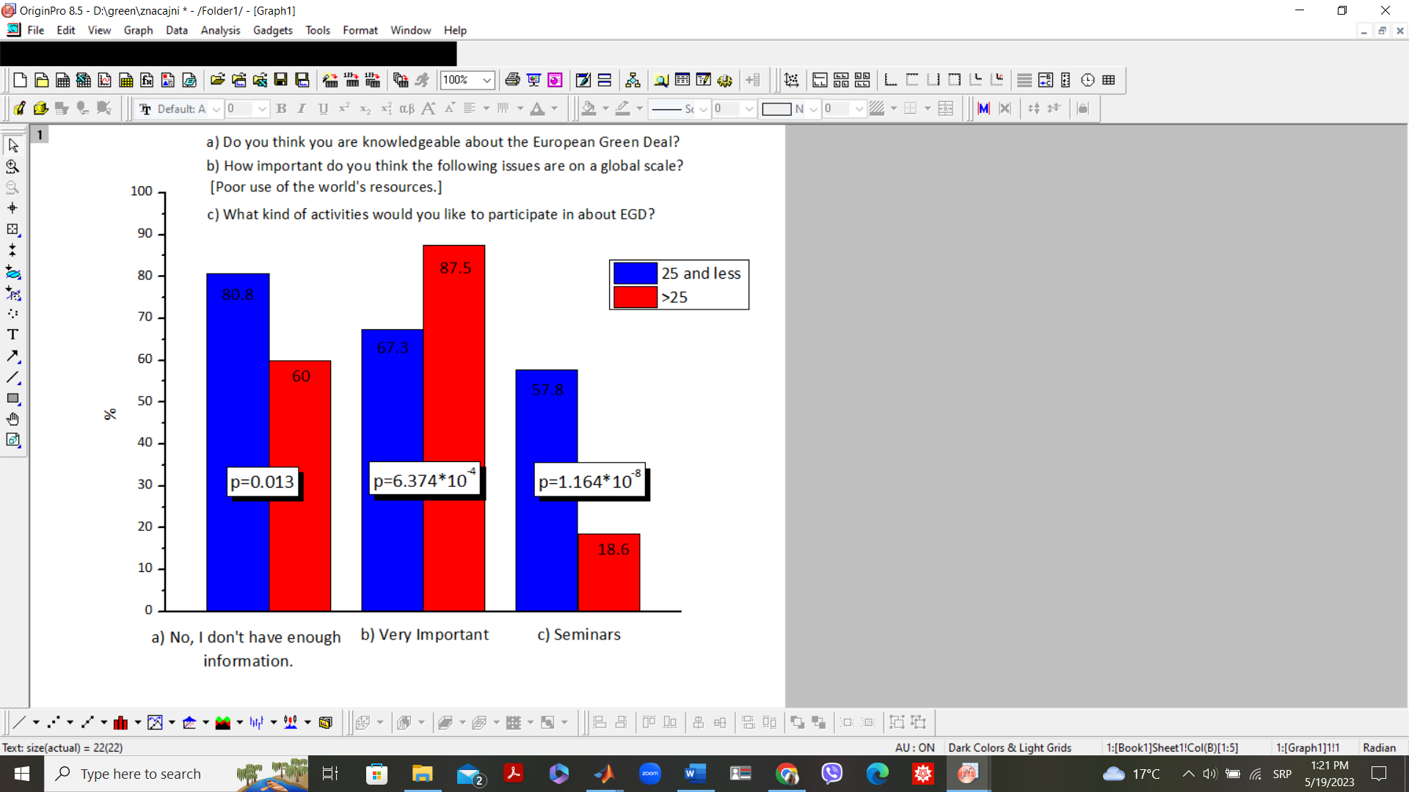
Fig. 21. Survey results with statistical significance
Green Deal Pact: Case study Bulgaria

Climate change and environmental deterioration pose a serious threat to the existence of Europe and the world. To overcome these challenges, the European Union has developed the European Green Pact, which envisages the EU becoming a modern, resource-efficient, competitive economy. The main objective of the Pact is to decarbonize the economies of the EU member states by 2050, with the aim of improving the well-being and health of European citizens and future generations by:
-clean air, clean water, healthy soil, and biodiversity.
- renovated, energy-efficient buildings.
- healthy food at affordable prices.
- public transport.
- cleaner energy and cutting-edge clean technology innovation.
- more durable products that can be repaired, recycled and reused.
- forward-looking jobs and training in the skills needed for the transition.
- a sustainable and globally competitive industry.
In other sectors, the objectives to be implemented include:
Agriculture - achieving food security, reducing the carbon footprint on the environment and climate resulting from food production, and moving towards competitive sustainability from farm to fork.
Industry - competitive, green, and digital production based on the concept of circular economy.
Environment - protecting biodiversity and ecosystems, reducing air, water, and soil pollution, improving waste management.
Transport - ensuring efficient, safe, and environmentally friendly transport.
Legislative measures to make Europe the world's first climate neutral continent.
Implementation of the European Green Pact in Bulgaria
Legal framework of the Green Deal in Bulgaria
In Bulgaria, the implementation of the Green Deal measures is monitored by the Bulgaria’s Advisory Board on Green Deal and Council of Ministers of the Republic of Bulgaria. The Consultative Council for Green Deal Pact, part of Council of Ministers of the Republic of Bulgaria, is the body that sets the framework for the upcoming reforms and investments for decarbonization and modernization of Bulgarian economy. The Energy Transition Commission (ETC) and the Sustainable Mobility Commission (SMC) have been established to support the Consultative Council.
Moving towards a circular economy and implementing the commitments made in the Green Deal require changes to the country's legislation. The local legislative initiatives are related to the adoption of the Climate Change Mitigation Act. In 2019 was approved by Council of Ministers the National Climate Change Adaptation Strategy and Action Plan for the Republic of Bulgaria. The aim of the Strategy is to serve as a reference document, setting a framework for climate change adaptation action and priority directions up to 2030. Our country has adopted the "Long-term strategy for climate change mitigation until 2050 of the Republic of Bulgaria" and “Strategy and Action plan for transition to a circular economy of the republic of Bulgaria for the period 2021-2027”.
International treaties and agreements the country has signed are the Paris Agreement, the Kyoto Protocol, and the United Nations Framework Convention on Climate Change (UNFCCC).
European Union legislative initiatives that the country has implemented are:
- Decision (EU) 2015/1814 of the European Parliament and of the Council of 6 October 2015 on the establishment and operation of a market stability reserve for the ETS and amending Directive 2003/87/EC
- Commission Regulation 601/2012/EC of 21 June 2012 concerning the monitoring and reporting of greenhouse gas emissions pursuant to Directive 2003/87/EC of the European Parliament and of the Council
- Commission Decision 2011/278/EU of 27 April 2011 laying down European Union-wide transitional rules for the harmonized free allocation of emission allowances pursuant to Article 10a of Directive 2003/87/EC of the European Parliament and of the Council
- Commission Regulation (EU) No 1031/2010 on the timing, administration, and other aspects of the auctioning of greenhouse gas emission allowances pursuant to Directive 2003/87/EC of the European Parliament and of the Council establishing an emissions trading scheme
- Directive 2009/29/EC of the European Parliament and of the Council amending Directive 2003/87/EC to improve and extend the greenhouse gas emission allowance trading scheme of the Community
- Directive 2009/28/EC of the European Parliament and of the Council on the promotion of the use of energy from renewable sources and amending and subsequently repealing Directives 2001/77/EC and 2003/30/EC
- Directive 2009/30/EC of the European Parliament and of the Council amending Directive 98/70/EC as regards the specification of petrol, diesel and gas oil and introducing a mechanism to monitor and reduce greenhouse gas emissions
- Directive 2009/31/EC of the European Parliament and of the Council on the storage of carbon dioxide in geological formations and amending Council Directive 85/337/EEC, Directives 2000/60/EC, 2001/80/EC, 2004/35/EC, 2006/12/EC and 2008/1/EC and Regulation (EC) No
- Regulation (EC) No 443/2009 of the European Parliament and of the Council setting emission performance standards for new passenger cars as part of the Community's comprehensive approach to reduce CO2 emissions from light-duty vehicles
- Directive 2008/101/EC of the European Parliament and of the Council amending Directive 2003/87/EC so as to include aviation activities in the scheme for greenhouse gas emission allowance trading within the Community
- Directive 2004/101/EC of the European Parliament and of the Council amending Directive 2003/87/EC establishing a scheme for greenhouse gas emission allowance trading within the Community as regards the project-based mechanisms provided for in the Protocol of
- Consolidated version of Directive 2003/87/EC of 13 October 2003 establishing a scheme for greenhouse gas emission allowance trading within the Community and amending Council Directive 96/61/EC Download
- Agreement between the European Union and the Swiss Confederation on the linking of their greenhouse gas emission trading systems
Green Deal in Bulgaria
Transport sector-The Integrated Transport Strategy for the period until 2030 was adopted by the Council of Ministers of the Republic of Bulgaria with Decision No 336/23 June 2017. The Strategy underlines the main aspects for the development of the national transport system for the period until 2030. The Integrated Transport Strategy for the period until 2030 is elaborated in accordance with the principles of consistency, continuity, and synergy with national and European strategic documents.
The strategic document complies with the requirements of the Ex-Ante Conditionalities 7.1, 7.2 and 7.3 (Transport) of the European Structural and Investment Funds and with the Partnership Agreement of the Republic of Bulgaria. As a part of the Strategy, a National Transport Model is prepared. The model covers freight and passenger traffic as well as all modes of transport. The Model is applicable to internal, international and transit transport.
The carbon intensity of the transport sector in the country is 3.5 times higher than the EU average, reaching 2.8 kg of greenhouse gases per €1 of gross value added in 2019. The sector is one of the main emitters of greenhouse gases and is associated with 26% of the total. Therefore, in the context of efforts to decarbonize the economy, there is a need to intensify investment in sustainable transport to reduce the sector's carbon footprint.
Bulgaria also plans to diversify the use of renewable energy sources in the transport sector by introducing biofuels and hydrogen. Greenhouse gas emissions in the sector can also be reduced by accelerating the introduction of advanced technologies in rail transport (European Rail Traffic Management System) as well as in other modes of transport. The improvement of current intelligent transport systems will continue in road transport.
In 2019, policies and measures were introduced to charge for road use, which is based on time and distance. Such policies and measures will provide further opportunities for decarbonization. Restricting lower emission zones also contributes to reducing emissions. The low-emission zones introduced by the National Air Pollution Control Program will restrict access to central urban areas by drivers of non-Euro and Euro I-type vehicles (many of which are diesel vehicles). Similar measures to those described in the program are expected to continue beyond the 2020-2030 program period.
One action Member States can take in this respect is to further expand the use of electricity in road transport (including through the deployment of charging infrastructure). The uptake of zero-emission passenger cars in Bulgaria is low and the density of public charging points is low. By 2021 there will be around 500 charging points in Bulgaria (according to the European Alternative Fuels Observatory - EAFO). An increase in electric vehicles is expected in the coming years. In its Recovery and Sustainability Plan, Bulgaria has committed to installing 10 000 charging points by 2026 to provide, among other things, the necessary energy for travel. According to the national energy and climate plan, every new building should be equipped with at least one charging station.
This would also contribute to making significant progress on the necessary infrastructure for electromobility. Bulgaria will promote the use of electric and hybrid vehicles (currently incentivized through tax incentives, free parking, or subsidies for municipalities only) in public and private transport.
There are 4,614 all-electric passenger cars in the country by 2022, according to the Ministry of Interior. Hybrid cars that use conventional fuel in addition to electricity are 25,467, of which the petrol-electric variant is 21,842.
Public transport in the big cities like Sofia, Varna, Burgas is conducted by electric buses and trams. The new trams and buses are low-floor and air-conditioned, with a platform for prams and people with reduced mobility. The vehicles are equipped with a stop button for disembarking and a voice signal for blind people. They are equipped with a highly efficient electric heating system and two separate air conditioning systems - for cooling the passenger compartment and the driver’s cabin.
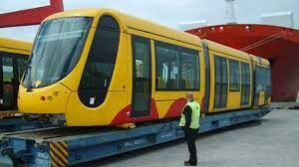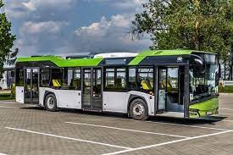
Environment - Bulgaria has achieved a significant reduction in greenhouse gas emissions over the last years, from 1988 - 2018 they decreased by 50.5%. In 2019, Bulgaria accounted for 57.2 MtCO2e of total emissions, equivalent to an 11.6% reduction. Bulgaria's total emissions also decrease by 8.5% from 2017 to 2019. In 2019, GHG emissions from the energy sector amounted to 22.3 MtCO2e, their share was 39%, followed by emissions from transport (16%), industrial processes and product use (12%) and agriculture (11%)
In 2019, the share of energy from renewable energy sources (RES) in Bulgaria is 21.6%. Meanwhile, the share of wind and solar energy has been growing steadily in the electricity sector. In 2019, solid biofuels used for electricity accounted for 5.7% of the share of RES. The contribution of transport biofuels is 6.4% in 2019.
To decarbonize the energy sector, Bulgaria's NEEAP foresees measures to increase electricity generated from wind, solar and biomass, to develop biomass cogeneration plants, to introduce biofuels. Additional measures, such as switching from coal to natural gas, increasing the share of heating and cooling with renewable energy sources, reducing losses in transmission networks, using non-conventional fuels for primary energy production, as well as policies and measures in the domestic and public sectors could also lead to a progressive reduction of GHG emissions.
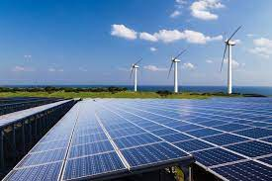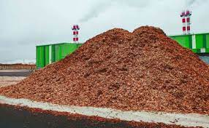

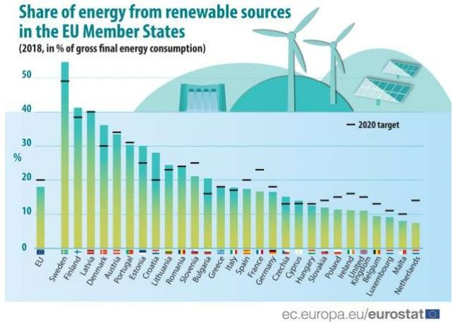
Air - The assessment of air quality on the territory of the country is carried out by a National control system through which the concentrations of key indicators are monitored daily. Republic of Bulgaria does not have chronic problems with major pollutants, except for excess levels of fine particulate matter, which is mainly due to the use of domestic solid fuels for heating and the old automobile stock – a problem in most of the EU Member States. The national monitoring system data shows a reduction in the past years in the number of both exceedances of daily average rate and average annual concentration of fine particles for almost all monitoring points.
These positive trends in air quality are due to the pro-active policies and measures as taken at all levels, including harmonization of legislation with the EU, the amendments in Clean Air Act towards the responsibility of municipalities to improve air quality and the increased control by the central government, the active implementation of the municipal programs and the integration of the policy for protection of air in the financing operational programs of other ministries.
Energy-efficient buildings - As regards buildings, Bulgaria plans to take measures to improve the energy performance of at least 5% of the total floor area of all public buildings with heating and cooling systems used by the public administration. According to the long-term strategy for the renovation of the national building stock of residential and non-residential buildings for the period 2020-2050, Bulgaria plans to renovate 60 % of the building stock and approximately 17 % of non-residential buildings by 2050. The estimated energy savings are 7329 GWh per year.
Overall, 1820 residential buildings have been renovated with the financial support of the Residential Energy Efficiency Program by 2019.
The Cleaner Air Program is implemented in 21 cities. The main objective of the project is to reduce fine particulate matter emissions and improve air quality by decommissioning old wood and coal heaters and replacing them with new environmentally friendly heating methods.
By 2030, measures for household gasification are expected through the development of the natural gas network with the aim of phasing out conventional fuels (solid fuels). After 2030, small-scale decentralized heating and/or cooling systems based on renewable energy (geothermal) are planned to be developed to achieve a carbon-neutral environment. All these measures will lead to a reduction in carbon intensity from 0.11 tons of CO2 per capita in 2005 to 0.04 to reach 0.01 tons of CO2 per capita in 2050.
Nature and biodiversity - The national policy on nature protection targets the management, control and conservation of biodiversity and protected areas. It is implemented by the Ministry of Environment and Water, assisted by Directorate National Office for Protection of Nature, in accordance with the international and national legislation – Environment Protection Act, Biodiversity Act, Protected Areas Act, Medicinal Plants Act, Genetically Modified Organisms Act and strategic documents – National Priority Action Framework for Natura 2000, Strategic Plan for Biodiversity, EU Strategy for Biodiversity, Global Strategy for Plant Conservation, National Plan for Protection of the Most Significant Wetlands.
The country has 3 national parks, 11 nature parks, 55 reserves, 35 maintained reserves, more than 500 protected areas and 350 natural landmarks. In order to protect and effectively manage the protected areas, management plans are being developed and implemented. A large part of the protected areas of Bulgaria is included in various international networks – the Convention for Protection of World Cultural and Natural Heritage and the Program for Biosphere Reserves of UNESCO, the Ramsar Convention on Wetlands, etc., that place additional responsibilities to ensure sustainable management of our natural resources.
Bulgaria is one of the richest in biodiversity among European countries and ranks third in the EU in percentage of national territory that is included in the European ecological network Natura 2000 (34.4%). As a contribution to the network, the Ministry provides the necessary care for long-term survival of endangered species and habitats in accordance with international agreements on environmental protection and biodiversity. In compliance with the European directives on protection of habitats, flora, fauna and birds, our country protects more than 90 types of natural habitats and over 300 species of plants and animals.
Waste - The state policy on waste management is a modern resource efficiency concept aiming to prevent waste, promote reuse through recycling, regeneration or other process of extracting secondary raw materials, provide safe disposal and storage of waste, increase producers responsibility, stimulate investment in the sector, within the available financial instruments.
The policy on waste management is carried out by the Ministry of Environment and Water, assisted by Directorate Waste management and soil protection, in accordance with EU and national legislation – Environment Protection Act, Waste Management Act, regulations, national planning and strategic documents – National Plan for Waste Management 2014-2020, National Strategic Plan for Urban Wastewater Treatment Plants Sludge Management 2014-2020, National Strategic Plan for Construction and Demolition Waste Management 2011-2020 and National Strategic Plan for Gradual Reduction of Biodegradable Waste.
In the context of European Commission waste policy and the development of circular economy, the linear economic model of the type “get, produce and dispose” no longer corresponds to the needs of modern society and the limited nature of natural resources. According to the accepted hierarchy of waste priority is given to waste prevention, followed by preparation for reuse, recycling, recovery and finally disposal, being the most undesirable option.
In this sense, the state policy on waste management is focused on the integration of new, sustainable from environmental and economic point of view models where everything that can be utilized and recycled from household waste is separated to be transformed into energy, raw material for the industry, fertilizer for the plants and only minimal amounts of waste are disposed at the newly built regional landfills.
By legislative and non-legislative initiatives, the policies of the Ministry are consistent with the policies at European level and the key aspects of the national interest to achieve a 65% recycling of household waste by 2030, 75 % recycling of packaging waste by 2030 and 10% maximum landfill disposal by 2030.
Water - The state policy on water management aims to achieve and maintain good status of all groundwaters, surface waters and marine waters, as a vital resource for life on the planet, limiting the harmful effects on human life and health, environment, cultural heritage, and business.
At a national level, the policy on water management is carried out by the Ministry of Environment and Water, assisted by Directorate Water Management and at a basin level – by 4 Basin Directorates and 16 Regional Inspectorates of Environment and Water, that monitor and control waste waters within their respective territorial scope.
The policy on water management is focused on development and implementation of the Plans for River Basin Management as a main planning document for integrated water management and the Marine Strategy; provision of sufficient quantity and quality of water for the needs of the population, economy and ecosystems – continuity of water supply and reduction of quantities of used water for consumption efficiency and management of water as an economic resource; control of discharges of wastewater and development of the monitoring system; mitigation of adverse climate impacts – threat assessment and flood risk, identifying areas with potential significant flood risk, development and implementation of Plans for Flood Risk Management to take specific preventive and protective measures and the preparedness of the competent authorities and the population; financing of sustainable investments in water infrastructure.
Water management is carried out in accordance with EU and national legislation – Environment Protection Act, Water Act, regulations, national strategic and planning documents – National Strategy for Management and Development of the Water Sector, Plans for River Basin Management, Plans of Flood Risk Management, Marine Strategy, national programs in the field of protection and sustainable development of waters.
Bulgaria is a partner in several international conventions for waters, including The Convention on Co-operation for the Protection and Sustainable Use of the River Danube, The Convention on the Protection of the Black Sea Against Pollution and The Convention on the Protection and Use of Transboundary Watercourses and International Lakes.
Agriculture - Agriculture emissions have increased significantly since 2005. Agriculture accounts for more than 10% of total GHG emissions in the European Union. Total non-carbon (CH4 and N2O) GHG emissions from agriculture are projected to decline by 2030 (1.5% to the equivalent of 433 Mt CO2) compared to the 2005 baseline. In 2030, livestock will continue to contribute 99% of methane (CH4) emissions from agriculture, with the largest share (85%) from ruminants. The model shows that non-carbon emissions in Bulgaria will increase until 2050, mostly in the crop production of the agriculture sector, starting from 4.071 ktoe CO2 eq. in 2020 to 6.348 ktoe CO2 eq. in 2050.
Our country has developed a tool (B)EST (Bulgarian) Energy System Tool), which is used for long-term energy assessment and planning in Bulgaria. The (B)EST tool has been developed by E3Modelling and adapted to the needs of Bulgaria in the project Contract No. SRSS/SC2019/032, funded by the European Union through the Structural Reform Support Program 2017-2020.
The Ministry of Agriculture has developed a Manual of Good Agricultural Practices that relates to soil, water, air conservation, the use of biofertilizers and the elimination of chemical inputs in agriculture.
Special software Farm Sustainability Tool for Nutrients (FaST) is planned to be used to calculate the required fertilizer rates and nutrient needs.
Farmers are encouraged to implement environmentally friendly schemes that are linked to the additional subsidies received by producers.

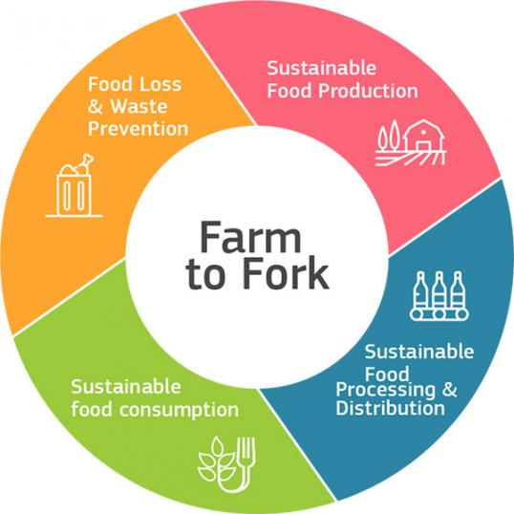
The European Commission's Farm to Fork Strategy is central to the European Green Pact and aims to transform Europe's food systems towards a more sustainable model of production and consumption. Among the strategy's main priorities are halving the use of antibiotics in livestock farming and achieving at least a 25% share of organic production in the Union by 2030.
Soil - The soil resources of Bulgaria generally have a high productive, regulatory, and buffer functions potential and are subjected to natural and anthropogenic degradation, which adversely affects the functioning of ecosystems. The intensification of agricultural production can lead to accelerated degradation processes – erosion, salinization, acidification, water pollution, loss of biodiversity, to unfavorable for agriculture and environment extent. The damage of soil is a result of pollution with heavy metals and metalloids, plant protection products (pesticides), resistant organic pollutants, including petroleum products, unregulated waste disposal on soil surface, and mining industry activities.
The policy on soil protection is carried out by the Ministry of Environment and Water, assisted by Directorate Waste management and soil protection, in accordance with EU and national legislation – Environment Protection Act, Soil Protection Act, Protection of Agricultural Land Act, Waste Management, Protection against Harmful Effects of Chemical Substances Act, strategic documents – National Action Program for Sustainable Land Management and Desertification Combat 2014-2020.
The main activities of the soil protection are related to the harmonization of the Bulgarian legislation with the regulations of EU in the field of conservation, sustainable use and restoration of land and soils; participation in the elaboration of documents at European level; development of legislation, strategies, programs, assessments and analyzes; coordination of activities of the commitments under the UN Convention on Desertification Combat, National Strategy and Action Plan to combat desertification and land degradation and measures for their implementation; implementation of preventive, current and ex-post control over the implementation provisions of the Soil Act and regulations.
Measures to promote organic farming. Promote the use of biofertilizers, herbicides that do not have a negative effect on soils. Reducing the use of chemicals and improvers.
Banking strategies
In November 2020, the European Central Bank published guidance on climate and environmental risks and since then the financial sector has been rethinking how to invest and banks are favoring innovative projects from companies that are reorienting investments towards more sustainable technologies and businesses.
This is expected to lead to significant changes in the operations of lending institutions, to ensure economic growth in the long term with the creation of a low carbon and circular economy.
Several of the major Bulgarian banks have even branded "green financial products" that meet the taxonomy requirements. Each project is evaluated on its carbon footprint.
"White papers" contain data on economic sectors with a carbon footprint and only after an environmental assessment do projects have a chance to enter the exposures of lending institutions. Lending is oriented towards businesses with energy efficiency, renewable energy, and electric vehicles. The Green Deal could be a catalyst to accelerate economic growth and raise the technological level of companies, if quality projects come forward for financing, adding to the free money in the banks the funds from the Sustainable Europe Investment Plan targeting energy, industry, infrastructure, transport, and the environment.

Trainings focus on Green Deal
Based on estimates by the International Renewable Energy Agency (IRENA), the energy transition is expected to have a net positive effect on employment levels. In general, the transition is expected to mitigate job polarization and favor middle-skill and middle-wage jobs that require IRENA skills.
The transition to a circular economy and the implementation of the Green Deal requires the acquisition of new knowledge and skills. There is a need to promote knowledge in science, technology, engineering, and mathematics (STEM). The skills that will be sought are teamwork, problem-solving, customer awareness, self-reliance, and IT literacy.
However, different skill levels will be affected at different stages of the process. Overall, the demand for lower-skilled labor will increase over time. This is particularly true for waste management and circular economy sectors. It should be noted, however, that in the later stages of the transition, automation may reverse the process and shift demand back towards higher-skilled labor.
Various institutions in the country offer Green Deal training such as:
- Institute of Public Administration at the Council of Ministers provides a variety of training for state government employees. The Institute offers training on "THE OPPORTUNITIES FOR BULGARIA FROM THE EUROPEAN GREEN Deal (U-6)". The training is designed for employees in managerial and expert positions in central and territorial administration who have responsibilities for taking action to achieve the objectives set out in the European Green Deal.
Key highlights of this course are climate neutrality; sectoral performance targets contributing to zero net emissions by 2050; investing in a green future - mobilizing public and private investment; research and innovation - driving transformation; benefits of the European Green Pact; Bulgaria's position on the European Green Deal and its targets.

- Ministry of Environment and Water held a webinar on "Improving Adaptation to Climate Change: Knowledge and Tools at National and European Level for Bulgaria".

- The Federation of Independent Trade Unions of the Light Industry (FNILP) and the Beer, Food and Beverage Syndicate (FBHN) organized a Training on "Working Conditions in the Context of Industry 4.0, Digitalization and the Green Deal".

- "Utilities" magazine (business publication for infrastructure and energy, public and utility services) together with the Centre for Educational Services (CES) of the Faculty of Economics of Sofia University "St. Kliment Ohridski" are organizing an online certification course- "European Green Deal - Energy and Climate Policies"

- Training Circular Economy and the Green Deal- Challenges and Opportunities for Development; https://circularedu.com/courses/kragovata-ikonomika-i-zelenata-sdelka-predizvikatelstva-i-vazmozhnosti-za-razvitie/

- The Graduate School of Insurance and Finance and the VUZF Lab for Applied Research held a roundtable on "The Green Deal and the Future of Investment and Banking."

- The Regional Information Centre - Ruse also participated in the second training module of the project "Circular Economy for a Sustainable Future - Civil Society in Bulgaria for the European Green Pact", funded by the EU LIFE Program. Participants were introduced to best practices in implementing sustainable product designs, circular business models and services in the country and abroad.
The second training module of the project built on the first one, introduced participants to the nature, key principles and intervention priorities of the Green Deal, the EU's 'Ready for 55' legislative package and the Social Climate Fund, as well as the characteristics of the circular economy.
The training organized within the framework of the project aim to raise public awareness and help prepare businesses for the transformation towards a circular economy. The beneficiary of the project is the NGO Club "Economika 2000", which conducts seminars not only in Ruse but also in Sofia, Burgas, Veliko Tarnovo, Varna, Plovdiv, Stara Zagora and Smolyan.
https://www.eufunds.bg/bg/node/10321

Green Deal Agreement:
Turkey case study


The "Green Deal Action Plan" refers to a strategic plan that includes goals such as achieving the goal of "the European Union to be carbon neutral by 2050", increasing energy efficiency, using renewable energy sources more widely, carrying out conservation and restoration works on environmental and biodiversity issues, creating sustainable agriculture and food systems, as well as developing sustainable transportation systems. This plan aims to transform the European economy sustainably and create green jobs.
Among the measures to be taken for the implementation of the plan are to increase energy efficiency and promote renewable energy sources to combat climate change, to support farmers and encourage organic agriculture to ensure sustainability in the agricultural sector, to adopt a zero waste policy and to increase recycling rates, to promote the use of electric vehicles in the transportation sector and to improve public transportation systems, to protect natural resources and to increase the biodiversity of forests and water There are measures such as the protection of resources. These measures will play a key role in effectively achieving the "Green Deal Action Plan" objectives. In this context, the "Green Deal Action Plan" is of great importance as it represents a strategic approach of Turkey focusing on sustainable development and environmental goals.
The Green Deal Action Plan aims to set targets on critical issues such as environmental sustainability, energy efficiency, carbon emissions, and natural resource use in various sectors of Turkey. These goals strengthen Turkey's goal of increasing its national contribution to the fight against climate change.
In line with the "Green Deal Action Plan" objectives, sustainable growth and development are supported in Turkey. At the same time, the Turkish economy and industry will provide a more effective integration into global supply chains with green transformation and will be effective in bringing green investments to Turkey. In this context, the Green Deal Action Plan highlights Turkey's efforts to consolidate its environmental sustainability commitments and rise to a leading position internationally.
Implementation of the European Green Deal in Turkey
The legal framework of the Green Deal in Turkey
The implementation of the Green Deal measures in Turkey is meticulously monitored by the Ministry of Commerce of the Republic of Turkey. The Ministry of Commerce played a leading role in this process and created the "Green Deal Action Plan" dated 2021 with all "public and private sector" organizations in this field. At the same time, it has undertaken the mission of determining the steps in this area.
This action plan aims to encourage the transition to an environmental, resource-efficient, and sustainable economy in line with Turkey's development goals.
PROGRESS MADE UNDER THE ACTION PLAN OBJECTIVES
The activities carried out within the "Turkey Green Deal Action Plan" framework are listed below.
Carbon Border Regulations
To achieve the goals set out by the "European Green Deal," many studies are carried out for the "Carbon Border Adjustment Mechanism," one of the main objectives. In this context, the transition to the "Carbon Border Adjustment Mechanism Regulation" started on October 1, 2023. In addition, under the leadership of the "Ministry of Environment, Urbanization, and Climate Change" and supported by the "European Bank for Reconstruction and Development," the project "Assessment of the Potential Effects of Carbon Border Regulations on the Turkish Economy" was implemented.
Turkey's Union of Chambers and Commodity Exchanges carried out "Carbon Border Adjustment Mechanism Training" for Fertilizer Exporters. Meetings were held by the "Specialized Working Group" with the participation of public and private sector representatives.
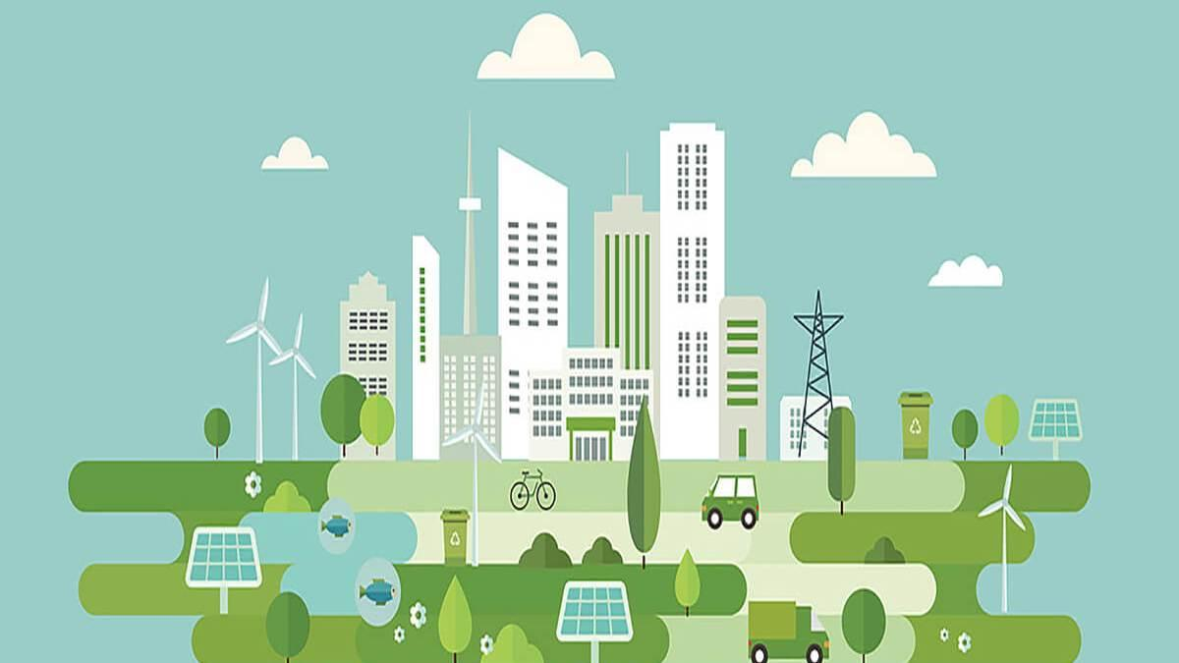
The "Low Carbon Roadmap for the Turkish Steel Industry" project was launched on 27.04.2022 by the funder of the European Bank for Reconstruction and Development and the contractor of the PwC-Escarus-Ekodenge consortium. In addition, within the scope of the "Technological Transformation/Development Specialization Working Group," "Green Growth Technology Roadmap" studies are carried out in the "Iron and Steel, Aluminum, Cement, Plastics, Chemicals, and Fertilizer sectors" under the direction of "T.R. Ministry of Industry and Technology" and "TÜBİTAK."

A Green and Circular Economy
Priority sectors have been identified to transition to a "Green and Circular Economy." Within the scope of determining the needs, studies have been initiated to prepare a "National Circular Economy Action Plan" within the framework of the "IPA II Period project" called "Technical Assistance for the Evaluation of the Potential for the Transition to Circular Economy in Turkey (DEEP)."
The "Working Group on Technical Legislation Harmonization on Sustainable Products" was established within the Ministry of Commerce.
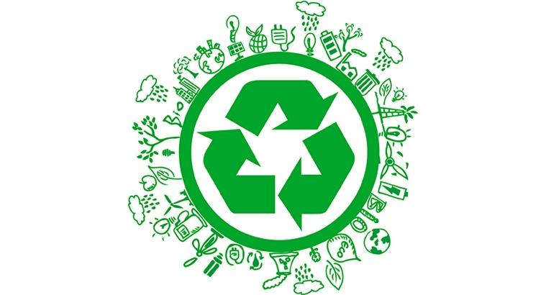
A sub-working group has been established to study Eco-Design. The "Draft Eco-Design Charter for Sustainable Products" has been prepared by this group. The "Guideline on Advertisements Containing Environmental Statements" has been published.
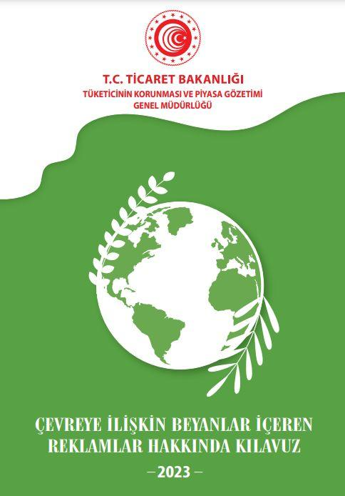
The "Research of Endocrine Disrupting Chemicals and Treatment Technologies Project" was initiated on the subject of "endocrine disrupting chemicals that pose a risk to the aquatic environment." The "Circular on Cleaner Production Practices in the Textile Sector" was published on December 31, 2022 and put into practice.
For the reuse of wastewater, the "Climate Change Adaptation in Water Resources Project" and the "Investigation of the Use of Marginal Waters in Agricultural Irrigation and Determination of Their Contribution to the Circular Economy (MARSUDE) project" were carried out.
Green Finance
The financial sector is effective in climate change and transitioning to a low-carbon economy. This role includes financing green projects and promoting the transition to a low-carbon economy. Different studies are carried out and targeted to finance green transformation in our country. On November 12, 2021, the "Sustainable Finance Framework Document" was published by the Ministry of Treasury and Finance. In this report, the criteria for the use and management of income and the support of sustainable finance are essential within the scope of the Green Deal.
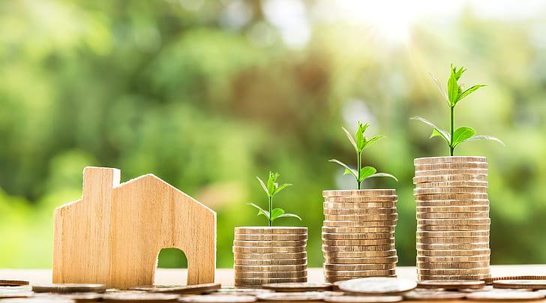
The "2022-2025 Sustainable Banking Strategic Plan" has been published by the Banking Regulation and Supervision Agency (BRSA) to ensure the dissemination of financial practices related to activities to solve environmental problems.
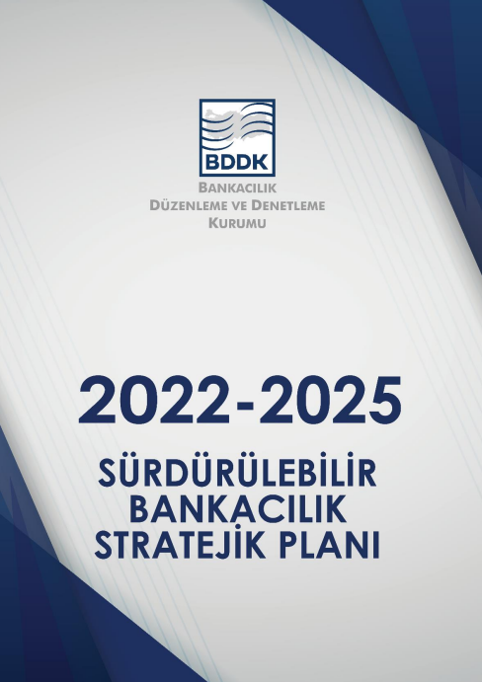
In May 2022, the "Green Sukuk Study Report" was published by the "Finance Office of the Presidency of the Republic of Turkey" to evaluate the role of the green lease certificate in the implementation of the actions within the framework of the "Green Deal Action Plan" in Turkey.
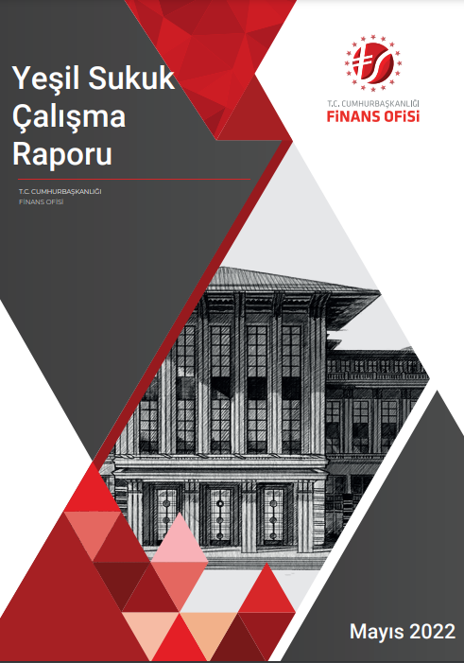
The "Green Finance Working Group" was established by the Climate Council in 2022. The Green Finance Working Group aims to address the problems and diversify resources in this direction by examining the sources, tools, and development of green finance used in Turkey to establish a national taxonomy and to evaluate the use of revenues from carbon pricing mechanisms.
The Banks Association of Turkey published the "Sustainability Guide for the Banking Sector" in 2021 to support sustainable development.
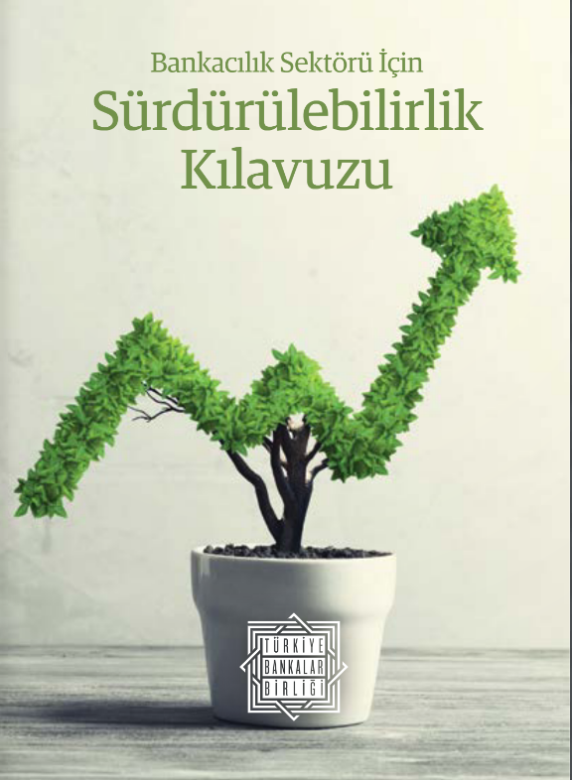
The Capital Markets Board ensures that investments contributing to sustainability are encouraged with the "Green Debt Instrument, Sustainable Debt Instrument, Green Lease Certificate, Sustainable Lease Certificate Guide".,
Clean, Economic, and Safe Energy Supply
In the fight against climate change, it is aimed to diversify clean energy and energy sources on a global scale while encouraging energy efficiency and clean energy use. In addition, it is aimed to carry out the necessary studies to achieve these objectives.
The "Ministry of Energy and Natural Resources of the Republic of Turkey" published the "National Energy Efficiency Action Plan" in March 2018. It carries the vision of a safe future with the efficient use of energy and natural resources.
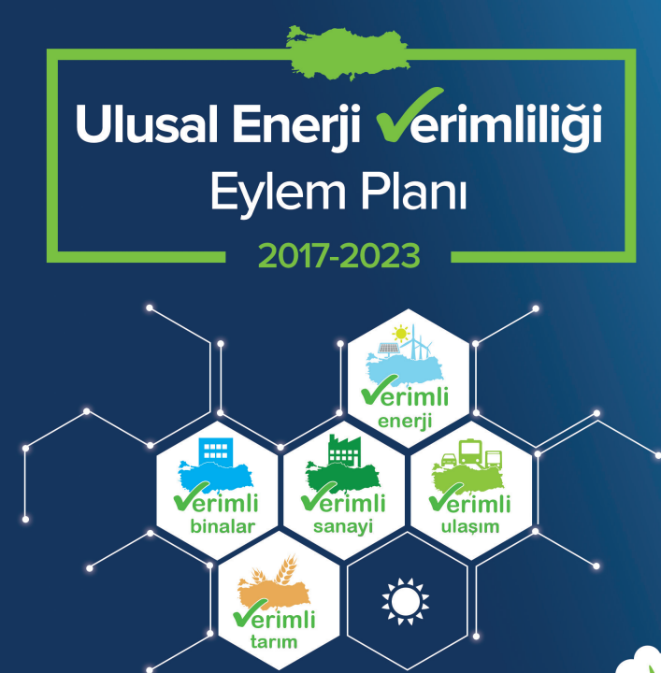
"Turkey's National Energy Plan" was published by the "Ministry of Energy and Natural Resources of the Republic of Turkey" in 2022. Within the scope of the study, information about our country's primary and final energy consumption and electricity production between 2020 and 2035 was given, and the projections planned for the 2035-2053 period were shared.
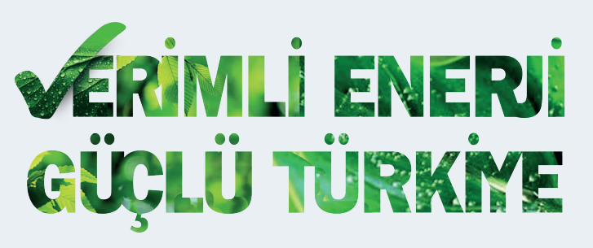
On March 19, 2019, the "IPA Technical Assistance for Institutional Capacity Building in Energy Efficiency Project" started to be implemented by the "Ministry of Energy and Natural Resources". Targets have been set for 2023, 2030, and 2050 to increase the efficiency of the energy sector in Turkey.
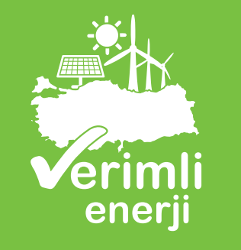
"Technical Assistance for Renewable Energy and Energy Efficiency for Municipalities and Universities (YEVDES)" was organized.
The "Turkey Hydrogen Technologies Strategy and Roadmap" was published by the "Ministry of Energy and Natural Resources" in 2023 and determined the needs, solutions, and roadmaps in hydrogen technologies.
With the "Green Tariff (RPPA)" application launched by the "Energy Market Regulatory Authority (EMRA)" on August 1, 2020, consumers who demand energy will be able to supply electricity based on renewable sources.
Sustainable Agriculture
While the "Organic Agriculture Legislation Harmonization Studies" for "sustainable agriculture" continue, the transition to organic agriculture and its dissemination has gained momentum.
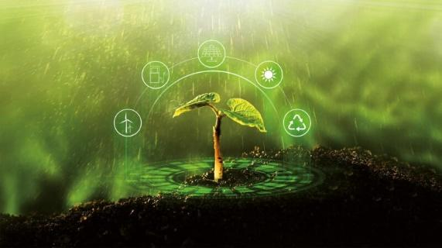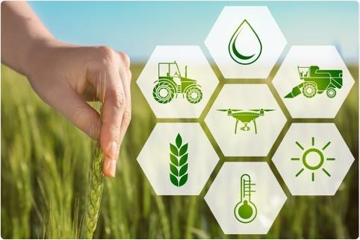
To disseminate organic agriculture, studies will be carried out in 58 provinces and 5 Research Institutes in 2022 within the scope of the "Dissemination and Control of Organic Agriculture Project."
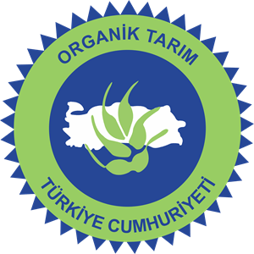
The "Ministry of Agriculture and Forestry" has implemented the "TAIEX Workshop on Harmonization Project of Turkey's Organic Farming Legislation)" to "ensure compliance with the current E.U. legislation."
To achieve the goal of "raising awareness on E.U. Farm to Fork and Biodiversity Strategies" in the "Green Deal Action Plan," the Provincial Directorates of National Education and the Regional Directorates of the Ministry of Agriculture and Forestry organized many trainings throughout the country.
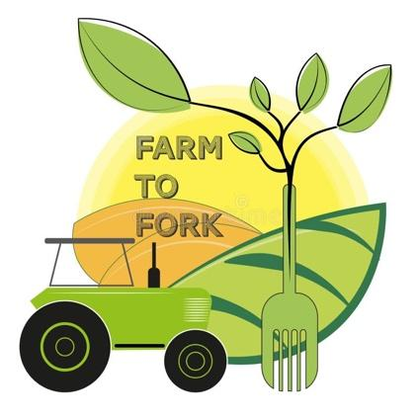
As a member of Teknopark Istanbul, MOVE ON carries out studies for Turkey's transition to the Agriculture 5.0 era. In this context, the company develops domestic autonomy systems that manage all processes in the field of agriculture and expands the use of artificial intelligence in agriculture.
In this regard, the Ministry of Agriculture and Forestry is trying to reduce the use of anti-microbials and pesticides under the "Sustainable Agriculture" title. In this context, fresh vegetable and fruit production areas were subjected to 24,000 controls, and residue monitoring programs were established for products deemed risky. The "Residue Action Plan (2022-2024)" has been implemented for products that may be risky with pesticide residues. For this purpose, the "National Veterinary Antibiotic Resistance Monitoring Project" has been implemented.,
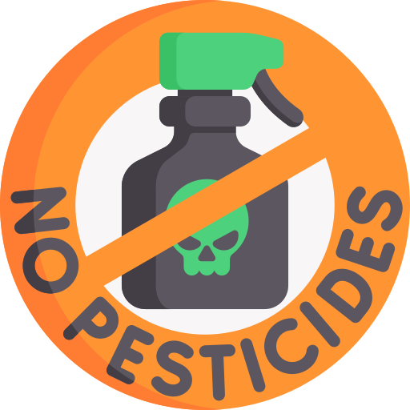
Within the framework of the "goal of improving waste and residue management in agricultural production," the focus is on the action of "investigating the possibilities of using wastes by applying them to the soil (olive, black water, biogas plant liquid fermented waste, etc.)." In this context, it is aimed to "directly use various plant and animal wastes and residues, compost them (chicken manures, peanut wastes, etc.) and evaluate them agriculturally by obtaining biochar." For this purpose, 12 projects are being carried out in Tekirdağ, Ankara, Konya, Giresun, Samsun, Antalya, Tokat, and Osmaniye. In addition, 4 different projects are being implemented in the cities of Ankara, Kırklareli, and Izmir with the aim of "recycling and evaluating wastes that cause environmental problems such as olive, black water, and biogas plant liquid fermented product resulting from agricultural production."
Within the scope of "strengthening the Land Degradation Stabilization (ATD) approach at the national level," the "Upper Sakarya Basin Project" and "climate-friendly agriculture practice demonstrations" continue.

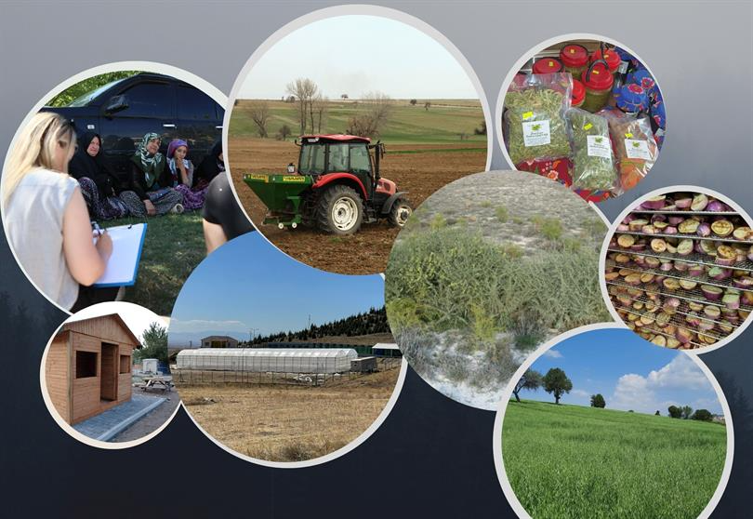
"Upper Sakarya Basin Project"
"Potential Soil Organic Carbon Storage Map" was produced for the whole of Turkey and combined with the "Decision Support System."
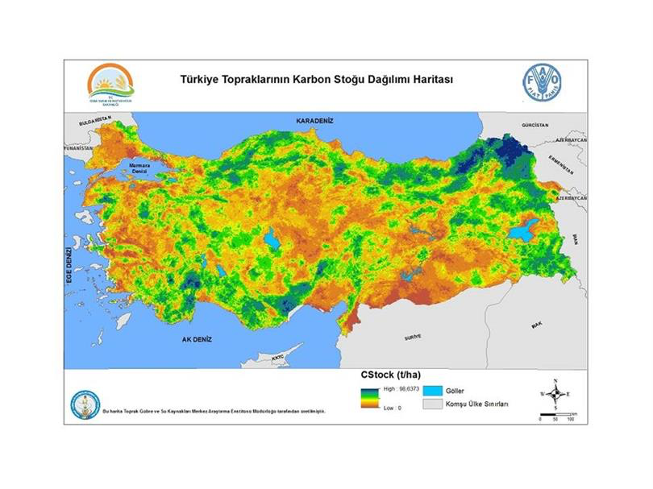
Turkey Soil Organic Carbon Map
Sustainable Smart Transportation
With the "Combined Transport Regulation" created in line with the goal of "developing sustainable and smart transportation in Turkey," important steps have been taken to support the transfer of cargoes transported by road to the sea. In this way, it is aimed to reduce the negative effects of factors such as accidents, traffic jams, environmental pollution, and noise among the problems brought about by "road transport."

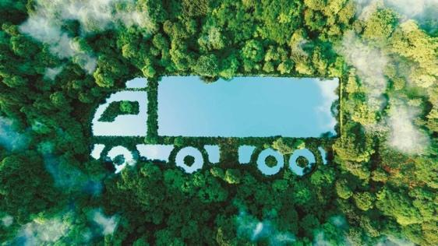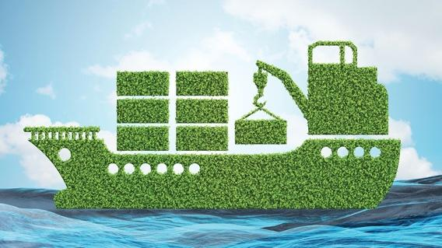

Within the scope of "studies to increase the use of railways in transportation," the "Çerkezköy-Kapıkule railway line project," under construction, is being carried out.
To accelerate the "studies on the development of green port practices," the "national legislation for the green port certification program" has been published. However, preparatory work for the Draft "Regulation on the Issuance of Green Port Certificates for Coastal Facilities" is progressing.
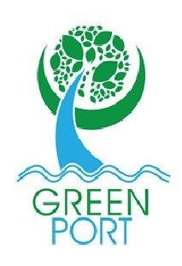
On the other hand, "World Maritime Organization (IMO) Committee for the Protection of the Marine Environment (MEPC) 79. Meeting" (12-16 December 2022). At this meeting, as of May 2025, the Mediterranean was announced as "SECA (Sulfur Emission Control Area)". Thus, it is planned to reduce the sulfur content in ship fuels from 0.5% to 0.1%.
With the aim of "Efforts to reduce harmful emissions from the maritime sector and to support green maritime," the "Regulation on the Encouragement of the Construction of New Ships to Replace Scrapped Turkish Flagged Ships" was published.
"Determination of the Site Selection of Electric Vehicle Charging Stations and Creation of Simulation Program" was initiated for "preliminary study and planning activities for the positioning of charging stations on urban and intercity roads."
To promote "sustainable urban transportation," the "Sustainable and Smart Mobility Strategy and Action Plan" activities were initiated by the "Ministry of Transport and Infrastructure." In this context, bicycle paths were prioritized. Legislative studies have been carried out to increase the use of micro-mobility vehicles (especially shared electric scooter systems and bicycles).
The "Mobility Vehicles and Technologies Roadmap," which aims to ensure the transition between different transportation modes in our country to "reduce emissions from the transportation sector," was announced through the "Presidential Circular No. 2022/9" through the "Ministry of Industry and Technology."
Within the framework of the "Technological Product Investment Support Program," under the leadership of the "Ministry of Industry and Technology," investments have been started for the establishment of a total of 1,572 charging units in 81 provinces, 216 districts, and 75 provincial highways across the country for the development of electric vehicles.
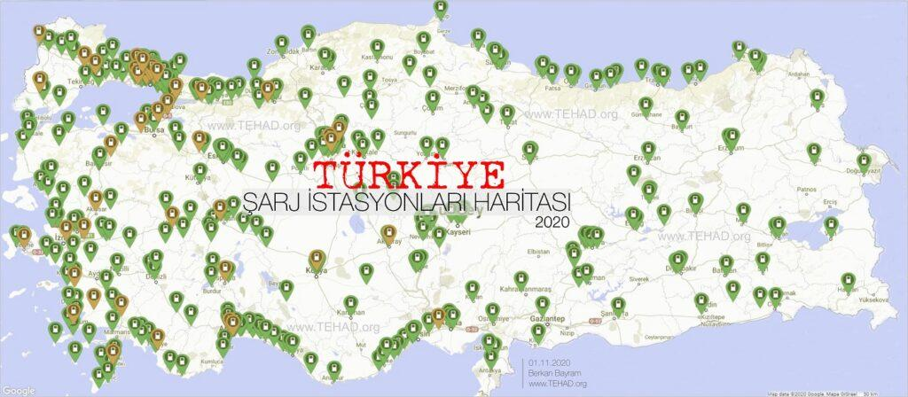
Turkey Charging Station Map – Regions 2020

Combating Climate Change
Turkey carries out essential studies within the "combating climate change" scope. In this context, in line with the targets of the "United Nations Framework Convention on Climate Change, the Paris Agreement and 2053 Net Zero Emissions", it has created the draft of the Climate Law. It continues to work to put this draft into effect.
In Turkey, the first Climate Council was held on 21-25 February 2022 within the scope of the Green Deal Action Plan, and the policies to combat climate change were reviewed. At the meeting, 217 new decisions were taken in line with the 2053 net zero emission targets.
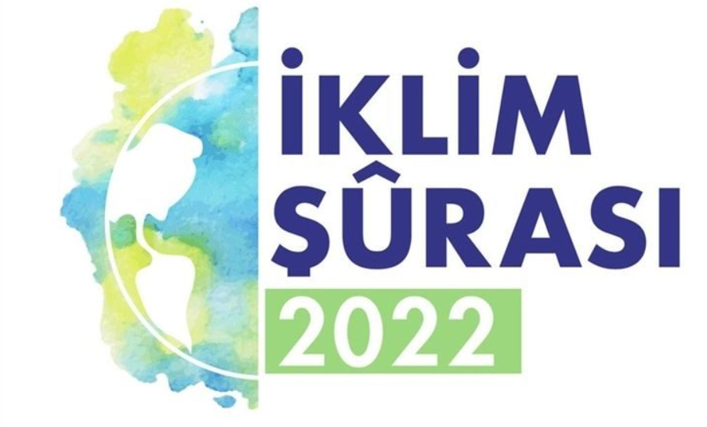
In addition, Turkey's "2023-2030 Climate Change Action Plan and 2050 Climate Change Strategy" are planned to be completed in the second quarter of 2023. In 2022, the nationally determined contribution that forms the basis of this plan was completed, and the "Ministry of Environment, Urbanization, and Climate Change" committed Turkey to a 41% reduction by 2030 at COP 27.
On the other hand, the "Strengthening Climate Adaptation Action in Turkey Project" with the city supports the efforts to adapt to climate change in the sectors and aims to increase social resilience. In addition, R&D projects and studies are carried out to evaluate the effects of climate change on land and marine ecosystems.
In Turkey's fight against climate change, regional projects are supported within the framework of the action of "Strengthening the Land Degradation Stabilization (ATD) approach at the national level," and efforts are made to disseminate this approach throughout the country. In addition, the "General Directorate of Forestry Strategic Plan," which includes afforestation, forest management, and fire prevention/protection activities , has been prepared.
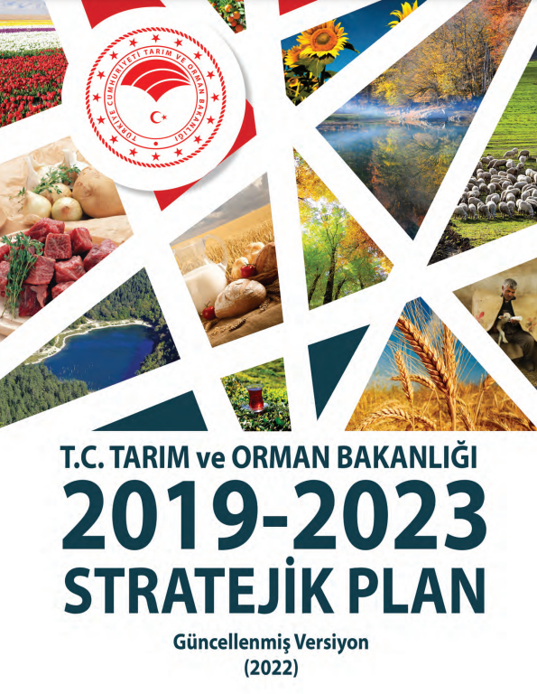
Finally, training, R&D projects, and dissemination studies are carried out to disseminate sustainable agricultural techniques, and projects that encourage the use of nature-based solutions in the fight against desertification and land degradation are implemented.
In addition to all these, it is possible to access comprehensive studies on the fight against climate change in Turkey at "www.iklim.gov.tr."
Just Transition Policies
Regulations made within the framework of combating and adapting to climate change are reflected in many commercial, social, legal, and economic areas. This multidimensional interaction requires the transformation of the green economy under the most favorable conditions for all segments of society. In this context, it is clear that Turkey's industrial and employment policy will change substantially on the way to achieving its net zero emission target for 2053. In implementing this strategic approach, the participation and cooperation of all relevant stakeholders, including the public, private sector, local government, and non-governmental organizations, is essential.
In our country, transition policies and strategies are being developed under the direction of the Ministry of Labor and Social Security. In this context, studies are carried out on platforms like the "Specialized Working Group on Just Transition Policies."

The "Migration, Just Transition, and Other Social Policies Commission" established within the framework of the "Climate Council studies" and the "12. Development Plan working groups" have carried out studies that deal with just transition policies from different perspectives.

In addition, the 2022-2025 period of the Medium-Term Plan emphasized that the necessary steps will be taken to ensure that the green transformation of the labor market is carried out fairly and that efforts for green change will continue in every sector of the economy.
In June and December 2022, the "Just Transition Policies POI" meetings organized by the "Ministry of Labor and Social Security" were held, a "communication strategy with internal and external stakeholders" was created, and training programs were developed, taking into account the need to raise awareness on just transition.

The Ministry has established a unit for monitoring "transformation to a green economy" and transition activities. At the same time, efforts to create a strategy for the Just Transition process, to eliminate the lack of data and information, to develop a management model, and to provide resources continue.

In addition, the "Just Transition TAIEX" project is being prepared to learn about the country's experiences on the Just Transition process and increase the awareness of relevant stakeholders.
Green Transformation in Education and Training
To "determine the necessary education policies in line to increase climate and sustainability awareness in the society," the "Green Transformation in Education Specialization Working Group" carries out activities within the "Ministry of National Education."
The workshop on preparing the "MEB Climate Change Action Plan" was held on 15-18 March 2022, and the "Ministry of National Education Climate Change Action Plan" was prepared.
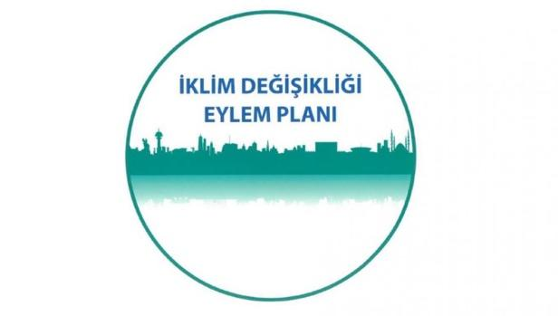

The CITYAIR Project, managed under the leadership of the "Ministry of Environment, Urbanization, and Climate Change" and supported by the "Ministry of National Education," is carried out by 40 formative trainers working in 30 cities. In this context, training was organized to "raise awareness against air pollution, prevent air pollution, and make necessary improvements."
Under the leadership of the "Turkish Foundation for Combating Erosion, Reforestation and Protection of Natural Habitats (TEMA)," Nature Education Programs and Projects have started to be implemented.
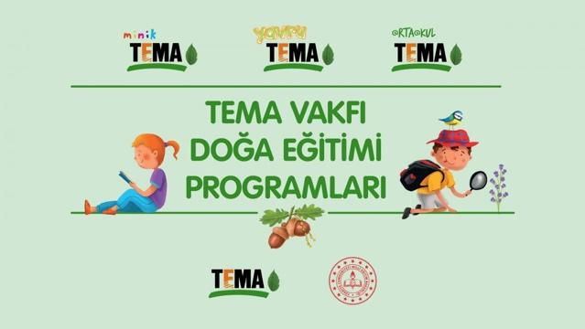
Tiny Theme, Puppy Theme, Middle School Theme Project
Within the framework of the "Nature Pioneers Project" carried out by the "World Wildlife Fund," "Nature Pioneers Training of Trainers Course" and "Nature Pioneers Training Seminar" were given to teachers from 11 different branches in 10 pilot cities on the topics of "plastic pollution, water, wildlife, climate change, sustainable food production and introduction of the project training portal."
"New Generation/Energy Efficiency" training seminars were offered to teachers in the fields of "electrical-electronic technology, construction technology, and renewable energy technology" in the pilot schools determined in the "NEXT-GEN Project" with the protocol signed with Özyeğin University within the scope of "Vocational Education."
"2204- A High School Students Research Projects Competition", "2204- B Middle School Students Research Projects Competition", "2204-D High School Students Climate Change Research Projects Competition", "2204-C High School Students Polar Research Projects Competition," and "2242 University Students Research Project" competitions advanced within the framework of "TÜBİTAK Scientist Support Programs Directorate (BİDEB) scholarship and support programs," Environment and Environmental Protection, Natural Disasters and Disaster Management, Ecological Balance, Food and Food Supply Security, Intelligent Transportation Systems, Biodiversity, Water Literacy, Global Warming and Climate Change, Forest and Forest Protection, Renewable Energy, Hydrogen Energy, Geothermal Energy, Responsible Production and Consumption, Agriculture and Livestock Technologies, Natural Heritage and Natural Resources, Sustainable Cities and Societies."
Finally, within the framework of the "COFUND project" called "ENRICH TOGETHER" carried out under the coordination of METU, "22 postdoctoral researchers" who are planned to come from abroad are supported to develop individual projects on "Green and Blue Transformation."
Diplomacy
Turkey's Green Deal Diplomacy refers to Turkey's diplomatic efforts by promoting its policies and goals related to sustainability, environmental protection, and climate change at the national and international level, cooperating with other countries on these issues, contributing to international agreements, and promoting the transition to a green economy. Green Deal Diplomacy aims to play an effective role in Turkey's environment and climate issues internationally and promote environmentally friendly policies and practices abroad.
This diplomacy includes Turkey's cooperation with other countries on combating climate change, conservation of natural resources, energy transition, sustainable development, etc. Green Deal Diplomacy aims to ensure that Turkey becomes a party to international agreements on climate change, commits to achieving carbon reduction targets, and offers innovative solutions in the field of sustainability.
Within the framework of this diplomacy, Turkey participates in international climate conferences, energy summits, and other environmental and sustainability-oriented events. In addition, it cooperates with other countries in areas such as technology transfer, financing, and developing joint projects. This aims to accelerate Turkey's transition to a green economy and to provide leadership in the international arena regarding sustainability.
Turkey Green Deal Diplomacy aims to further cooperate with the international community in environment, climate, and sustainable development and contribute to Turkey's global sustainability goals. The EU's Green Deal is becoming an important issue affecting the Customs Union between Turkey and the EU and supporting the green transformation. In this process, studies are carried out on topics such as access to finance and technical compliance to protect Turkey's rights and interests. In December 2019, the EU Commission presented the 'European Green Deal' proposal, which aims to create a carbon-free economy by 2050 and reduce carbon emissions by half by 2030. The "Carbon Border Adjustment Mechanism," which will be implemented in 2023, should be handled with caution as it may impose an additional burden on Turkey's exporters. Close cooperation and communication with the EU is essential to ensure the proper functioning of the Customs Union and support the green transition.
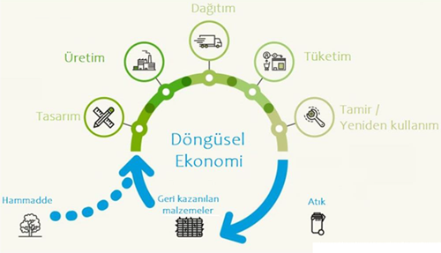
"Industries such as food, electronics, automotive, textile, packaging/plastics, and construction are handled within the circular economy framework."
The establishment of closer cooperation with the EU in the field of the Green Deal should be carried out, especially considering the regulations directly related to the EU's Customs Union. In addition, it is important to share the country's position with the EU on issues such as state aid for the iron and steel industry. In this context, Turkey needs to increase its cooperation with the EU and support environmentally friendly and digital transformation. This could accelerate the transition to a green and sustainable economy and strengthen Turkey's integration into international value chains.
European Green Deal Information and Awareness Raising Activities
To increase "information and awareness activities" regarding the "European Green Deal," Working Groups have been organized for the parties responsible for realizing the targets in the Action Plan, especially the private sector. These groups aim to raise awareness of participants and ensure a more active participation in the green economy through activities such as meetings, workshops, and seminars.
The Presidential Circular, in which the Green Deal Action Plan is published, states that specialized working groups can be established, which are intended to assist the Green Deal Working Group. In this context, 20 Specialized Working Groups have been established with different participants, such as the private sector, stock exchanges, the public, chambers, non-governmental organizations, academics, and exporters' associations. These groups carry out "information and awareness activities about the Green Deal Action Plan and the developments in the EU." In addition, information was conveyed to a broader audience by participating in events organized by universities, sector organizations, chambers of commerce and industry, and non-governmental organizations.

It refers to the support of the private sector to the EU Green Deal
Activities carried out in the public sphere: The "Ministry of Commerce" held meetings to inform the text of the Green Deal. The conferences held regularly by the "Ministry of Commerce" regarding the "European Green Deal" are as follows:
- The first meeting, held in 2020 under the coordination of "Deputy Ministers and Ministry representatives and the Ministry of Commerce", was held to discuss the effects of the European Green Deal on Turkey and determine the steps to be taken.
- In 2020, a second meeting was held to evaluate the work carried out within the scope of the Working Group and the steps forward.
- In 2020, a third meeting was held to evaluate the work and review the progress within the framework of the Green Deal Action Plan preparations.
- A situation assessment meeting was held in 2021.
- A meeting was held in 2021 to evaluate the developments in the Green Deal Action Plan.
- In 2021, the second "Green Deal Working Group" meeting was held to review the progress in the "Green Deal Action Plan".
- In 2021, a third meeting was held to evaluate the developments in the Green Deal Action Plan.
- In 2022, the fourth meeting was held to evaluate the developments in the Green Deal Action Plan.
Informative meetings were also held by the "Technical Committees of the Ministry of Industry and Technology." Many seminars and events have been held in connection with universities. "Ministry of Foreign Affairs Directorate for EU Affairs," "Ministry of Environment, Urbanization and Climate Change," "Climate Change Presidency," "Ministry of Labor and Social Security," "Ministry of Industry and Technology," "Ministry of Agriculture and Forestry," "Central Bank of the Republic of Turkey" all of these public institutions have been involved in all their activities through universities and social society organizations to inform them about the "Green Deal and EU Cooperation" and to ensure that the studies carried out are understood correctly.
In the Private Sector, Public and private sector cooperation is important for the effective implementation of the Green Deal Action Plan objectives. For this reason, an Advisory Board has been established within the "Green Deal Working Group," which includes members of the relevant private sector umbrella organizations. This board consists of the Turkish Exporters Assembly (TIM), the Union of Chambers and Commodity Exchanges of Turkey (TOBB), the Foreign Economic Relations Board (DEIK), the Turkish Industrialists and Businessmen's Association (TÜSİAD), the Independent Industrialists and Businessmen's Association (MUSIAD), the Turkish Confederation of Employers' Associations (TİSK), the Turkish Contractors Association (TMB) and the International Investors Association (YASED)". These institutions carry out studies that contribute to the goals of the Green Deal Action Plan.
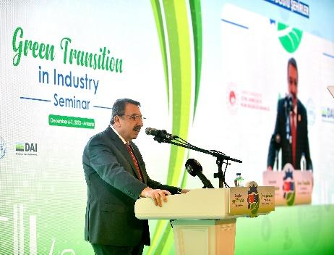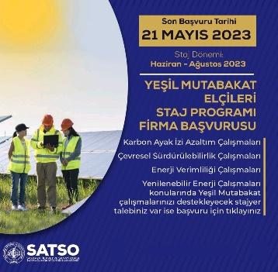
Images from some of the events organized by TOBB

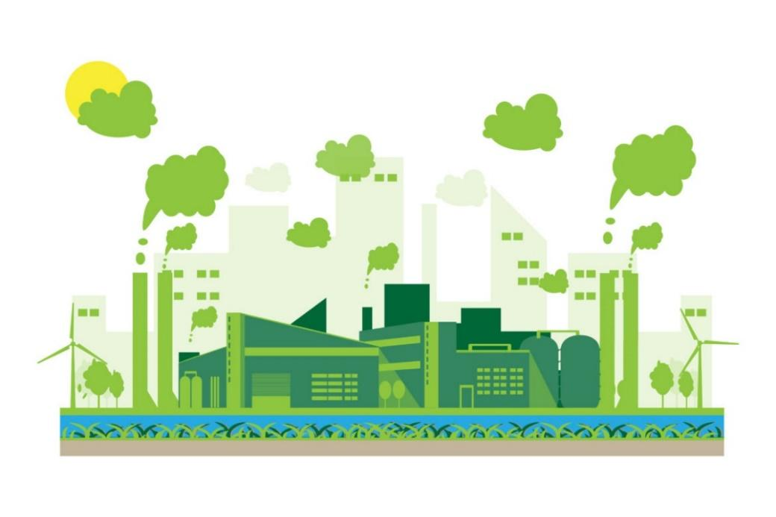
"With the Green Deal Industrial Plan, Europe is preparing to pioneer green transformation in the industry."
With the "Green Deal Industrial Plan," Turkish Industrialists aim to create the necessary green technology production capability to achieve Europe's challenging green goals and to create an environment that encourages it. "Istanbul Chamber of Industry" has changed its entire vision with the "sustainable environment" theme. Chambers of Commerce also organized informative "carbon border adjustment" events in the production sector.
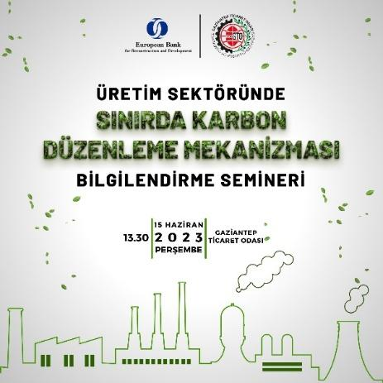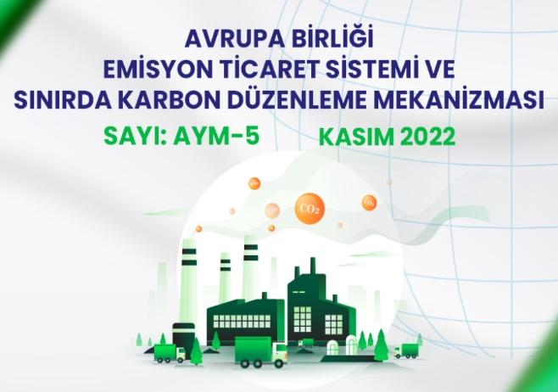
Posters of some events carried out by the Chambers of Commerce

The changes that the European Green Deal will make on the sectors

Europian Green Deal benefits
Parliament adopted the EU Climate Law on 24 June 2021, which makes legally binding a target of reducing emissions 55% by 2030 and climate neutrality by 2050. This moves the EU closer to its post-2050 objective of negative emissions and confirms its leadership in the global fight against climate change. It should allow the targets to be more easily applied to legislation and should create benefits such as cleaner air, water and soil; reduced energy bill; renovated homes; better public transport and more charging stations for e-cars; less waste; healthier food and better health for current and future generations.
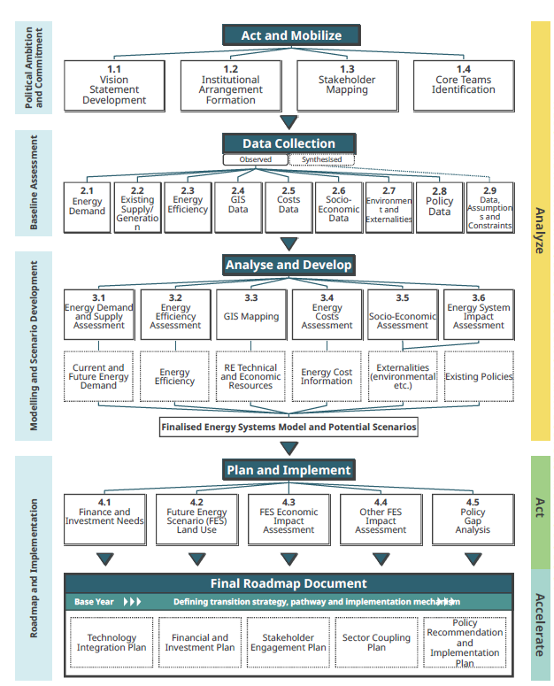
Business will also benefit as opportunities are created in areas where Europe aims to set global standards. It is also expected to generate jobs, for example in renewable energy, energy efficient buildings and processes.
Achieving a global energy transition that is compatible with the world's climate goals is undoubtedly a difficult task. Current pledges from governments around the world to reduce emissions to net-zero levels cover about 70% of today's global economic activity and global CO2 emissions. The case of the announced pledges shows that, if those pledges are met in full, the gap between where we are going and where we need to arrive to achieve net zero emissions by 2050 worldwide would narrow. But it also shows that the gap would remain wide. Meeting all existing net-zero consumption or emissions pledges in full would leave 22 Gt of CO2 emissions from energy and industrial processes globally by 2050 unsolved, consistent with a temperature rise of around 2.1° C (with a probability of 50%).
The Energy transition roadmaps according to European Green deal and Green Agenda for the Western Balkans provides an overview of the key assumptions and market dynamics on which the projections are based. It discusses trends in energy use and investments, including the key roles played by energy efficiency measures, behavioural changes, electrification, renewable energy sources, but also technologies that are not yet mature enough for the market (such as hydrogen, etc.). Further, some of the key uncertainties surrounding the global path to net-zero emissions related to behavioural change, the availability of sustainable bioenergy, and the introduction of energy storage are discussed.
In order to achieve the goals and reach the desired state of the green cities, countries and Europe, it is necessary to change the behaviour model of citizens and other actors and interested forces, as well as decision makers. It is necessary to create conditions for changes in energy supply, maintenance and management of the network and changes on the side of energy consumption in all sectors, by creating a fertile environment for energy transition on the part of the state, local self-government, and decision makers from the industry sector. Based on the review of the scenario, it is clear that the city will have to continue to be supplied with at least part of the electricity from the grid, but it will presumably have the option of choosing electricity produced without carbon dioxide emissions, and in order for the energy transition to be carried out in the right direction, it is necessary is:
- Development and improvement of the city's energy supply system - strategically develop a diversified portfolio of partnerships for the supply of electricity from renewable sources, in order to ensure security of supply and avoid over-reliance on suppliers. Use the possibility of producing electricity from biomass.
- Creating an environment for the maximum use of solar systems with energy storage - it is important that the city recognizes the importance, possibilities, and advantages of solar energy and that there is a systematic approach to searching for new innovative solutions for the use of solar systems. For the best possible use of solar energy, it is necessary to create a Cadastre of solar roofs and locations on the territory of the city of Niš. It is also necessary to create an environment for more mass use of energy accumulators, whereby Li-Ion battery technology is reaching technological maturity, and a decline in investments in such systems can be expected.
- Positioning the city in the market of low-carbon alternative supply options. The city of Niš is very dependent on energy and is supplied with energy that is not produced on the territory of the city, so it is necessary to constantly look for possible alternative solutions for the supply of decarbonized energy.
- Participation in the emissions market. According to the Green Agenda, calculation and payment for carbon dioxide emissions will start at the national level soon. On the path of energy transition, it is necessary to look at this aspect to always make decisions for the implementation of the most profitable solutions.
- Creating a network that is ready for massive local distributed energy production. Based on the current national legislation, the possibility of local decentralized energy production and the transfer of excess energy to the grid is already foreseen, and it can be expected that this trend will continue.
- Active management of the growth of energy needs. The city's energy transition, considering the growth of energy needs in line with population growth and the desired economic development, should ensure the decarbonization of the energy sector, even in the conditions of the city's growth, which requires active planning and budgeting of energy consumption. It is necessary to apply energy efficiency measures, especially in energy-intensive industrial plants, but also with all consumers in general, to establish appropriate synergies. It is necessary to make a Cadastre of geothermal potential in the territory of the city of Nis and harmonize this data with the urban conditions and development plans of the city.
- Optimization of energy consumption of all consumers in the city. It is necessary to prepare the network for a quick response in case of peak loads arising because of the mass use of smart digital technologies for managing energy systems on the part of consumers. Finally, it is necessary to form a unified cadastre of the city's Renewable Energy Sources potential with data on locations suitable for buildings with net zero energy consumption using active and passive energy systems.
- Development and use of green hydrogen for electricity generation. In the long term, low-carbon hydrogen will also be the key to decarbonization globally, according to current forecasts. The city's energy sector can potentially play a major role in future national supply. Another possibility is to create conditions for research and development at the local level in order to develop hydrogen solutions that suit the needs of the city.

Energy transition roadmap, case study city of Nis

Achieving a global energy transition that is compatible with the world's climate goals is undoubtedly a difficult task. Current pledges from governments around the world to reduce emissions to net-zero levels cover about 70% of today's global economic activity and global CO2 emissions. The case of the announced pledges shows that, if those pledges are met in full, the gap between where we are going and where we need to be to achieve net zero emissions by 2050 worldwide would narrow. Climate change represents a current challenge not only for the city of Nis, but also for the EU and the world, and is the main driver of the energy transition in the world. Propagation of the green agenda at the national level in the economic, investment and consumer sectors is still in its infancy. The city of Niš has shown the initiative to take concrete steps to fight climate change, and more importantly, through the TOMORROW project, it has shown its ambitions to reach the level of net zero emissions by 2050 in a planned and orderly manner.
The road map of the energy transition of the city until 2050 should predict possible steps and directions of the city's development and help decision makers to enable the achievement of energy and climate neutrality of the city by 2050, under different circumstances. As the city of Niš relates to the rest of the country and with the region, EU and the world, in terms of market and energy primarily, decision makers will have to monitor changes in the energy market and energy technologies revise planning activities and make new decisions in accordance with the current situation.
The assessment of the total potential for local energy production was made on the basis of previously presented data from the Development Plan of the City of Niš for the period from 2021 to 2027, the City's Energy Balance for 2020 and the Action Plan for Sustainable Energy Development in accordance with the Muniment of the Mayor. According to the energy balance of the city from 2020, the most significant final energy consumption is related to electricity with 743,868.0 MWh per year or 43.3% of the total consumption, followed by biomass with 22.1% (380,201.3 MWh), and approximately the same amount of energy consumed using diesel fuel i.e., 236,320.7 MWh (13.8%) and for the purposes of supplying heat/cooling energy (heating/cooling) 229,176.8 MWh (13.3%). To define the desired future state in accordance with energy consumption, future projected trends and available resources, i.e., renewable energy sources, a scenario analysis was performed:
- Green scenario, green energy technologies and digital technologies in energy are going through rapid technological development, are widely present on the market and are massively applied in the city.
- Stagnation scenario, a global interest in climate change is declining, leading to stagnation in the technological development of energy solutions aimed at decarbonization, and thus to a lack of green technological solutions on the market and in the city.
- The scenario of moderate development of new green technologies and digital solutions in the energy sector, the development of green technologies is slow, but technological solutions still appear and are available on the market.
- Stochastic scenario where the application of green technologies is not planned, there is no energy planning, there is no change in behaviour, the level of energy efficiency in the city stagnates, and projects for the application of renewable energy sources and decarbonization are implemented sporadically.

All four scenarios imply certain assumptions related to the development of green and digital technologies, but also the development of the domestic and international green energy market in the period up to 2050. All scenarios imply different possible development directions for reaching net zero emissions at the city level by 2050. The aim of the analysis of the mentioned scenarios is to show the projection of the future state with the maximum utilization of the potential. In addition to the mentioned scenarios, a stochastic scenario is presented, according to the back-casting method. By analysing the potential for electricity production, at the current level of technological development with the above assumptions, we arrive at a possible annual production of 43,750 MWh using solar photovoltaic systems, 2,172 MWh from organic biomass of animal origin and 211.43 MWh of electricity by obtaining energy from municipal waste, which is a total of 49735.43 MWh, and corresponds to 6.7% of current electricity consumption.
When it comes to thermal energy, the estimated thermal power of wood biomass and waste wood and straw of 430,500 MWh represents 90% of the energy of the sources that are assumed to be used to obtain heat, where the estimated thermal power of straw (320,000.00 MWh ) is the most important, and it seems that more attention should be paid to local electricity production and, with the increase in the number of locations with distributed energy production, attention should be paid to solutions for balancing the power grid and solving the problem of fluctuations caused by the stochasticity of energy production from renewable sources. According to the Green scenario, with the application of all the achievements of technological development, it is possible to achieve complete energy independence in terms of energy supply for heating and cooling, but it is necessary to supply decarbonized electricity produced outside the territory of the city.
Involvement of citizens in the process of creating the roadmap for the energy transition of the city of Niš until 2050 was prepared in accordance with the dynamics of the process in such a way that there is two-way communication between citizens at each planned step, with maximum synergy of already existing processes in the city and low additional costs for campaigns.
The activities foreseen for the duration of the project are carried out by the Faculty of Mechanical Engineering of the University of Niš, in accordance with the Communication Plan for the implementation of the Energy Transition Roadmap in the city of Niš adopted by the Transition Team within the "TOMORROW" project. The research entailed the setting of the following tasks and indicators, which would enable the achievement of the research goal - the involvement of citizens, educational institutions, city administration and business entities for the creation of the Energy Transition Roadmap in the city of Niš:
- In the territory of the city of Niš, less than 20% of respondents are at the stage of poverty, while almost 25% of households are energy poor in terms of energy problems.
- Based on the results of the research, it can be concluded that the citizens are not aware that the City of Niš is one of the first cities that started the procedure of allocating funds for the financing of the Energy Rehabilitation Program of residential buildings, family houses and apartments (55.6%), while 42.1% are aware but did not apply and only 2.4% of the population applied for the mentioned funds.
- It is especially important to emphasize that citizens have confidence in institutions, especially institutions that deal with research and science. Most respondents believe (95.2%) that higher education institutions should be engaged in the energy transition of the city of Niš.
- Bearing in mind the rapid development of technologies, the emergence of innovative solutions in technology, especially in the field of renewable energy sources, it is necessary to revise the energy transition roadmaps for 5 years. During the research, the largest number of citizens, as much as 97% of the respondents indicated that it is necessary to revise the plans for the energy transition of the city of Niš every 2 to 5 years.
- The research identified that the largest number of companies in the territory of the city of Niš, more than 80%, do not have a certified Environmental Management System (SRPS ISO 14001) and Energy Management System (SRPS ISO 50001). Also, more than 90% of companies have not ever done an energy balance of the organization so far, which indicates the need for scientific and research institutions to be involved in providing professional assistance in order to improve the sector, the use of sources more rationally, reduce their costs and make their products competitive.
- It is extremely important that non-governmental organizations and citizens' associations are active and follow new knowledge in the field of energy. The research showed that most of the surveyed associations (60%) have the capacity to spread awareness in the field of rational energy management and environmental protection.

The future state of the city after the fulfilment of the stated goals
Reaching the goal of net zero energy consumption or net zero carbon dioxide emissions by 2050 is such that it must include a series of actions whose actors are all city sectors. Also, one of the accompanying goals can be the elimination of methane emissions, which in the city can be linked to the storage of waste, and partly to livestock in rural areas.
Global CO2 emissions related to energy and industrial processes fall to around 21 Gt CO2 in 2030 and to net zero in 2050 according to the global goals of net zero emissions. CO2 emissions in advanced economies as a whole fall to net zero by around 2045 and these countries together remove 0.2 Gt of CO2 from the atmosphere in 2050. Emissions in several individual emerging markets and developing economies also fall to net zero well before 2050, but overall, there are about 0.2 Gt of CO2 remaining emissions in this group of countries in 2050.
Reducing CO2 emissions requires the application of several technologies, but also a systemic approach and the development of a local policy that supports, creates the necessary preconditions, but also motivates and accelerates the energy transition. The key drivers of decarbonization in general are energy efficiency, behavioural model change, electrification, renewable energy sources, hydrogen and hydrogen-based fuels, bioenergy, and energy storage.
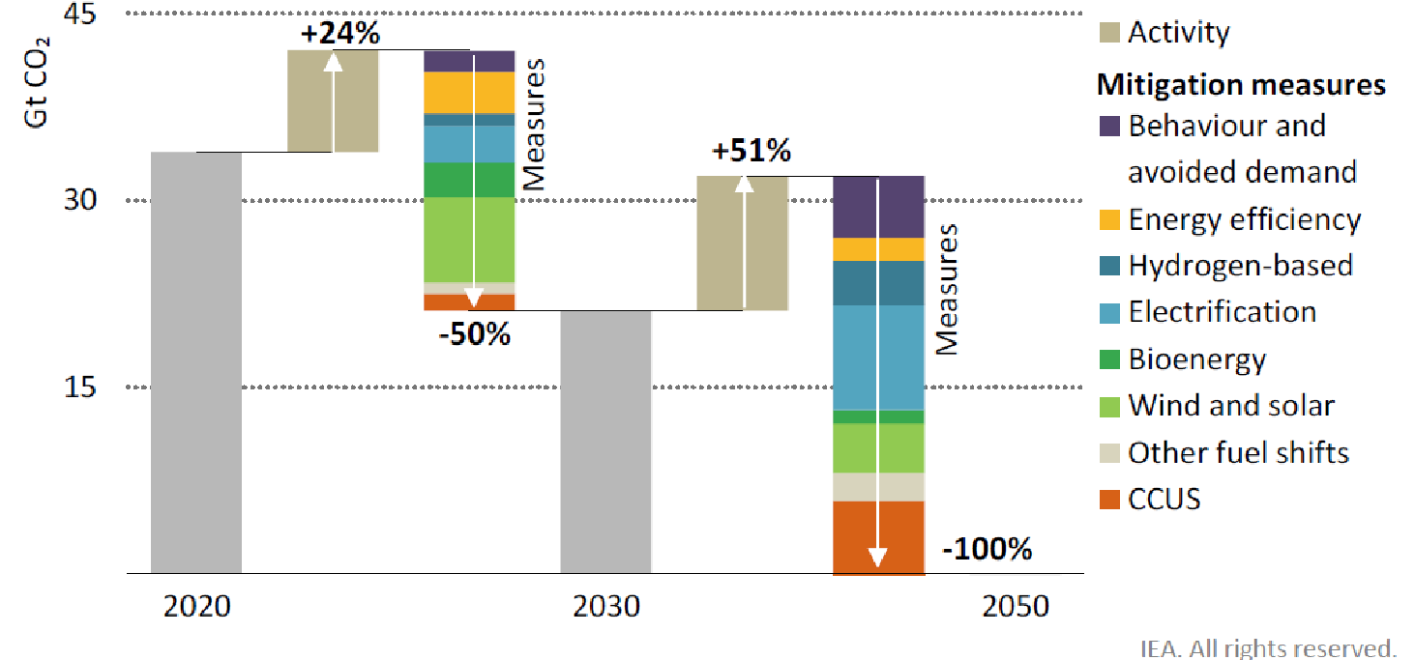
Fig. 22. Carriers of the energy transition at the global level
The state of the city at the end of the energy transition process included in this document will be considered through 3 scenarios, where the possible course of the global energy transition, the course of research and development of decarbonization technologies, international cooperation regarding the energy transition and the possible course of the energy transition and the state of the city in accordance with global events:
- Green Scenario - the global initiative of decarbonization and energy transition has united the whole world in the fight against climate change, which leads to the rapid development of key energy technologies, joint international action, etc. Energy and digital technologies are developing very quickly and are becoming widely available on the market under strong global international cooperation. In these conditions, the national context is such that it maximally stimulates the energy transition and the implementation of new technological solutions available on the market, and the energy transition takes place very successfully and quickly. Within this scenario, it can be assumed to improve the energy efficiency of technologies for the use of renewable energy sources, but also to solve the problem of stochastic energy production using renewable energy sources by developing technologies for long-term energy accumulation and digital solutions for balancing fluctuations in the network.
- Stagnation scenario - the global initiative of decarbonization and energy transition to combat climate change exists, but the market situation is such that there are too few positive results of research and development, and there is stagnation in terms of the technological development of green technologies and digitalization in energy. The market is waiting for the maturity of green energy technologies and green digital solutions, and the energy transition is carried out mainly by applying technological solutions that are close to today's level of technological development. There are still current problems of network fluctuations introduced by systems for local distributed energy production using renewable sources, as well as problems with network balancing and energy accumulation.
- Moderate development scenario - the world is geopolitically divided in efforts to realize the energy transition and decarbonization of global society. Research and development in the field of green technologies and digital green solutions is progressing. In such circumstances, the state, and therefore the city, are forced to implement more profitable energy transition measures themselves.
- Stochastic scenario – The energy transition does not take place according to plan in the city, nor at the national level. Sporadic solutions are applied, not systemic solutions, and there is no synergistic effect. There is no significant progress in the technological development of energy technologies.

Location and natural resources of the city of Niš
The city of Niš, as the third city in Serbia with more than 260,237 inhabitants, makes up 3.3% of the population of the Republic of Serbia and 69.15% of the inhabitants of the Nišava District. The city consists of five city municipalities: Palilula, Medijana, Crveni Krst, Niška Banja and Pantelej and is the administrative center of the Nišava district and the regional centre of southeaster Serbia. Niš is in the 1st degree of development of municipalities, which means that it is above the average level of development of municipalities.
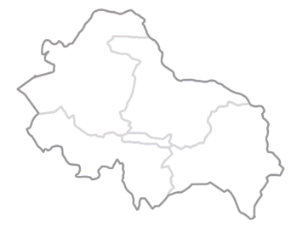
The area of ​​the city is 597 km2 (about 0.7% of the area of ​​Serbia and 21.8% of the area of ​​the Nišava district). Niš is a crossroads of Balkan and European roads. A highway and a railway connecting the north and south of Serbia pass through the territory of the city.

Fig. 23. Administrative border of the city of Niš (five city municipalities)

Protected areas
The following areas are protected on the territory of the City of Niš: Sićevačka Klisura-Nature Park (" Sl. Glasnik" RS No. 16/2000) with a flora of 1138 species and a protection regime of II and III degrees, Jelašnička Klisura-Special nature reserve ("Sl. Glasnik". RS No. 9/95) with a protection regime of II degree, Suva Planina was declared a Special Nature Reserve in 2015. It is located on the territory of Bela Palanka, Gadžin Han, and the city of Niš, it covers over 18,000 ha and is under the jurisdiction of JP "Srbija Šuma" Novi Beograd. of the city of Nišˮ Niš and is located on the territory of the city of Niš and Merošina and extends over 251 ha, Cerjanska Pećina - Nature monument with II level protection regime ("Official Gazette" RS No. 5/98), Kamenički Vis - Forest Park (Act SO Niš no. 01-267/90-II-4 from 1990) and ten protected trees-Monuments of Nature ("Official Gazette of the City of Niš" no. 11/2003, 28/2003, 97/2005).
The following areas are included in the international lists of importance for nature protection (Regulation on the National Ecological Network - "Official Gazette of the RS", No. 102/2010):
- PP Sićevačka Klisura, SRP Jelašnička Klisura and Suva Planina included in the List of Internationally Important Ornithological Areas (IBA), List of Internationally Important Plant Areas (IPA) and List of Selected Areas for Day Butterflies (PBA).
- PP Sićevačka klisura and Suva planina are included in the EMERALD network, as part of the European ecological network for the preservation of wild flora and fauna and their habitats.
- The watercourse and coastal zone of South Morava is included in the List of Ecological Corridors of International Importance.

Natural potentials and resources
The area of ​​Niš is characterized by a variety of natural potentials such as agricultural land, forests, waters and natural rarities and values. Water (underground, surface, karst, juvenile) is a first-class potential, but there is a lack of water accumulations of all kinds: lakes, artificial lakes, swimming pools.

Surface water flows
The hydrographic network is significantly developed. Two major streams stand out: South Morava and Nišava. The area is characterized by many streams, rivers and torrents (Gabrovačka river, Kutinska river, Jelašnička river, Ostrovička river, Suvodolska river, Malčanska river, Matejevacka river, Brenička river, Humska river, Velepoljska river, Vlaška river, Rujnička river, Toponička river) with permanent and intermittent river flows.
In its lower course, the river Nišava flows through the area of ​​the city of Niš in a length of 39,795 m. In this area, Nišava receives the Malčanska Trebinjska, Matejevacka and Rujnička rivers from the right, and the Ostrovička, Studena, Jelašnka, Kutinska and Gabrovačka rivers from the left. The hydrological characteristics of Nišava are defined by the flow of small and large waters, which measured at the water measuring station Bela Palanka have a flow of Qmin 3.39m3/sec, Qsr 24.33m3/sec and Qmax 495m3/sec. Nišava belongs to the II/III real watercourse quality class (Niš profile).
Groundwater
Based on the hydrogeological picture of the terrain, the following areas of ground water are distinguished: complexes of Miocene deposits and local areas with fissure type released within Palaeozoic schists, (the yield of springs and water capacity of these rock complexes is small except in Miocene gravels). These are rock complexes where surface runoff is most significant, followed by karst-fissure-type areas (the most favourable groundwater zones in terms of yield, the "Mediana" source area occupied for water supply to the population), and a wider zone of alluvial plains along South Morava and Nišava together with narrow coastal belts along their tributaries. Other areas, where potential underground water occurs, represent areas with narrow local significance. The total number of sources in Nis has not been determined yet. There are most of them in the valley of the Ostrovička river, which formed Vrelo Potok, Kovačevac and Blatni Potok, then 14 springs and fountains in the river valley, right tributaries of the Studene (Vodenički kamen, Petkovo kladenac, Smrdanac, etc.), as well as numerous springs in the source parts of the Grkinja and Gabrovačka rivers, the flow of which exceeds 10 l/s.
Thermal mineral waters
A study by the Faculty of Mining and Geology from Belgrade points to the fact that at a depth of about 1200m below Niš there is a geothermal lake with an area of ​​approximately 65km2, with a water temperature of 57 to 71°S, which represents great potential in the fields of energy, tourism, economy, agriculture, and medicine.
The thermal mineral springs of Niška Banja, Topila and Ostrvice are particularly rich:
- the source "Glavno vrelo" yield of 35‒80 l/s, water temperature of 39‒24°S;
- spring "Suva banja" yield 36‒550 l/s, water temperature 37.4‒11.8°S;
- spring "School fountain" yield 1‒2 l/s and water temperature of 18‒22°S;
- well Kalafata (Topilo) and
- well Ostrovica (Banjica) with a yield of 2.5‒8.6 l/s and a temperature of 22°S
Based on data from the Annual Report on Based on data from the Annual Report on the State of Air Quality in the Republic of Serbia 2018 of the Ministry of Environmental Protection of the Republic of Serbia, Environmental Protection Agency, it was determined that in the agglomeration of Niš during 2018, the air was of category I due to the insufficient volume of measurement of suspended particles PM10. In the agglomeration of Niš, the air was category I, because there was not enough percentage of valid data on the concentration of suspended particles RM10 (66% during the year with an average value in that period of 41μg/m3). in the Republic of Serbia in 2018, the Ministry of Environmental Protection of the Republic of Serbia, the Environmental Protection Agency, determined that in the agglomeration of Niš during 2018, the air was of category I due to the insufficient volume of measurement of suspended particles PM10. In the agglomeration of Niš, the air was category I, because there was not enough percentage of valid data on the concentration of suspended particles RM10 (66% during the year with an average value in that period of 41μg/m3).
Based on the air pollution indicator, in 2019, there were 24% of cases in which daily concentrations of PM10 were higher than GV, of which 16% of cases were in the "polluted" air class and 8% of the cases were in the "highly polluted" air class.
Forests
As the most dominant type of green areas in the territory of the city of Niš, forests have a very important function in improving the quality of the environment and preserving biodiversity. The administrative area of ​​the city includes an area with distinct height differences that caused the horizontal and vertical spread of different plant communities. The degree of coverage by overgrown forest vegetation is about 26% of the total territory of the administrative area of ​​Niš.
According to data from GUP Niš for the period 2010–2025. year, forests, and forest land cover 27% of the total territory. Of the total area of ​​forests and forest land (15,671 ha), 34% of forest land is covered by planned use and management through the social sector.
Climatic characteristics
The city of Niš is in an area with a moderate continental climate. The mean annual temperature is 11.6°C, the coldest month is January with an average temperature of 0.10°C, and the warmest is July and August with average temperatures of 21.7° and 21.6°C, respectively, while the annual temperature amplitude is 22 °C.
The average annual precipitation is 586.8 mm/m2. Snowfall occurs in the period from October to May, lasting an average of 24.7 days per year. The average annual relative humidity is 70.40%, with the highest in January at 80%, and the lowest in August at 61.90%.
The average annual cloud cover is 5.70%, with the highest cloud cover in the winter and the lowest in the summer.
Electricity infrastructure
The entire territory of Niš is covered by electricity with 99.7% (households). The distribution network of Elektrodistribucija Niš covers an area of ​​1,750 km2, with 5 urban settlements and 187 suburban settlements, over 178,000 metering points, which indicates an excellent percentage of coverage of the electricity distribution network of the city of Niš with the surrounding area. In non-urban areas, the network is predominantly overhead, while in Niš it is carried out by underground cable lines, due to the larger city core, which requires a developed and branched underground power infrastructure.
The electric energy infrastructure in the territory of the city of Nis consists of substations, distribution network and other facilities that provide optimal, safe, high-quality, and economical supply of electricity to consumers. The distribution of electricity for the city of Niš is carried out by the company "Elektrodistribucija Niš" whose main goal is to enable the uninterrupted service of existing and future consumers with the required amount of electricity, power, and voltage quality.
In the area of ​​Niš, there are 4 substations of voltage level 110/35kV and 3 substations of voltage level 110/10kV, 27 substations of 35/10kV and 1190 substations of 10/04kV, which are covered by "Elektrodistribucija Niš" (data from June 2016, EPS Distribucija).
Production, distribution, and supply of heat energy
PUK "Gradska toplana" Niš produces heat energy in two heating plants and 14 boiler houses, and distribution to users is carried out over 69 km of hot water network and in 1,114 heat substations. The number of substations and the length of the hot water network is growing because the Heating Plant is continuously expanding its capacities and opening opportunities for new connections to the district heating network. The total nominal installed capacity is 246.56 MW, of which residential users account for 81.25% and business users for 18.75%. The average annual production of thermal energy is 235,000 MWh.
Parts of the city are defined by urban planning documents as heating zones, i.e., gasification zones. The central heating system of the city consists of thermal energy sources within the PUK "Gradska toplana" and a network of main heating pipes. The main sources of thermal energy are two heating plants: the "Krivi Vir" heating plant and the "Jug", with an installed boiler capacity of 188.00 megawatts and another 12 local boiler plants, with an installed boiler capacity of 58.26 megawatts. The heating plant "Krivi Vir" and the heating plant "Jug"primarily use gas, but they also have the option of working with fuel oil. Out of a total of 14 heat sources, 8 smaller ones are exclusively on fuel oil, with the adopted strategy of conversion to natural gas, compressed gas and biomass.
In the total production of thermal energy, natural gas is used with a 93.76% share and fuel oil with a 6.24% share, based on data from the 2019/20 heating season. Of the mentioned heat sources managed by PUK "Gradska toplana" Niš, only the average annual production of thermal energy in heating plants and boiler houses within PUK "Gradska toplana" Niš is about 230,000 MWh (data from the heating season 2019/20)."Jug" heating plantreplaced the boilers (2×30 megawatt power). The distribution of thermal energy to consumers is carried out through a network of main heating pipes with a length of approximately 70 km and 1,045 substations. This system currently covers 29,853 residential and 2,109 business users.
Production, distribution, and supply of gas
In terms of the supply of natural gas, the Republic of Serbia is fully supplied with gas from the Russian Federation, which is transported by gas pipelines through Ukraine and Hungary and enters the Republic of Serbia near Horgoš (Serbian-Hungarian border). Realization of the main gas pipeline Niš-Dimitrovgrad will enable, first of all, a higher level of environmental protection, the creation of new social value and an increase in the number of jobs during the period of construction and exploitation of the gas pipeline.
Supply of drinking water
On the territory of the city of Niš there are three territorially separate, but functionally dependent systems for the city's water supply:
- the water supply system "Medijana" ‒ an underground water source fed with previously purified water from the Nišava watercourse, with a capacity of 100‒500 liters per second;
- "Studena" water supplysystem ‒ karst natural spring and supply pipeline with facilities, capacity 220‒340 liters per second, 18 km from Niš;
- "Ljuberađa" water supply system,Niš - a series of karst natural springs (Krupac spring - 30 km from Niš, Mokra spring - 50 km away, Divljana spring - 55 km away and Ljuberađa spring - supply pipeline with facilities, capacity 800 - 1450 liters in seconds).
This water supply system supplies water to about 240,000 people and Niš industry, more than 50,000 connections, as well as Babušnica and settlements along the Ljuberađa-Niš main pipeline, with an amount of 37,732,608 m3 of water per year, i.e. 103,377 m3 of water per day.
Realization of the investment-technical project of the Selova water supply system, the innovation of planning and project documentation (alignment with the plans and activities of the Republic of Serbia, related to the realization of the Niš-Priština highway) will enable the city of Niš to supply water that corresponds to the plans for infrastructural-spatial development.
Provision of public lighting
The public lighting system of the city of Niš includes 21,804 light bulbs with a total installed power of 2407.78 kilowatts (data from August 2016). The lamps are placed on poles with one and two lamps. High-pressure mercury lamps, so-called HPM bulbs are mounted on poles with one bulb. The total number of these pillars is 9,798. High-pressure sodium lamps, so-called HPS bulbs are installed on poles with one and two bulbs. The total number of poles with one bulb is 7,642, and the number of poles with two bulbs is 1,044. Metal halogen bulbs, so-called MH bulbs are installed on poles with one and two bulbs. The total number of poles with one light bulb of this type is 104, and the number of poles with two bulbs is 50. The total number of poles on which lamps are installed is 20,545 (data from August 2016). Of the total number of bulbs, 118 are LED.
City and suburban passenger transport
The main bus station is in the very centre of the city, not far from the Niš fortress. The result is many buses of various ecological and other categories in the central city area, which does not have a sufficiently developed infrastructure to accommodate the current volume of bus traffic.
The city has a public transport system based on bus transport, but also many taxis. Public transport is based on vehicles of different ages. In addition to the age structure of buses, the impact on the environment is also influenced by different ecological engine categories that use different propellant fuels.
The total capacity of Niš taxi service vehicles is over 700 vehicles based on the data of the City of Nis, the office for communal operations and inspection. The number of passengers transported daily by public transport is 75,797 passengers per day, which means 30% of the population. According to the study involving passenger counting, (Study of the public city and suburban transport in the City of Nis, FTN 2019), the public city transport realized 111.583 passenger rides, and 21.812 suburban rides. The contracts of Public-Private partnerships regarding the service of city and suburban transport are currently signed between the “JKP Direkcija za javni prevoz grada NIša”, as a public partner and “Niš-ekspres doo”, “Lasta AD Beograd” and “Strela Obrenovac doo”, as private partners. The transport park consists of 144 busses, all of which are powered by diesel fuel combustion engines, with various euro norm standards and various ages.
Purification and removal of atmospheric and wastewater
The number of households connected to the city's water supply network, according to the report from 2018, is 48,142. According to the latest census from 2018, there are 89,903 households in the city of Niš. This means that 53% of the population is connected to the city's water supply network. In 2018, 38.32% were connected to the sewage network.
The city of Niš has a combined sewage system (NIKAS). In the narrower city core, mixed-type collectors are installed, while in certain newly built parts of the city, a separate type of sewage system is built, i.e., atmospheric water is separated from faecal water. The total length of the NIKAS network is about 531.74 km. Today, all wastewater in Niš is evacuated to the natural recipient, the river Nišava, via several outlets on the left and right banks of the river.
It is necessary to improve the water supply system, because only 53% of households are connected to the water supply network. 38% of the population is connected to the sewage system.
Municipal waste management
Municipal waste management in the territory of the city of Niš is entrusted to the public utility company "Mediana" Niš, whose activity is maintaining cleanliness in the city, organized removal of municipal and industrial waste and its disposal, as well as maintenance of public hygiene.
PUK "Mediana" Niš has fully harmonized the handling of waste in accordance with the Rulebook on categories, testing and classification of waste (Official Gazette of RS No. 56/10); Rulebook on the form of daily records and annual report on waste with instructions for its completion, and the Regulation on disposal of waste in landfills ("Official Gazette of RS", no. 92/2010;). Waste characterization has been done, and daily and annual records are kept regularly, and the data is submitted to the Environmental Protection Agency within the stipulated time frame. Monitoring of landfill operation is carried out and copies of reports are forwarded to the Environmental Protection Agency.
Waste disposal - The "Bubanj" municipal waste dump, where waste is disposed of, is located on the territory of the City Municipality of Palilula and is in the process of rehabilitation. The existing municipal solid waste landfill is located on the border of the territory of the city of Niš and the municipality of Doljevac, on an area of ​​31.07ha, of which 23.25ha is in the area of ​​the city of Niš. The use of the city landfill at the "Bubanj" location began in 1968, and the location was officially designated for that purpose in 1971, with the elements of surface use and organization of the space of the municipal waste dump being fully incorporated into the General Urban Plan. It is planned to dispose of municipal and other non-hazardous waste, and it is planned that the site in question will be used for a period of 30 years. The existing city landfill "Bubanj" consists of four segments (S1, S2, S3, S4), three of which are closed and partially recultivated and one active segment for depositing S4. The construction of a new sanitary field S5 is also planned. Municipal waste, which is disposed of at the "Bubanj" landfill, is collected from the territory of the city of Niš and the municipality of Doljevac, and, if necessary, the municipalities of Gadžin Han and Merošina. Due to the unsanitary character of the landfill, further measures were taken, and a plan was drawn up for the adaptation of the municipal waste disposal facility "Bubanj" in Niš. In accordance with the planning documentation, the manager is renovating the "Bubanj" landfill until it is closed, in accordance with positive domestic and EU regulations, and is moving in the direction of building a new Regional Waste Management Center "Keleš". Preparations for the construction of a plant for the purification of leachate from the body of the landfill and the construction of drainage channels for the collection of this water are also underway. During 2020, a total of 171,770.7 tons of waste was deposited at the landfill, of which 102,819 tons were municipal waste.
In the territory of the city of Niš in 2020, 42 illegal landfills were recorded. Of that number, there are 7 landfills with a total area of ​​45,900 m2 in the municipality of Pantelej, 7 landfills with a total area of ​​11,500 m2 in the municipality of Niška Banja, 7 landfills with a total area of ​​16,350 m2 in the municipality of Crveni krst, and 21 in the municipality of Palilula. of wild landfills with a total area of ​​191425m2. Most wild landfills are located in rural parts of city municipalities, and wild landfills are often found on the very banks of the Nišava and Južna Morava rivers, as well as next to agricultural crops intended for human consumption. The estimated amount of disposed waste at these locations is 42,837.76 tons.
Collection of municipal and recyclable waste in Niš - From the point of view of waste collection, the area of ​​the city of Niš is divided into areas of which there are a total of 30. Depending on the containers for waste disposal, two groups of areas are distinguished: areas for waste collection in bins and areas for collection waste in containers. In addition to the urban part of the city, 48 rural settlements are also included in the organized system of waste collection and transportation, and in 2021 it is planned to include the remaining 13 municipal offices from the rural area on the territory of the city of Nis, which will achieve 100% service coverage. At the beginning of 2020, the RJ "Collection and Transport of Waste" fleet consisted of a total of 48 vehicles, distributed by type and form of superstructure, i.e., executive functions of work devices. The average age of vehicles at the end of 2020 was 19 years. Containers for collecting individual fractions - bells for glass and mesh containers for plastic packaging - have also been installed. On the territory of the city municipalities of Medijana and Palilula, a system of collecting recyclable waste in blue bins was implemented, which were allocated for use by individual households. The purpose of this project is to provide conditions for the development of positive environmental habits of citizens and their active involvement in the process of waste management, the expansion of the system of separation of recyclable materials, but also the creation of new jobs in the recycling industry.
Collection of municipal and recyclable waste in Niš - From the point of view of waste collection, the area of ​​the city of Niš is divided into areas of which there are a total of 30. Depending on the containers for waste disposal, two groups of areas are distinguished: areas for waste collection in bins and areas for collection waste in containers. In addition to the urban part of the city, 48 rural settlements are also included in the organized system of waste collection and transportation, and in 2021 it is planned to include the remaining 13 municipal offices from the rural area on the territory of the city of Nis, which will achieve 100% service coverage. At the beginning of 2020, the RJ "Collection and Transport of Waste" fleet consisted of a total of 48 vehicles, distributed by type and form of superstructure, i.e., executive functions of work devices. The average age of vehicles at the end of 2020 was 19 years. Containers for collecting individual fractions - bells for glass and mesh containers for plastic packaging - have also been installed. On the territory of the city municipalities of Medijana and Palilula, a system of collecting recyclable waste in blue bins was implemented, which were allocated for use by individual households.
Sorting and preparation for treatment, treatment of recyclable waste - In the industrial zone of the city in the street Ivana Milutinovića bb, on an area of ​​about 5.5 ha, a Recycling Center was built, where the collection, sorting and processing of secondary raw materials is carried out. The center for sorting and storage bases its business system on receiving waste from three types of waste generators: industry, commercial and households. The raw materials that are collected are recyclable materials collected by primary selection, namely paper, cardboard, PET (coloured and uncoloured), plastic film, tetrapak, aluminium cans and glass. Recyclable waste that is collected from "blue bins" and standard containers for packaging waste is brought to the Recycling Center for further sorting by waste fractions. Separated fractions are further baled and, after a sufficient amount collected, handed over to operators for recycling. Unprocessed quantities are separated and taken to the landfill. The amount of recyclable waste collected in 2020 was 1,205 tons. Based on the amount of collected recyclable waste in 2020, we see that the share of recyclable waste in the total collected waste is very small and amounts to only 0.7%.
Housing -mIn 2017, Niš accounted for 2.1% of the total value of construction works in the Republic of Serbia, and 3.5% of the value of residential construction. The total number of completed apartments in 2017 in Niš was 579 (14,080 apartments in Serbia). The number of built apartments per 1,000 inhabitants in the city is 2.03, which is more than the Nišava region (by 1.7) but not compared to Serbia.17 In 2018, the number of built apartments increased by as much as 313 more in 2018. , and the number of built apartments per 1,000 inhabitants in 2018 was 3.5.
Agricultural land - In the territory of the city of Niš, the percentage of agricultural land is at the level of the average of Serbia, but the utilization, that is, the share of used agricultural land is almost half lower compared to the national level and about 20% lower compared to Central Serbia and the region.
vineyards are almost three times higher than the average in Serbia (14.23% of KPZ), and 60% higher than the average of Central Serbia.
The land fund of the City of Niš includes 36,996 ha of agricultural land, of which 31,921 ha is privately owned. II, III, IV and V credit class of land dominate. The average land holding is around 3 ha, and the size of the used agricultural land is 1.56 ha per farm.
The available land of agricultural holdings is 26,644 ha, of which agricultural land was used on 13,063 ha, which is 49.02%.
Livestock: Favourable conditions for raising large livestock are in the valleys, and hilly and mountainous areas are suitable for the development of sheep and goat farming.
The livestock fund of the City of Niš consists of 2,870 cattle, 5,591 sheep, 3,784 goats, 15,292 pigs, 125,101 chickens, 2,964 other poultry, 89 horses and 6,383 beehives.

Management of the transition process
"Participatory Backcasting" approach in planning
Planning involves predicting future events based on the current situation (predictive planning), i.e., considering future events based on the continuation of current practice, but also considering possible changes (technological, legislative, ...) in the future (research planning). "What will happen?" and "What could happen?" are questions asked in classic planning procedures.
The "participatory backcasting" approach, however, sets a goal to be achieved as a basis for planning. "How to achieve the desired goal?" is the question that is asked in this planning process. This question is jointly answered by all actors in the research in a participatory procedure.
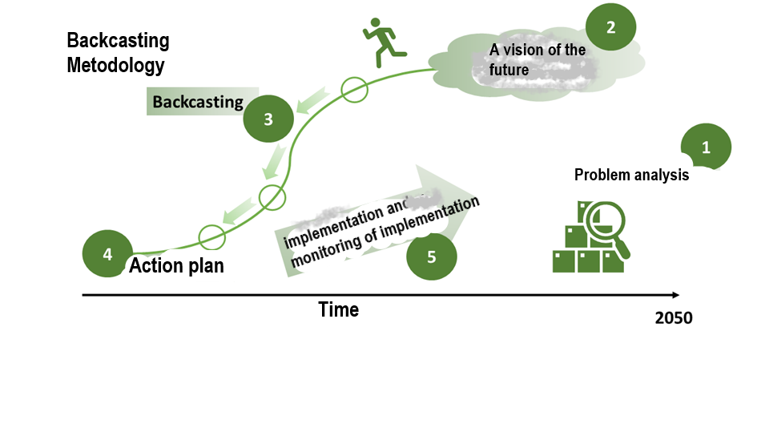 Fig. 24. Backcasting methodology
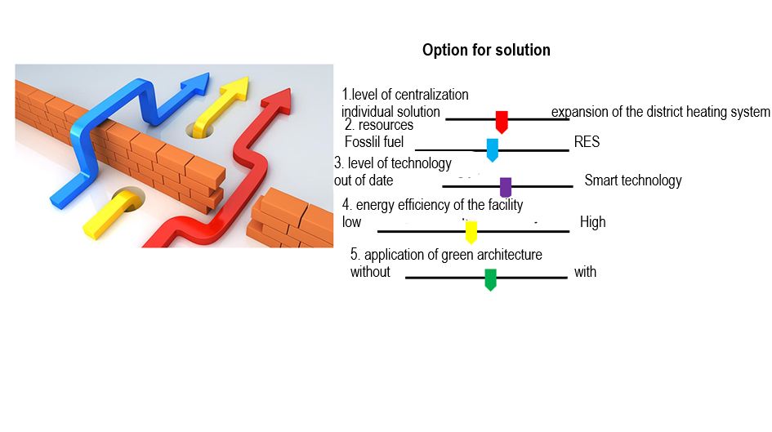 Fig. 25. Options for solutions

Integration of the Roadmap of the energy transition of the city of Nis until 2050 in the "Participatory backcasting" procedure
In the combined procedure of energy planning, the solutions obtained by the "Participatory backcasting" procedure can be considered using tools for modelling in energy. Also, in the evaluation phase of the proposed scenarios, it is useful to look at possible energy flows, consider the energy sources that would be used, analyse the impact on the environment, characteristic indicators, etc.
The goal of the "participatory backcasting" procedure is the development of a long-term strategy and creation of the Energy Transition Roadmap of the City of Niš until 2050.
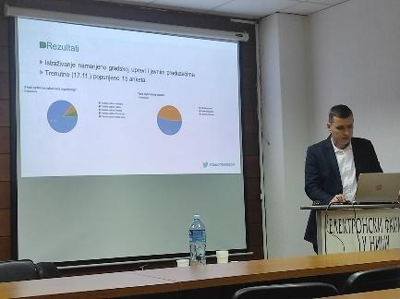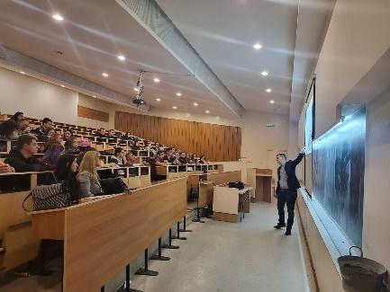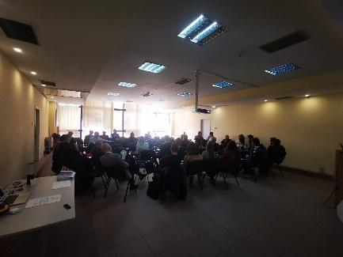
Fig. 26. Held workshops

Role and contribution of citizens and interested parties
Interest target groups were defined, accordingly, special questionnaires were formed, where the questions for each of the target groups are given in the text in the extension. Questionnaires were created specifically for each of the target groups that will represent the main actors of the city's energy transition, with the aim of determining the current state of the city based on the responses of the main actors, but also to determine the realistic dynamics of the implementation of some measures as well as to determine the desired directions of action when defining the measures.

Initiatives for the involvement of citizens and their results
The sample on which the research was conducted includes citizens in the territory of the city of Niš, City and Municipal Administrations and Public Enterprises in the territory of the city of Niš, production and service organizations in the territory of the city of Niš, organizations in the research and education sector, citizens' associations on the territory of the city of Niš. A random sample of 572 respondents was used.
The data was collected using a standardized questionnaire specially constructed for the needs of this research, which consisted of 40 questions in the questionnaire intended for citizens of the city of Niš, 33 questions in the questionnaire intended for City and Municipal Administrations and Public Enterprises in the territory of the city of Niš, 31 questions in the questionnaire intended for citizens' associations in territory of the city of Niš, 41 questions in the questionnaire intended for production and service organizations in the territory of the city of Niš, 23 questions in the questionnaire intended for organizations in the research and education sector. Wherein the first part of the questionnaire referred to standard sociodemographic variables, and the second was devoted to dependent variables related to energy efficiency, energy planning, decarbonization of the city.
Research conclusions
The research set out the following tasks and indicators, which would enable the achievement of the research goal - the involvement of citizens, educational institutions, city administration and business entities for the creation of the Energy Transition Roadmap in the city of Niš:
- Identifying energy problems in households (energy indicators) to which energy indicators imply energy problems in households. Households that have more than one problem (leaking roof, moisture, bad carpentry, etc.) can be considered energy poor, while households with one problem are at risk of energy poverty.
In the territory of the city of Niš, less than 20% of respondents are in the stage of energy poverty, while almost 25% of households are energy poor in terms of energy problems.
One of the ways to solve the problem of energy poverty in terms of energy problems are programs, subsidies, loans that cover part of the costs for solving household problems such as replacing carpentry, wall insulation, attic, and roof insulation, and similar.
The results of the survey indicate that most citizens (77.6%) are not familiar with the ways in which they can improve energy efficiency in the household. This directly indicates the need to include non-governmental organizations, citizens' associations, educational institutions in the training of citizens, to improve their lifestyle in terms of energy efficiency.
- Involvement of scientific and expert bodies in the energy transition activities of the city of Niš
It is especially important to emphasize that citizens have trust in institutions, especially institutions that deal with research and science. Many respondents believe (95.2%) that higher education institutions should be engaged in the energy transition of the city of Niš.
Organizations from the field of science and education (70% of the examined sample) showed readiness to solve problems in the fields of: rational energy management, environmental protection, climate change, renewable energy sources, decarbonization. Also, the vast majority (80%) of educational institutions indicated that they have capacities for spreading awareness in the areas of: rational energy management, environmental protection, climate change, renewable energy sources, decarbonization, which indicates the existence of capacities on the one hand and needs on the other material from the other. It is necessary to find ways to involve as many citizens as possible in ongoing trainings, lectures, courses organized by higher education institutions.
- Determining the level of readiness of non-governmental organizations and citizens' associations for the energy transition of the city of Nis.
It is extremely important that non-governmental organizations and citizens' associations are active and follow new knowledge in the field of energy. The research showed that most of the surveyed associations (60%) have the capacity to spread awareness in the field of rational energy management and environmental protection. You alone, by including citizens' associations in educating citizens about environmental awareness, providing assistance when applying for various subsidies and funds in the field of energy, can certainly do a lot to overcome the existing obstacles between the institutions of the city of Niš and the citizens themselves. Also, citizens would expand their knowledge and make their homes energy efficient and contribute to the green agenda of the city of Nis.

Opportunities in the Green Deal transition processes

Future skills that young people need to acquire and their active citizenship in this field, needed for the European Green Deal
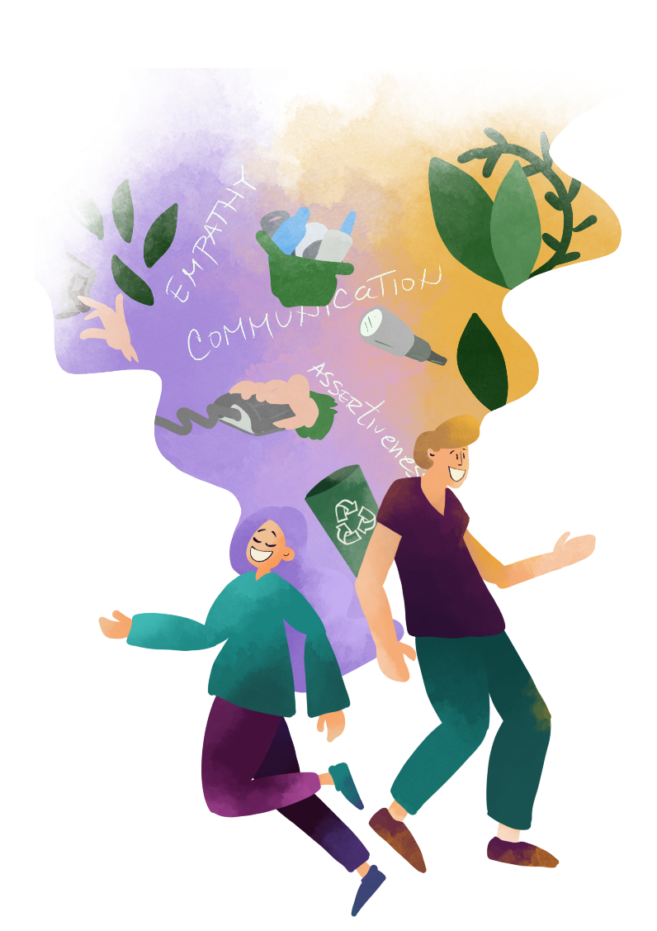
Youth and youth education activities on Green Deal in Europe and Turkey

Non-formal teaching techniques and strategies, best practices, case studies; particularly in universities

Formal vs. non-formal teaching techniques in universities
Sitting and lecture is NOT an effective engagement strategy. On the contrary to teacher-centered approach (teacher is formal authority, an expert that gives old-fashioned lecture), student-centered approach means inquiry-based learning and cooperative learning. A modern teacher is expected to be able to use a wide variety of teaching techniques to facilitate the learning needs of all students.
Interactive activities have multiple benefits: they engage students and thus support their learning and understanding, and they often enable the teacher to quickly assess the student level of knowledge, comprehension, or mastery of the material. Several basic types of student interaction could be distinguished:
Individual work escalating to pair-work or group-work,
- Pair-work,
- Interaction via technology – Instagram, Facebook, Tweeter, YouTube, blogs, chat rooms, applications….
- Interactions through homework
Each of these basic types of interactive activities could include different formal or non-formal teaching technics. Non-formal teaching techniques should enable students to discover or gain new knowledge easily, facilitate learning processes, and to be natural and as close to real life outside the school as possible.
Case studies - Case studies are an innovative approach in higher education, a specific genre within academia which can also be used as a starting point for research. They are highly relevant for the theme of sustainable development in global, regional, and local contexts: working with case studies allows collection of experiences from different regions while opening them up for discussion about sustainability practices under specific cultural, environmental, and other circumstances – uncovering common principles and differences within local cases and foster the application of knowledge to real-life situations.
Two detailed case studies (namely: „Energy transition roadmap - case study city of Niš, and ,,Implementation of the European Green Pact in Bulgaria”) are explained in detailed through this handbook.
Since Best practice is related approach to the case study, it is therefore used as a benchmark against which other activities can be measured. Best practice is closely related to the term “state of the art”, which is sometimes also used to refer to a collection of good practice examples. Examples of best practices for the selected topic are a real-world example (case study) of where a method or technique has been applied that has consistently shown results superior to those achieved by other means (e.g., examples of effective energy efficiency model applied and following discussion).
Field learning as an informal educational method
Field learning is one of the methods of outdoor education which is conducted outside the classroom. It is typical in the fields of philosophy, epistemology, and especially natural sciences. Many instructors, teachers and professors have been influenced by this way of learning and have applied many of the ideas presented in them in different teaching practices. In the last period, important educational efforts have been made focusing on studies conducted in the natural environment. Today, field learning forms part of the curriculum of subjects in a wide range of sciences including biology, geomorphology, geology, and archaeology as well as in various social sciences, while it is often implemented as informal teaching and education programs as part of practical exercises, student’s practical work, etc.


Field study corresponds to activities that take place in a variety of learning environments, usually outside the traditional classroom, such as botanical gardens and zoos, historic sites and museums, national parks, wetlands, wild-nature areas, etc. It offers the opportunity to acquire the most valuable experiences of students through images captured personally, by their senses. It is related to most educational techniques and is often part of some specific project. It allows participants to get involved in the design of the educational activity and to gain experience and knowledge on the spot through the research process. More specifically, it helps students acquire new knowledge and skills in a different and more interesting way of learning than traditional.
The observations and tasks that students do in the field can vary because they can be involved in describing an area of study, comparing visual or another type of data in some kind of research or survey. In other words, this way of learning cannot be accomplished as effectively in a classroom. On the basis of the results of many types of research, students learn faster and more efficiently certain subjects if they find themselves in a suitable external environment, different from a traditional closed space.
The relevance of field study as an appropriate educational method depends on learning, the goal and objectives of the learning process, the learning style, the learning environment, available time and specific moment, as well as available resources. More precisely, in a field study, participants are offered wide opportunities for active participation as they are invited either in groups or individually to plan, implement, apply, and evaluate specific activities related to the theoretical background of their study. Learning in the field deals with both the consolidation of acquired knowledge and the acquisition or development of skills and attitudes.
In the case of environmental issues, students have the opportunity to observe and collect data from the field and exchange their views with members of ecological organizations, representatives of local authorities, as well as residents, thereby determining differences in understanding some problems. In this way, learning becomes more active and related to experience with an emphasis on the local environment.
Like all learning techniques, field study requires systematic and careful preparation by the instructor or teacher. For the field study to be effective, the instructor must take care that the study is well defined, that the students' activities are clear and well planned, and that the outcome is well prepared.
Application
Field study comprises of three phases: preparation, implementation, and presentation. Preparation, the first phase, involves the preliminary action of preparing or finding relevant literature and locating subjects suitable for field study, studies of the places or areas of observation or exploration, and organizing a preliminary visit to the field area to familiarize students/participant with the study object. The instructor or teacher prepares activities for the students together with a list of the required materials, selects the best time for implementation, secures the relative permit/s (if necessary) for the visit, and explores the best possible way of transportation together with the costs involved. The instructor or teacher explains the field study technique and sets the rules for the fieldwork. It also organizes a preliminary discussion to determine the subject of the field study, the objectives, the area of the field study, the activities that will be performed, the duration, and the final product or benefit of the field study. If it is student group work on the field, each group must be assigned specific activities. The instructor or teacher encourages the students’ active involvement. Finally, prior to the visit to the place to be studied, a relevant presentation can take place within the classrooms. This is quite important since thus the students’ interest can be raised, and they could start processing the questions to be answered as a result of the observations to take place in the field.
The second phase is the fieldwork itself. On the field, students, either in groups or alone, are assigned certain activities. These activities may vary, and their nature depends on their goals and abilities, as well as opportunities. Field activities may include observation and comparison, mapping, sampling, taking images, collecting some important objects, stones, or plants to document their activities, etc.
The third stage is the analysis and presentation of the results of the field study. After the completed fieldwork, the processing of the collected data follows, which leads to the analysis and interpretation of the collected data. During this phase, students can prepare a report containing the main points of their research. Communication between students is considered important at this stage.
Field study in biodiversity and endangered species conservation
In this kind of field study, students engage in research on topics of importance to biodiversity and species conservation. Emphasis is on building a solid framework for facilitating field research, species conservation and management in protected areas, including developing appropriate research ideas and methodologies, using literature and other resources for the project work, and primary data collection skills, including interviews and laboratory analyses. Studying in the field is usually planned to be carried out in groups. Each group carries out an observation with a field component and makes a report, the content of which is also presented to other colleagues or interested parties.
Goals of the field study
Participants or students in such a study are introduced to the context of biodiversity and species conservation meaning; develop a research project that more clearly outlines research questions, methodology, and sources to be used to address the research topics; participants focus on collecting relevant field data; the instructor or teacher facilitates student contact with appropriate sources; final presentations are delivered to peers or invited guests.
Field learning: The case of "Jerma" Special Nature Reserve
Fieldwork will be carried out in the rich natural environment of the gorge and canyon of the Jerma River in eastern Serbia. This area abounds with internationally significant, as well as protected and endangered representatives of flora and fauna. In accordance with the presence of high natural values of biodiversity and geodiversity, this area is protected as a natural asset under the name "Jerma" -Special Nature Reserve. It belongs to category Ι – Protected area of international, national, that is, of exceptional importance. This protected natural area is in southeastern Serbia and includes the massifs of Greben and Vlaška mountains, as well as a major part of the Jerma river basin. The Special Nature Reserve "Jerma" is a unique complex of valleys and limestone gorges with imposing cliffs over 700 m high and with numerous caves, pits, karst valleys, sinkholes, and hummocks. Jerma is characterised by exceptional floristic diversity, ecosystems, and a large number of rare and endangered species. Of the 901 plant species recorded so far the most important which will be observed in the field are Malcolmia serbica, Achillea serbica, Parietaria serbica, Parietaria serbica, Taxus baccata, etc.
Among animal species, 110 bird species, 25 mammal species, 11 amphibian and reptile species, 9 species of fish, 181 species of butterflies, some of which will be observed during the visit. The most important nesting birds in terms of conservation are the golden eagle (Aquila chrysaetos), the long-legged buzzard (Buteo rufinus), the rock partridge (Alectoris graeca), corn crake (Crex Crex), the Eurasian eagle-owl (Bubo bubo) and others. Among the protected mammals, the most important are the endangered species of bats (Rhinolophus ferrumequinum. R. hipoposideros, Myotis myotis), otters (Lutra lutra) and lynx (Lynx lynx). A special kind of attractiveness is given to the exceptional landscape diversity and beauty by the pronounced geomorphological forms, and numerous speleological sites, but also by the interesting and important hydrographic phenomena and processes. Cave Vetrena dupka (with canals about 4000 m long) and karst pit Pešterica (160 m deep) are particularly important speleological sites in this area. In the gorge near the village of Poganovo is a monastery with the church of St. John the Theologian, which was built during the fourteenth century, at the time of the Serbian medieval state. For more information, visit the website of the Institute for Nature Protection of Serbia (www.zzps.rs).
Field learning: The case of extinction and species conservation
Venus hair Fern (Adiantum capillus-veneris) is a small fern species, inhabiting moist, shaded and rocky habitats of the Mediterranean and tropical regions of the world. It was first discovered in Serbia in 1968., growing close to the thermal springs in the Jerma River gorge. This is the only habitat in Serbia for this species as well as one of the rare, northernmost distribution locations in the Balkans. For these reasons, the species is included in the Red Book of the Flora of Serbia as a Critically endangered taxon. It is also a Strictly protected species in Serbia, whereas the habitat in Zvonačka Banja is protected since 2001, the first as a Special Nature Reserve, and today as a Protected Habitat "Venus’ slope", a natural asset of national importance (I category). Unfortunately, by capturing the thermal springs that keep the species alive, the habitat of the species becomes endangered. A dramatic reduction in the number of the population was observed, as well as its potential disappearance in the locality. Due to the quick reaction of the local community and the Institute for Nature Conservation of Serbia, in the last 20 years, in-situ and ex-situ protection activities have been carried out. The species has been reintroduced to the habitat, and an artificial water inflow system has been established which provides the thermal water necessary for the preservation of the habitat and species.
Brainstorming
Brainstorming is one of the problem-solving techniques, used to generate fresh ideas, involve the whole group, and encourage creativity. The teacher is just a motivator: he asks a question and students provide as many answers as possible. Quantity is needed and criticism is not allowed. Brainstorming is usually used as a motivation technique and after writing down all ideas (suggestions on how the problem could be solved) the group decide which of them may be used immediately and which might be improved and combined.
Solving the quiz/ the puzzle / the jigsaw crossword puzzle / true or false statements
Solving the quizzes can help the students not only better understand new topics and connect acquired knowledge but also realize that education isn’t about showing up, it’s about finding solutions. Easy competition in the group by:
- seeking the right answers (questions related to topic with or without offered answers),
- Odd One-Out Tasks (choose the option which is not correct by looking at a sentence, a statement, or a situation and three or four possible options followed by explanation why that option is chosen),
- true or false? (popular activity with a lot of variants): teacher prepares the statements from which half is true and the other are false; students decide if the statement is true or not and explain the choice.
- Think-Pair-Share (after a posing a question to students they must consider it alone and then discuss with a neighbor before settling on a final answer) is a technique that encourages and allows for individual thinking, collaboration, and presentation in the same activity.
- Jigsaw crossword puzzle (crosswords or half-crosswords)
Crossword puzzle is an attractive information gap activity that could be done individually or in groups. The teacher creates a crossword puzzle from words important for the topic. Crosswords puzzle could be delivered as such to a group (with or without online answers check) or prepared as half-crosswords to turn a regular crossword puzzle into a speaking activity for pairs. Each student in a pair is given a copy of the crossword with half the words already filled in (A and B sheets). Student A needs to ask student B about the words that are missing in his/her half of the crossword and vice versa. Combining their words will complete the crossword. While answering their partner´s enquires, the students are not allowed to say the words directly. They must give explanations or hints so that their partners can guess the word. The teacher may help them by presenting a list of hints in the worksheet together with a half-crossword.
Crossword puzzles can be easily created online and shared as a link.
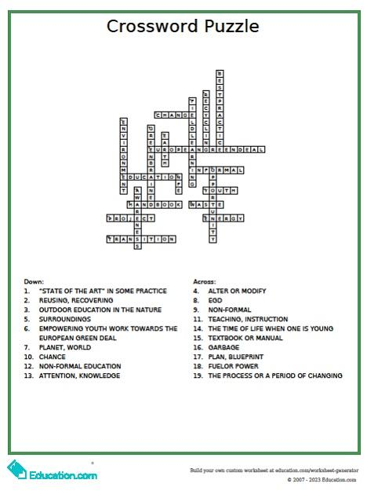
Fig. 27. Example of simple EGD thematic crossword puzzle

Debate
Discussions (small or large group discussion), dialogues, role plays, group work and debate (creation of two groups with conflicting views with task to come to an agreement/conclusion) are social techniques of learning.
Debate is made about some controversial topic. Participants should form two teams: “pros” and “cons”. They must take sufficient time to prepare their arguments and both teams must delegate one ‘’speaker”. After brief presentation of both teams, they could ask questions and answer them and finally summarize both teams´ points.
Proposed topic for debate: Must we ban fossil fuels to save our planet?
Project work in the community
Project is a student-centered teaching technique which is characterized by the fact that students need to use their personal creativity and work independently to generate a final product. It is a large-scale teaching technique that involves research and provides students with opportunities to gain meaningful experience. The teacher plays many roles when organizing project work: he/she is an organizer, coordinator, motivator, facilitator, a participant in project activities (to some extent) and a monitor. Despite all these roles, the irony of organizing project work lies in the fact that the more passive the teacher appears to be, the more successful the project is in terms of students´ autonomy and independent learning.
After setting general aims and defining an end-product, a time frame (at least the deadline) for project realization should be set. Literature seeking through recommended information sources must be done before practical part of project. Evaluation of the project is an important part of it and should be done in accordance with already established criteria of evaluation.
Project work in the community: Raising awareness about pharmaceutical waste in community
The Waste Framework Directive, the EU’s legal framework for treating and managing waste in the EU, introduced the “waste hierarchy”. Certain categories of waste require specific approaches. The main focuses nowadays are waste prevention monitoring, separate collection of dry recyclables and biowaste, and the sustainable management of waste oils. Yet, one type of hazardous waste that is still not adequately considered and managed is pharmaceutical waste as a critical part of medicinal waste. Health Care Without Harm estimates that “if the global health care sector were a country, it would be the fifth-largest greenhouse gas emitter on the planet”. WHO defines medical waste as waste generated by health care activities, ranging from used needles and syringes to soiled dressings, body parts, diagnostic samples, blood, chemicals, pharmaceuticals, medical devices, and radioactive materials. Of the total amount of waste generated by healthcare activities, 15% is considered hazardous material that may be infectious, chemical, or radioactive. The global COVID-19 pandemic, among all others, poses an impact on the amount and composition of medicinal waste. The increased volume of plastic waste due to COVID-19-related practices (including personal protective equipment such as masks, sanitary gloves, and face shields) is a new challenge with respect to ensuring a sustainable environment. Environmental protection and cost reduction through medical waste reduction depend on the activities and actions of related organizations and medical staff on the front lines of medical waste discharge. Proper pharmaceutical waste management is essential for a pharmacy, an outpatient center, a cancer center, an independent physician’s practice, or a hospital. As part of the pharmaceutical waste management processes, healthcare professionals are required to be able to classify categories of pharmaceuticals, particularly distinguishing between hazardous and non-hazardous pharmaceuticals. Yet, patients’ medicines (that are applied outside the hospitals, in the patients’ homes) could easily become a part of mixed waste from households or even could be “dumped” in sewers or flushed down toilets or drains.

Pharmaceuticals are found in surface and groundwater across Europe that is used for irrigation and drinking water production and that is essential for wildlife. Awareness has grown in recent years of the possible risks from pharmaceuticals in the environment, and the "Strategic Approach to Pharmaceuticals in the Environment" is aimed at drawing attention to those risks. Several pharmaceuticals pose well-documented risks to nature and human health. The release of specific chemical entities such as antibiotics, cytostatics, hormones, etc. into the environment relates to serious risks and consequences to the whole planet. Pharmaceuticals discarded in the environment pose a risk to fish or other wildlife, may contribute to the serious problem of antimicrobial resistance, or may act as endocrine-disrupting chemicals (chemicals that mimic, block, or interfere with hormones in the body's endocrine system).
Bearing in mind the ever-growing overall consumption of medication per capita, self-medication (self-medication is the use of drugs to treat self-diagnosed disorders or symptoms, or the intermittent or continued use of a prescribed drug for chronic or recurrent diseases or symptoms without getting advice from a physician for either diagnosis or treatment) and incorrectly disposed medicines, raising global awareness about pharmaceutical waste is extremely important. Since COVID-19 led to the creation of an alarming amount of medical waste and left homes well-equipped with home-kept prescription and/or over-the-counter drugs, the so-called home pharmacies are also a big issue from an environmental point of view.
The improvement of the general level of knowledge, promotion of positive attitudes, and practices of citizens regarding pharmaceutical waste represent a solid base for the successful management of these hazardous waste materials. Raising awareness about pharmaceutical waste could be done through unformal training of youth workers and young people to achieve better understanding on issue and following optimal pharmaceutical waste management. Indeed, simple control of the expiration date medicines present in personal “home pharmacy” and adequate disposal of unused or expired medications would reduce global pollution. Non-formal teaching technics proposed here are:
- Action in the town square on a sunny Sunday under the working title “Not through the medicines in the household waste!” with collection and adequate separation of unused or old medicines from households (prescription medicines stored at home, over-the-counter medicines, but also dietary supplements, used personal protective equipment such as masks, hygienic gloves, and face shield remnants COVID -19 pandemic). Seek a responsible person to be included in the action. Provide brief education on proper disposal of medical and pharmaceutical waste. Demonstrate why pharmaceutical waste disposal is extremely important to the planet and human welfare. Measure (in kilograms) how much pharmaceutical waste is collected and discuss how it is properly managed.
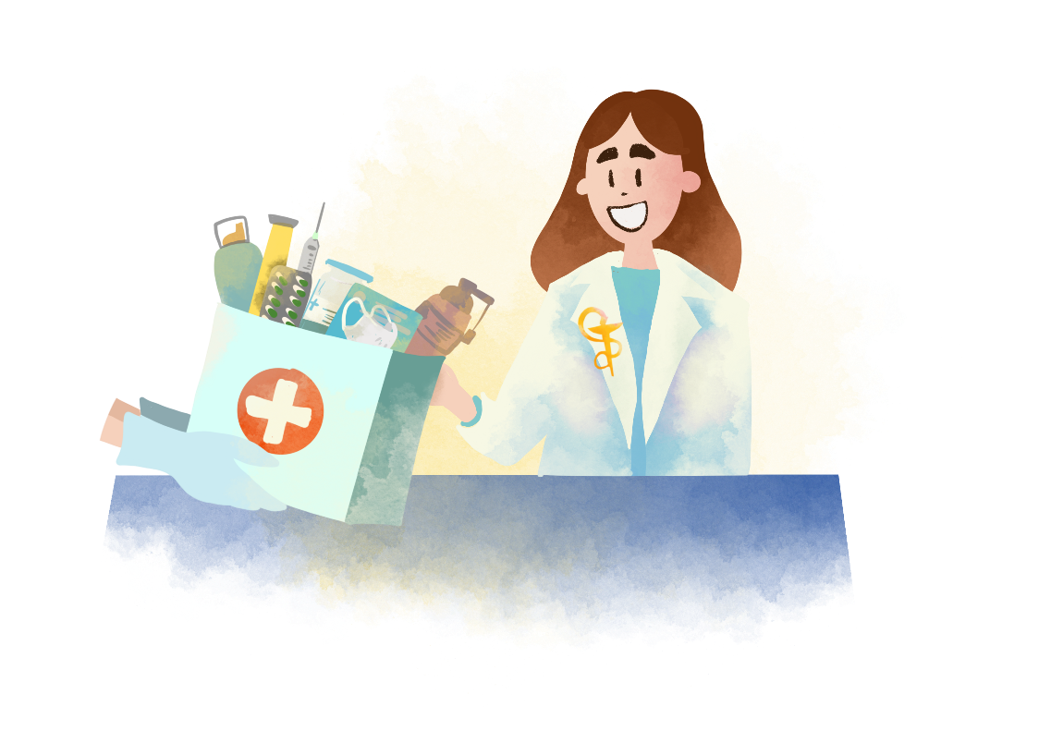
Project work in the community: Trees can reduce CO2 levels and the effects of climate change in urban environments
Compared to the period before the sudden industrialization (the end of the 19th century and the beginning of the 20th century), the average surface temperature of the air above the land has increased significantly. Various studies say that during the 20th century, the average air temperature over continental masses increased by more than 1.53°C.
The effect of such warming, called global warming has caused an increase in the frequency, intensity and duration of disasters related to the temperature parameter of the global climate. At the same time, the frequency and intensity of droughts have increased in some regions, including the Mediterranean region, western Asia, many parts of South America, much of Africa, and northeast Asia. The frequency and intensity of heavy rainfall have also increased globally.
Changes in forest cover, for example, due to deforestation, directly affect regional surface temperature through the water and energy cycle. Also, according to the feedback loop principle, it is assumed that climate changes will change the spatial belts of vegetation zones and affect the migration of living species. In those boreal regions the tree line migrates northward as the growing season lengthens, warming during winter will be enhanced due to reduced snow cover and albedo, while warming will be reduced during the growing season due to increased evaporation and transpiration. On the other side, in those tropical areas where precipitation is projected to increase, increased vegetation growth will reduce regional warming.
In contrast to this, partially drastic, but mostly slow process, man is exposed to immediate climate changes, which accompany our daily life: by changing our immediate environment, primarily in the urban expansion of cities, a locally highly differentiated climate system is formed in the lower layers of the atmosphere, which is called urban climate.
Together, global warming and urbanization can increase the warming of cities and their surroundings (heat island effect), especially during events associated with local changes in temperature conditions, including heat waves forming. Increased global warming and urbanization may also increase extreme precipitation events over cities or in the wider area around them.
Climate and air quality in cities vary depending on regional conditions but are also influenced by various factors, from the distribution of pollutants to the percentage of green areas. By building parks, forming rows of trees and other forms of greenery in the urban environment, the urban microclimate can be modified or improved. To this should be added the formation of urban grasslands, although other types of greening, such as the greening of facades and roofs, which have recently become very popular, also come into play.
Planting trees, there is a possibility to help in the modification of the urban climate. As trees grow, they help stop climate change by removing carbon dioxide from the air, storing carbon in biomasses and soil, and releasing oxygen into the atmosphere. The most effective effect in urban areas is that the canopies of planted trees shade the space they occupy during the day and prevent excessive heating. Since tree leaves have almost no heat storage capacity, and in addition, part of the absorbed radiation is used to evaporate water, there is no danger that the energy collected during the day will be delivered at night.
During the night hours, the influence of trees on the microclimate is much more complex, and the achieved result largely depends on local conditions. Basically, the cooling occurs relatively quickly and is a consequence of the transpiration of the upper layers of the crown, and in this way, the cooling of the observed area is achieved. In parks and green areas, there are almost no materials that absorb solar energy, and the accumulation of heat in the ground due to the evaporation of water from the soil is less than in an asphalted street.
In cities, greenery also plays an important role by affecting circulation and air quality. According to many calculations and analyses, trees in cities reduce CO2 emissions. Basically, trees, due to their relatively large leaf mass, are able to directly absorb or deposit harmful substances on their surface. Microclimate and air quality can be impacted in cities with appropriate urban planning. First of all, the quality of life can be improved by planning green plantings. Urban greenery affects the reduced demand for the installation of air conditioners in buildings and affects the increase of air quality through the reduction of smog. In this connection, energy savings and maintenance costs, depending on the region, can reach a significant amount.
Greenery in cities has a great influence on relative air humidity. The intensity of evaporation from the soil surface during the summer is lower under trees than in an open field because the air temperature is lower, the relative humidity is higher, and the wind speed is lower. As the water evaporates from the plants, the amount of water vapor in the ground layers of the air increases. Urban greenery also has a great influence on sun exposure conditions. The crowns of trees retain direct and diffuse sun radiation. A certain part of the radiation is reflected into the atmosphere from the vegetation cover. It has also been proven that tall tree plantings in city parks reduce air currents in terms of mitigating strong winds due to sudden temperature changes in the summer months and storms.
Certain studies have found that trees around buildings can reduce the consumption of electricity used for heating or cooling in households. The results of certain studies indicate that a tree with an average height of (8-10 m) planted in front of the house can reduce the annual costs of cooling buildings through devices by 8 to 12%. Analysis of the results of the cooling effects revealed that the walls in front of which there is a green area are significantly cooler during the summer months. Strategies that define the increase of the area under greenery not only provide savings for homeowners but also reduce the total energy consumption of a city.
Action: By planting a young tree in the green area in front of the Faculty of Medicine in Niš, we will symbolically join the efforts of the community to increase green areas on a local level. The message we want to send is - value the trees, plant trees, grow trees, and protect them. Let's try to plant as many trees as possible in cities to make the air cleaner and the weather more pleasant!

Learning for the green transition and sustainable development
A recommendation on learning for the green transition and sustainable development was approved by the Council of the European Union in June 2022. This policy statement outlines how sustainability can be integrated into all aspects of education and training. It calls on Member States to
- make learning for the green transition and sustainable development a priority in education and training policies and programmes;
- provide all learners with opportunities to learn about the climate crisis and sustainability in formal education (for example, schools and higher education) and non-formal education (such as, extra-curricular activities, youth work);
- mobilise national and EU funds to invest in green and sustainable equipment, resources and infrastructure;
- support educators in developing their knowledge and skills to teach about the climate crisis and sustainability, including dealing with eco-anxiety among their students;
- create supportive learning environments for sustainability that span all activities and operations by an educational institution and enable teaching and learning that is hands-on, interdisciplinary and relevant to local contexts;
- actively involve students and staff, local authorities, youth organisations and the research and innovation community in learning for sustainability.
Learning for environmental sustainability:
- Starts from early childhood education and care;
- Takes a lifelong learning approach;
- Creates supportive learning environments where the institution as a whole is active on sustainability;
- Is learner-centred, engaging, positive and based on real-life experiences;
- Supports educators, including leadership teams, to teach and act for sustainability;
- Fosters collaboration and partnerships in local and wider communities;
- Involves young people in meaningful ways;
- Builds sustainability competences;
- Is founded on strong policies.
The European green competence framework
Green competence framework consists of four competence ‘areas’ that correspond to the definition of sustainability; and the 12 ‘competences’ that, taken together, make up the building blocks of the sustainability competence for all people. The two dimensions are listed in Table 1. Each competence is accompanied by a descriptor that best represents its main aspects.
Table 1. The European sustainability competences
AREA | COMPETENCE | DESCRIPTOR
1. Embodying sustainability values | 1.1 Valuing sustainability | To reflect on personal values; identify and explain how values vary among people and over time, while critically evaluating how they align with sustainability values.
 | 1.2 Supporting fairness | To support equity and justice for current and future generations and learn from previous generations for sustainability.
 | 1.3 Promoting nature | To acknowledge that humans are part of nature; and to respect the needs and rights of other species and of nature itself in order to restore and regenerate healthy and resilient ecosystems.
2. Embracing complexity in sustainability | 2.1 Systems thinking | To approach a sustainability problem from all sides; to consider time, space and context in order to understand how elements interact within and between systems.
 | 2.2 Critical thinking | To assess information and arguments, identify assumptions, challenge the status quo, and reflect on how personal, social and cultural backgrounds influence thinking and conclusions.
 | 2.3 Problem framing | To formulate current or potential challenges as a sustainability problem in terms of difficulty, people involved, time and geographical scope, in order to identify suitable approaches to anticipating and preventing problems, and to mitigating and adapting to already existing problems.
3. Envisioning sustainable futures | 3.1 Futures literacy | To envision alternative sustainable futures by imagining and developing alternative scenarios and identifying the steps needed to achieve a preferred sustainable future.
 | 3.2 Adaptability | To manage transitions and challenges in complex sustainability situations and make decisions related to the future in the face of uncertainty, ambiguity and risk.
 | 3.3 Exploratory thinking | To adopt a relational way of thinking by exploring and linking different disciplines, using creativity and experimentation with novel ideas or methods.
4. Acting for sustainability | 4.1 Political agency | To navigate the political system, identify political responsibility and accountability for unsustainable behaviour, and demand effective policies for sustainability.
 | 4.2 Collective action | To act for change in collaboration with others.
 | 4.3 Individual initiative | To identify own potential for sustainability and to actively contribute to improving prospects for the community and the planet.
The four competence areas are tightly interrelated: sustainability as a competence encompasses all four taken together. The 12 sustainability competences are also interrelated and interconnected, and should be treated as parts of a whole.
Non-formal education for green transition
To let young people participate in addressing global challenges, education plays a main role. Not only formal education, but also non-formal and informal education. Informal and non-formal education are an integral part of lifelong learning for sustainability, allowing young people and adults to acquire and maintain the skills, abilities and the outlook needed to cope with and adapt to a continuously changing environment. It refers to the collective learning that takes place outside of formal educational systems in everyday life, for instance in the context of families, workplaces, clubs, web-based communities, etc.

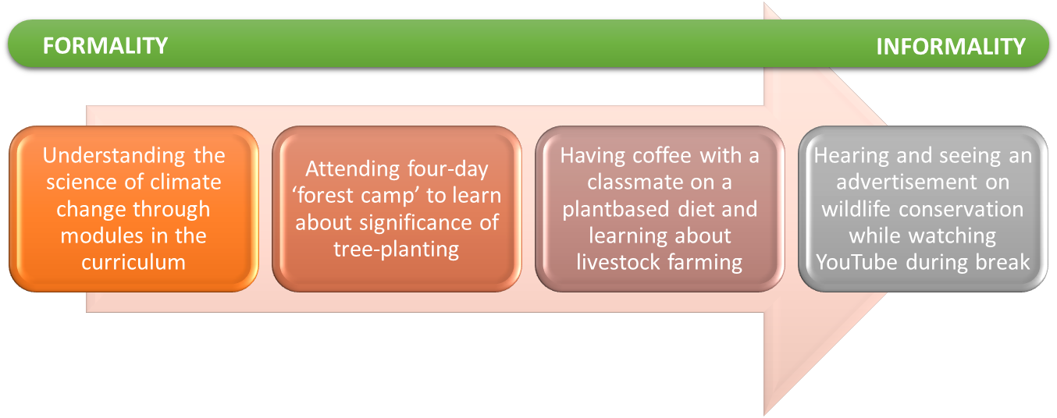
Fig. 28. Formality and informality in learning - an example
Informal learning results from daily life activities related to work, family, or leisure. It is not structured (in terms of learning objectives, learning time, or learning support) and typically does not lead to certification. Informal learning may be intentional but, in most cases, it is nonintentional. Typical example of informal learning is learning about another’s culture through travelling.
Non-formal learning is ‘planned, structured programmes and processes of personal and social education, designed to improve a range of skills and competences, outside the formal educational curriculum’. It is typically not provided by an education or training institution and typically does not lead to certification. Non-formal learning can be structured (in terms of learning objectives, learning time, or learning support) and range from the learning occurring in study groups, non-governmental organizations, social movements, youth clubs, churches, folk high schools etc. From the learner’s perspective, non-formal learning is intentional. Typical example of non-formal learning is learning through environmental camps for young people to learn about conservation.
According to the Council of Europe, non-formal education should be:
- voluntary;
- accessible to everyone with educational objectives;
- participatory;
- learner-centred;
- about learning life skills and preparing for active citizenship;
- holistic and process-oriented;
- based on experience and action.
Key characteristics of non-formal education
Non-formal education (NFE) may take different shapes and forms. There are some common characteristics, however:
- NFE is a planned learning process with educational objectives.
- NFE activities are based on the needs of learners. NFE activities are open to the input of learners to the learning process and encourage making links to real life.
- NFE is based on the voluntary participation of learners (in other words, NFE is not a compulsory activity).
- NFE is inclusive and accessible, in other words every young person can take part and organisers actively seek ways to include persons that may experience exclusion or marginalisation.
- NFE methodologies are varied, participatory and learner-centred, they include a mix of individual and group learning and encourage people to learn from each other.
- NFE it is all about learning life skills and preparing for active citizenship.
- NFE is holistic, which means engaging learners’ emotions, minds, and bodies.
- NFE activities may be run by professional educators/trainers and/or volunteers.
NFE is based on active participation (doing, experiencing). A central part of the learning process is self-reflection. Exercises in NFE are of an experiential nature (for example, simulations and role-plays) and input will always be interactive (a product of the facilitator and participants; they contribute with their experiences and knowledge).
Glossary
Competence | A set of knowledge, skills, and attitudes.
Formal learning | Learning that occurs in an organised and structured environment, such as in an education or training institution, or on the job, and is explicitly designated as learning. Formal learning is intentional and typically leads to certification.
Informal learning | Learning that results from daily activities related to work, family, or leisure. It is not organised or structured and, in most cases, unintentional from the learner’s perspective.
Knowledge | Knowledge is the outcome of the assimilation of theoretical or information by learning. Knowledge is the body of facts, principles, theories, and practices that is related to a field of work or study
Learning outcomes | Learning outcomes are statements of what a learner knows, understands, and can do after completion of learning.
Non formal learning | Learning that is embedded in planned activities not explicitly designated as learning, but which contains an important learning experience. Non-formal learning is intentional and typically does not lead to certification.
Skills | Skills means the ability to apply knowledge and use know-how to complete tasks and solve problems. Skills can be cognitive (involving the use of logical, intuitive, and creative thinking) or practical (involving manual dexterity and the use of methods, materials, tools, and instruments).
Transformative learning | Transformative learning goes beyond acquiring skills and knowledge. It helps learners reflect on how they acquire and frame knowledge. It also helps them become aware and critical of their own and others’ assumptions. This can lead to changes in thinking, perceptions, beliefs, and values, which can transform how learners interpret the world around them.

https://ticaret.gov.tr/data/643ffd6a13b8767b208ca8e4/YMEP%202022%20Faaliyet%20Raporu.pdf
https://www.ab.gov.tr/test_53490.html
https://iklim.gov.tr/sinirda-karbon-duzenleme-mekanizmasinin-turkiye-ekonomisine-potansiyel-etkileri-calismasi-tamamlandi-haber-4147
https://www.tobb.org.tr/Sayfalar/Detay.php?rid=11740&lst=Haberler
https://ticaret.gov.tr/dis-iliskiler/yesil-mutabakat/duyurular/ab-skdm-ihtisas-calisma-grubu-3-toplantisi
https://udder.org.tr/wp-content/uploads/SanayiveTeknolojiBakanligiSanayiGenelMudurlugundenOrcanUfukEKERinSunumu.pdf
https://ticaret.gov.tr/data/643ffd6a13b8767b208ca8e4/YMEP%202022%20Faaliyet%20Raporu.pdf
https://ticaret.gov.tr/dis-iliskiler/yesil-mutabakat/yesil-mutabakat-eylem-plani-ve-calisma-grubu
https://ticaret.gov.tr/dis-iliskiler/yesil-mutabakat/ab-dongusel-ve-surdurulebilir-sanayi-politikalari/ab-surdurulebilir-urun-inisiyatifi
https://tuketici.ticaret.gov.tr/data/63ada5bc13b876a1c8715f73/%C3%87EVREYE%20%C4%B0L%C4%B0%C5%9EK%C4%B0N%20BEYANLAR%20%C4%B0%C3%87EREN%20REKLAMLAR%20HAKKINDA%20KILAVUZ.pdf
https://www.tarimorman.gov.tr/SYGM/Sayfalar/GormeEngellilerDetay.aspx?OgeId=47&Liste=Haber
https://webdosya.csb.gov.tr/db/cygm/icerikler/tekst-l-sektorunde-tem-z-uret-m-uygulamalari-genelges--20230102182517.pdf
https://www.tarimorman.gov.tr/SYGM/Haber/816/Su-Kaynaklarinda-Iklim-Degisikligine-Uyum-Projesi-Basladi
https://www.konyaninsesi.com.tr/yerel/marsude-tarima-hayat-verecek-4643.html
https://www.hmb.gov.tr/surdurulebilir-finansman
https://www.bddk.org.tr/KurumHakkinda/EkGetir/18?ekId=122
https://www.cbfo.gov.tr/sites/default/files/docs/2022-05/cbfo-yesil-sukuk-calisma-raporu.pdf
https://iklimsurasi.gov.tr/klavuz.pdf
https://www.tbb.org.tr/surdurulebilirlik/tbb-surdurulebilirlik-kilavuzu.html
https://spk.gov.tr/data/6231ce881b41c612808a3a1c/b2d06c64099c9e7e8877743afc7d2484.pdf
https://ticaret.gov.tr/dis-iliskiler/yesil-mutabakat/duyurular/2022-yili-faaliyet-raporu
https://ticaret.gov.tr/dis-iliskiler/yesil-mutabakat/duyurular/2022-yili-faaliyet-raporu
https://enerji.gov.tr/bilgi-merkezi-enerji-verimliligi-ulusal-enerji-verimliligi-eylem-plani
https://enerji.gov.tr/Media/Dizin/EIGM/tr/Raporlar/TUEP/T%C3%BCrkiye_Ulusal_Enerji_Plan%C4%B1.pdf
https://enerji.gov.tr/bilgi-merkezi-enerji-verimliligi-ulusal-ve-uluslararasi-projeler-gelistirme
https://enerji.gov.tr/bilgi-merkezi-enerji-verimliligi-ulusal-ve-uluslararasi-projeler-gelistirme
https://www.epdk.gov.tr/detay/icerik/2-8181/elektrik-faturalarinda-yesil-isaret
https://www.mevzuat.gov.tr/anasayfa/MevzuatFihristDetayIframe?MevzuatTur=7&MevzuatNo=14217&MevzuatTertip=5
https://aydin.tarimorman.gov.tr/Duyuru/66/2014-Yili-Organik-Tarim-Destekleme-Basvurulari-12-Ocak-2015-Tarihinde-Basliyor
https://www.tarimorman.gov.tr/BUGEM/Sayfalar/GormeEngellilerDetay.aspx?OgeId=643&Liste=Haber
https://ticaret.gov.tr/duyurular/ab-ciftlikten-catala-stratejisi-ve-ab-turkiye-tarim-iliskilerine-etkileri-hakkinda-webinar
https://www.surdurulebiliruretim.com/yarinin-garantoru-surdurulebilir-tarim/
https://www.tarimorman.gov.tr/GKGM/Haber/539/Kalinti-Eylem-Plani-Kapsaminda-Kitapcik-Liflet-Ve-Afis-Basimi-Yapildi
https://www.tarimorman.gov.tr/GKGM/Haber/215/Ulusal-Veteriner-Antibiyotik-Direnc-Izleme-Projesi-Yil-Sonu-Degerlendirme-Toplantisi
https://ticaret.gov.tr/data/643ffd6a13b8767b208ca8e4/YMEP%202022%20Faaliyet%20Raporu.pdf
https://www.tarimorman.gov.tr/TRGM/Haber/610/Arazi-Tahribatinin-Dengelenmesi-_atd_-Yukari-Sakarya-Havzasi-Projesi-Kapsaminda-Iklim-Dostu-Tarim-Uygulama-Demonstrasyonlari-Devam-Ediyor
https://www.tarimorman.gov.tr/TRGM/Haber/610/Arazi-Tahribatinin-Dengelenmesi-_atd_-Yukari-Sakarya-Havzasi-Projesi-Kapsaminda-Iklim-Dostu-Tarim-Uygulama-Demonstrasyonlari-Devam-Ediyor
https://cem.csb.gov.tr/toprak-organik-karbonu-projesi-i-103572
https://arastirma.tarimorman.gov.tr/toprakgubre/Haber/148/Ulkesel-Toprak-Bilgi-Sistemi-Olusturulmustur
https://www.resmigazete.gov.tr/eskiler/2022/05/20220527-1.htm
https://ipa.uab.gov.tr/halkali-kapikule-demiryolu-hatti-cerkezkoy-kapikule-kesimi-insasi-projesi
https://denizcilik.uab.gov.tr/yesil-liman
https://www.denizticaretodasi.org.tr/tr/sirkuler/yesil-liman-sertifikasi-duzenlenmesi-hakkinda-taslak-yonetmelige-iliskin-gorus-talebi-16684
https://www.resmigazete.gov.tr/eskiler/2021/04/20210428-1.htm
https://trugo.com.tr/?gclid=CjwKCAjwv-2pBhB-EiwAtsQZFLGvY3ZyKZw4wbz85wg7AEpahlDRllcptpQOv5ftn2Vn9ZEfSEDRkhoCFWwQAvD_BwE
https://www.sanayi.gov.tr/assets/pdf/plan-program/MobiliteAracveTeknolojileriYolHaritasi.pdf
https://www.tehad.org/2020/11/09/turkiye-sarj-istasyonu-haritasi-bolgeler-2020/
www.iklim.gov.tr
https://iklim.gov.tr/turkiye-nin-2053-yili-net-sifir-emisyon-rotasi-hazirlaniyor-haber-22
iklimsurasi.gov.tr
https://ticaret.gov.tr/data/643ffd6a13b8767b208ca8e4/YMEP%202022%20Faaliyet%20Raporu.pdf
https://www.ogm.gov.tr/tr/stratejik-plan
https://ticaret.gov.tr/data/643ffd6a13b8767b208ca8e4/YMEP%202022%20Faaliyet%20Raporu.pdf
https://ticaret.gov.tr/dis-iliskiler/yesil-mutabakat/yesil-mutabakat-eylem-plani-ve-calisma-grubu/ihtisas-calisma-gruplari
https://iklimsurasi.gov.tr/sayfa/hakkimizda/goc-adil-gecis-ve-diger-sosyal-politikalar
https://www.sbb.gov.tr/wp-content/uploads/2022/09/Orta-Vadeli-Program-2023-2025.pdf
https://www.csgb.gov.tr/cgm/haberler/adil-gecis-politikalari-icg-toplantisi/#:~:text=Adil%20Ge%C3%A7i%C5%9F%20Politikalar%C4%B1%20%C4%B0htisas%20%C3%87al%C4%B1%C5%9Fma,M%C3%BCd%C3%BCr%C3%BCm%C3%BCz%20Nurcan%20%C3%96nder%20Ba%C5%9Fkanl%C4%B1%C4%9F%C4%B1nda%20ger%C3%A7ekle%C5%9Ftirildi.
https://ticaret.gov.tr/data/643ffd6a13b8767b208ca8e4/YMEP%202022%20Faaliyet%20Raporu.pdf
https://www.ab.gov.tr/202.html
https://ticaret.gov.tr/dis-iliskiler/yesil-mutabakat/yesil-mutabakat-eylem-plani-ve-calisma-grubu/ihtisas-calisma-gruplari
For the Ministry of National Education Climate Change Action Plan: https://merkezisgb.meb.gov.tr/meb_iys_dosyalar/2022_09/29171316_Milli_EYitim_BakanlYYY_Yklim_ DeYiYikliYi_Eylem_PlanY.pdf
https://merkezisgb.meb.gov.tr/www/mill-egitim-bakanligi-iklim-degisikligi-eylem-plani/icerik/437
https://ab.csb.gov.tr/cityair-ankara-da-tanitildi-haber-267983
https://www.tema.org.tr/calismalarimiz/egitim/doga-egitim-programlari
https://tegm.meb.gov.tr/www/miniktemayavrutemaortaokultemaprojesi/icerik/609
https://ozuecem.net/projeler/enerji-verimliligi-egitim-projeleri/isdb-next-gen/
https://ufukavrupa.org.tr/en/node/2939
https://ticaret.gov.tr/data/643ffd6a13b8767b208ca8e4/YMEP%202022%20Faaliyet%20Raporu.pdf
https://www.cevremuhendisligi.org/index.php/98-haberler/yazar-ozs/1650-yesil-mutabakat-ve-sinirda-karbon-duzenlemesi-mekanizmasi
https://mc2haber.com/enerjisa-enerji-yesil-mutabakat-eylem-planlarina-destek-veriyor
https://ticaret.gov.tr/data/643ffd6a13b8767b208ca8e4/YMEP%202022%20Faaliyet%20Raporu.pdf
https://ticaret.gov.tr/data/643ffd6a13b8767b208ca8e4/YMEP%202022%20Faaliyet%20Raporu.pdf
https://ticaret.gov.tr/data/643ffd6a13b8767b208ca8e4/YMEP%202022%20Faaliyet%20Raporu.pdf
https://ticaret.gov.tr/data/643ffd6a13b8767b208ca8e4/YMEP%202022%20Faaliyet%20Raporu.pdf
https://iklim.tobb.org.tr/index.php
https://www.isoyesilblog.com/yesil-mutabakat-sanayi-plani-sanayinin-donusumunde-yeni-sayfa-aciyor/
https://www.gaib.org.tr/tr/haberler/avrupa-birligi-emisyon-ticaret-sistemi-ve-sinirda-karbon-duzenleme-mekanizmasi-aym-5-raporu-375.html
https://www.gto.org.tr/tr/etkinlikler/seminer-uretim-sektorunde-sinirda-karbon-duzenleme-mekanizmasi-167.html
Net Zero by 2050, A roadmap for the global energy sector, International Energy Agency, 2021
The Council of Europe, https://www.coe.int/en/web/european-youth-foundation/definitions.

